**PROFORMA FOR ANNUAL REPORT**

**2017-18 (April 2017to March 2018)**

1. GENERAL INFORMATION ABOUT THE KVK

1.1. Name and address of KVK with phone, fax and e-mail

|  |  |  |  |
| --- | --- | --- | --- |
| Address | Telephone | | E mail |
|  | Office | FAX |  |
| Darjeeling KVK  Uttar Banga Krishi Viswavidyalaya  Kalimpong, Darjeeling, West Bengal - 734301 | 03552 256283 | 03552 256283 | [djkvk@yahoo.com](mailto:djkvk@yahoo.com)  djkvk93@gmail.com |

1.2 .Name and address of host organization with phone, fax and e-mail

|  |  |  |  |
| --- | --- | --- | --- |
| Address | Telephone | | E mail |
| Office | FAX |  |
| Dr. Prabhat Pal  Uttar Banga Krishi Viswavidyalaya  P.O Pundibari, Cooch Behar | 03582-270141/986 | 03582-270249/986 | dee\_ubkv@gmail.com |

1.3. Name of the Programme Coordinator with phone & mobile No.

|  |  |  |  |
| --- | --- | --- | --- |
| Name | Telephone / Contact | | |
|  | Residence | Mobile | Email |
| Dr. Mendel Wangchuk Moktan | 10½ Mile, Kalimpong  9434407412 | 9434407412 | mendelmw@gmail.com |

1.4. Year of sanction of KVK: 1993

1.5. Staff Position (as on 1st April, 2017)

|  |  |  |  |  |  |  |  |  |
| --- | --- | --- | --- | --- | --- | --- | --- | --- |
| **Sl.**  **No.** | **Sanctioned post** | **Name of the incumbent** | **Designation** | **Discipline** | **Pay**  **Scale with present basic** | **Date of joining** | **Permanent**  **/Temporary** | **Category (SC/ST/**  **OBC/**  **Others)** |
| 1 | Senior Scientist- cum- Head | Dr. Mendel Wangchuk Moktan | Senior Scientist- cum- Head | Agril. Extension | PB-4  49240 | 10.12.2001 | Permanent | ST |
| 2 | Subject Matter  Specialist | Dr. Rakesh Roy | SMS | Animal Science | PB-3  31350 | 29.06.2010 | Permanent | SC |
| 3 | Subject Matter  Specialist | Miss Akriti Pradhan | SMS | Home Science | PB – 3  22280 | 14/07/2014 | Permanent | OBC |
| 4 | Subject Matter  Specialist | Dr. Pranab Barma | SMS | Plant Protection | PB – 3  22280 | 21/07/2014 | Permanent | SC |
| 5 | Subject Matter  Specialist | Mrs. Snehlata Lama | SMS | Horticulture | PB – 3  22280 | 25/11/2014 | Permanent | ST |
| 6 | Subject Matter  Specialist | Vacant | SMS | Soil Science |  |  |  |  |
| 7 | Subject Matter  Specialist | Vacant | SMS | Agril Extension |  |  |  |  |
| 8 | Computer  Programmer | Sri. Subrata Manna | Programme Assistant (Comp) | M.C.A | PB – 3  21630 | 30.01.2006 | Permanent | OBC |
| 9 | Programme Assistant | Dr. Basu Deo Kharga | Programme Assistant (Training) | Agril. Extension | PB-2  19200 | 20.06.2007 | Permanent | General |
| 10 | Farm Manager | Akash Deep Thapa | Farm Manager | Agril. Extension | PB-2  19200 | 02.07.2007 | Permanent | OBC |
| 11 | Assistant | Dinesh Kr.Diyali | Assistant | M.com. | PB – 2  19720 | 30.01.2006 | Permanent | SC |
| 12 | Stenographer cum computer operator | Vacant |  |  |  |  |  |  |
| 13 | Driver | Ashok Tamang | Driver | HS | PB – 1 12230 | 12.09.2007 | Permanent | ST |
| 14 | Driver | Harish Kr.Chhetri | Driver | HS | PB – 1 12230 | 13.09.2007 | Permanent | General |
| 15 | Supporting staff | Mrs. Mingma Lhamu Lama | Supporting staff | HS | PB-1 7600 | 31/10/2014 | Permanent | ST |
| 16 | Supporting staff | Sri Sandeep Thapa | Supporting staff | B.A. | PB-1 7600 | 03/11/2014 | Permanent | OBC |

1.6. Total land with KVK (in ha) :

|  |  |  |
| --- | --- | --- |
| ***S. No.*** | ***Item*** | ***Area (ha)*** |
| 1 | Under Buildings | 0.25 |
| 2. | Under Demonstration Units | 1.00 |
| 3. | Under Crops | 2.50 |
| 4. | Orchard/Agro-forestry | 1.88 |
| 5. | Others with details | 16.77 |
|  | Total | **22.4** |

*Total area should be matched with breakup*

1.7. Infrastructure Development:

A) Buildings and others

|  |  |  |  |  |  |  |  |  |  |
| --- | --- | --- | --- | --- | --- | --- | --- | --- | --- |
| **S. No.** | **Name of infrastructure** | **Not yet started** | **Completed up to plinth level** | **Completed up to lintel level** | **Completed up to roof level** | **Totally completed** | **Plinth area (sq.m)** | **Under use or not\*** | **Source of funding** |
| 1. | Administrative  Building |  |  |  |  | 2004 | 293 | Yes | ICAR |
| 2. | Farmers Hostel |  |  |  |  | 2006 | 293 | Yes | ICAR |
| 3. | Staff Quarters (6) |  |  |  |  | 2009 | 400 | 4 out of 6 | ICAR |
| 4. | Piggery unit |  |  |  |  | 2012 | 14 | Yes | RKVY Project |
| 5 | Fencing |  |  |  |  | 2018 |  |  |  |
| 6 | Rain Water harvesting |  |  |  |  | 2009 | 75000 L | Yes | ICAR |
| 7 | Threshing floor |  |  |  |  | 2012 | 400 sq ft | Yes | RKVY Project |
| 8 | Farm godown |  |  |  |  | 2010 | 800 Sq ft | Yes | ICAR |
| 9. | Apiary Unit |  |  |  |  | 2018 |  |  |  |
| 10. | Poultry unit |  |  |  |  | 2012 | 450 Sq ft | Yes | RKVY Project |
| 11. | Goatary unit |  |  |  |  | /2012 | 120 Sq ft | Yes | RKVY Project |
| 12. | Mushroom Unit |  |  |  |  | 2018 |  |  |  |
| 13 | Shade house |  |  |  |  | 2012 | 800 Sq ft | No | RKVY Project |
| 14. | Soil test Lab |  |  |  |  | 2012 | 180 Sq ft | Yes | University |
| 15. | Others, Please Specify |  |  |  |  | 2012 | 300 sq ft | No | RKVY Project |
| 16 | Vermi Compost Unit |  |  |  |  | 2018 | 293 | Yes | ICAR |

\* If not in use then since when and reason for non-use

B) Vehicles

|  |  |  |  |  |
| --- | --- | --- | --- | --- |
| Type of vehicle | Year of purchase | Cost (Rs.) | Total km. Run | Present status |
| Mahindra Max (4 wheel drive) | 2006 | 5.0 lacks | More than 2 Lakh | Condemn by MVI |
| Honda Unicon Bike | 2016 | 0.75 Lakh | 2500 | Good |
| Mahindra Gusto Scooty | 2016 | 0.60 Lakh | 3000 | Good |

C) Equipment & AV aids

|  |  |  |  |  |
| --- | --- | --- | --- | --- |
| **Name of equipment** | **Year of purchase** | **Cost (Rs.)** | **Present status** | **Source of fund** |
| **a. Lab equipment** | | | | |
| Spectrophotometer |  | 0.60 |  | ICAR |
| Flame Photometer |  | 0.50 |  | ICAR |
| PH Meter |  | 0.10 |  | ICAR |
| Conductivity bridge |  | 0.10 |  | ICAR |
| Physical balance |  | 0.10 |  | ICAR |
| Chemical balance |  | 1.00 |  | ICAR |
| Digestion unit |  |  |  | ICAR |
| Kjeldhal Distillation set |  | 0.60 |  | ICAR |
| Mechanical shaker |  | 0.50 |  | ICAR |
| Refrigerator |  | 0.20 |  | ICAR |
| Hot air oven |  | 0.15 |  | ICAR |
| Hot plate |  | 0.25 |  | ICAR |
| Grinder |  | 0.30 |  | ICAR |
| Water distillation unit (double) |  | 1.00 |  | ICAR |
| Chemical and Glass wares |  | 2.50 |  | ICAR |
| Soxlet Apparatus (Big &Small) |  | 0.50 |  | ICAR |
| Laboratory set up |  | 3.30 |  | ICAR |
| Soil and plant sample processing and storage facility |  | 0.50 |  | ICAR |
| **b. Farm machinery** | | | | |
| Power tiller | (2 nos) one from RRS, Hill Zone & another from Khoribari | One is in working condition another working but need some repairing | |  |
| Rotary power tiller | 2011 | 68500 | working | RKVY |
| Weed cutter | 2011 | 32800 | Working | RKVY |
| Mobile sprayer | 2011 | 32600 | Working | RKVY |
| Rocker sprayer | 2011 | 4800 | Working | RKVY |
| Branch cutter | 2011 | 61000 (2nos) | Working | RKVY |
| Paddy cutter | 2011 | 36000 | working | RKVY |
| Weigh machine | 2011 | 16640(2nos) | Working | RKVY |
| P.A. System | 2011 | 2860 | working | RKVY |
| **C. AV Aids** | | | | |
| Over Head Projector | 1995 | 9042 | Not good |  |
| Television | 2004 | 13500 | Good |  |
| DVD | 2006 | 4050 | Good |  |
| Camera | 1994 | 2350 | Not good |  |
| Digital Camera Sony F217 | 2004 | 64990 | Not good |  |
| LCD Projector | 2008 | 78000 | Good |  |
| LCD Projector | 2009 | 56000 | Not Good |  |
| Nikon SLR Camera | 2009 | 30000 | Not Good |  |
| Handy Cam | 2009 | 25000 | Not Good |  |
| Laptop | 2009 | 30000 | outdated |  |
| Laptop | 2011 | 30000 | Not Good |  |
| Netbook | 2011 | 25000 | Not Good |  |
| Ahuja Sound system for Conference Hall |  |  | Not Good |  |
| Canon Photo copier |  |  | Good |  |
| FAX Machine |  |  | Good |  |
| Laptop | 2011 | 44780 | Working |  |
| Desktop | 2011 | 40980 | Not Working |  |
| LCD Projector | 2011 | 54000 | Working |  |
| Printer | 2011 | 10900 | Not Working |  |
| UPS | 2011 | 1750 | Not working |  |

D) Farm implements

|  |  |  |  |  |
| --- | --- | --- | --- | --- |
| **Name of equipment** | **Year of purchase** | **Cost (Rs.)** | **Present status** | **Source of fund** |
| Maize Sheller | 2011 | 1500 (10 pcs) | Working | ICAR |
| Secateurs | 2011 | 2100 (6pcs) | Working | RKVY |
| Tree pruner | 2011 | 1645 (1pc) | Working | RKVY |
| Hedge shear | 2011 | 1000 (1pc) | Working | RKVY |
| Pruning saw | 2011 | 400 (2pcs) | Working | RKVY |
| Garden tools | 2011 | 1200 (3 pcs) | Working | RKVY |
| Spade | 2011 | 3750 (12 pcs) | Working | RKVY |
| Rake | 2011 | 1344 (6 pcs) | Working | RKVY |
| Khurpa | 2011 | 900 (8 pcs) | Working | RKVY |
| Datri | 2011 | 375 (3pcs) | Working | RKVY |
| Knapsack sprayer | 2011 | 5100 (2 pcs) | Working | RKVY |
| Turmeric cutter machine | 2016 | 14000 ( 1 Pcs) | Working | TSP |
| Honey Extractor | 2016 | 6600 (2 pcs) | Working | TSP |
| Bee Hives | 2016 | 5400 ( 3 Pcs) | Working | TSP |

1.8. Details SAC meeting\* conducted in the year

|  |  |  |  |  |  |
| --- | --- | --- | --- | --- | --- |
| Sl.No. | Date | Number of Participants | Salient Recommendations | Action taken | If not conducted, state reason |
| - | - | - | - | - | - |

*\* Salient recommendation of SAC in bullet form*

*Attach a copy of SAC proceedings along with list of participants*

2.a. District level data on agriculture, livestock and farming situation (2017-18)

|  |  |  |  |  |
| --- | --- | --- | --- | --- |
| **Sl. no.** | **Item** | **Information** | | |
| 1 | Major Farming system/enterprise | Hill and mountain farming system with horticulture base crop enterprise | | |
| 2 | Agro-climatic Zone | | | |
|  | Hill Zone | 1. Sloppy land – high soil erosion, shallow depth 2. Acidity problem 3. Low soil fertility – due to NPK and micro nutrient 4. Low Nitrogen release from organic matter due to soil acidity and low temperature | | |
|  | Tarai Zone | 1. High leaching loss of nutrient due to light texture soil 2. Low availability of P due to soil acidity 3. Bo and Mo deficiency | | |
| 3 | Agro ecological situation | 1. Due to sub-humid climate organic matter content moderate to high (2%) but decrease with depth 2. The eastern Himalayan region acidic to neutral range pH found | | |
| 4 | Soil type |  | | |
|  | Brown forest soil | 1. Slow release nutrients from organic matter due to acidity and low temperature 2. Micro nutrient deficiency 3. Leaching loss of nutrients due to high rainfall | | |
| 5 | Productivity of major 2-3 crops under cereals, pulses, oilseeds, vegetables, fruits and others | Crop | Productivity (q/ha) | |
| Rice | 16.98 | |
| Wheat | 13.18 | |
| Maize | 20.42 | |
| Gram | 10.65 | |
| Other Pulses | 6.19 | |
| Mustard | 3.01 | |
| Linseed | 2.05 | |
| Potato | 164.40 | |
| Tea | 18.89 | |
| Chilli (dry) | 7.5 | |
| Ginger | 35 | |
| Mandarin Orange | 92 | |
| Tomato | 160.79 | |
| Cabbage | 340.21 | |
| Cauliflower | 343.55 | |
| Radish | 135.04 | |
| Gladiolus | 146733 spikes | |
| 7 | Production of major livestock products like milk, egg, meat etc. | **Category** | | **Population** |
| **Cattle** | |  |
| *Crossbred* | | **277057** |
| *Indigenous* | |  |
| **Buffalo** | | **5520** |
| **Sheep** | |  |
| Crossbred | | **2649** |
| *Indigenous* | |  |
| **Goats** | | **187975** |
| **Pigs** | | **53875** |
| *Crossbred* | |  |
| *Indigenous* | |  |
| **Rabbits** | |  |
| **Poultry** | | **673026** |
| Hen | |  |
| *Desi* | |  |
| *Improved* | |  |
| Duck | |  |
| others | | **71593** |

Note: Please give recent data only

2.b. Details of operational area / villages (2017-18)

2. c. Details of village adoption programme:

Name of the villages adopted by PC and SMS in 2017-18 for its development and action plan

|  |  |  |
| --- | --- | --- |
| **Name of village** | **Block** | **Action taken for development** |
| Bidyang | Kalimpong II | Training, Demonstration, OFT, Field day |
| Sangsey | Kalimpong II |
| Sittong | Kurseong |
| Chenga | Mirik |
| Bong Busty | Kalimpong I |

| **Sl.**  **No.** | **Name of Taluk** | **Name of the block** | **Name of the villages** | **Major crops**  **& enterprises** | **Major problems identified (crop-wise)** | **Identified Thrust Areas** |
| --- | --- | --- | --- | --- | --- | --- |
| 1 | Kalimpong | Kalimpong I | Bong Busty | Paddy, Vegetables, Maize, Ginger | Ginger Rhizome rot, low productivity of paddy and vegetables | Rhizome rot disease of ginger |
| 2 |  | Kalimpong II | Bidyang | Large Cardamom, Maize Potato Vegetables | Blight in Large cardamom, potato, low market price for vegetables | Blight in Large cardamom |
| 3 |  | Algarah | Sangsey | Ginger, Maize, Vegetables, Darjeeling Orange | Fruit drop in orange, Rhizome rot in ginger | Fruit drop in orange, Rhizome rot in ginger |
| 4 |  | Mirik | Chenga Pani | Ginger, Maize, Vegetables, Animal Husbandary, Black pepper & Betal Nut | Fruit drop of Betal Nut, Rhizome rot in ginger | Fruit drop of Betal Nut, Rhizome rot in ginger |
| 5 | Kurseong | Mirik | Sittong | Ginger, Darjeeling Orange, Vegetables | Rhizome rot in ginger, fruit drop and trunk borer in orange and low market rate for vegetables | Fruit drop in orange, Rhizome rot in ginger |
| 8 | Siliguri | Phansidewa | Phansidewa | Animal husbandry | Diseases Problem | Vaccination |

2. d. Sansad Adarsh Gram Yojona (Hatighisha)

2.1 Priority thrust areas

|  |  |
| --- | --- |
| **S. No** | **Thrust area** |
| 1. | Management of declination of Darjeeling Mandarin orange. |
| 2. | Mulching in Citrus orchard (to conserve soil moisture). |
| 3. | Management of Gerbera (cut flowers) & Marigold |
| 4. | Production management of Rice. |
| 5. | Production management of Potato. |
| 6. | Promotion of I.P.M. in Rice and Potato. |
| 7. | Introduction of off season vegetables under plastic house. |
| 8. | Socio-Economic empowerment of women through Preservation, Mushroom production, Backyard Poultry and Goatery. |
| 9. | Entrepreneurship development of rural youth through floriculture, small scale piggery and production of vermi compost. |
| 10. | Production & Management of Large Cardamom and Ginger |
| 11. | Production & Management of Maize. |

3. TECHNICAL ACHIEVEMENTS

3.A.Details of target and achievement of mandatory activities by KVK during the year

|  |  |  |  |  |  |  |  |  |  |  |  |
| --- | --- | --- | --- | --- | --- | --- | --- | --- | --- | --- | --- |
| OFT | | | | | | FLD | | | | | |
| No. of technologies: | | | | | | No. of technologies: | | | | | |
| Number of OFTs | | Number of farmers | | | | Number of FLDs | | Number of farmers | | | |
| Target | Achievement | Target | Achievement | | | Target | Achievement | Target | Achievement | | |
| 8 | 6 | SC/ ST | Others | Total | SC/ ST | Others | Total |
|  |  | 65 | 28 | 24 | 52 | 16 | 12 | 200 | 97 | 88 | 185 |

|  |  |  |  |  |  |  |  |  |  |  |  |
| --- | --- | --- | --- | --- | --- | --- | --- | --- | --- | --- | --- |
| Training | | | | | | Extension activities | | | | | |
|  | | | | | |  | | | | | |
| Number of Courses | | Number of Participants | | | | Number of activities | | Number of participants | | | |
| Target | Achievement | Target | Achievement | | | Target | Achievement | Target | Achievement | | |
|  |  |  | SC/ ST | Others | Total |  |  |  | SC/ ST | Others | Total |
| 70 | 75 | 2500 | 1946 | 1158 | 3123 | 120 | 135 | 2000 | 1347 | 1413 | 2760 |

|  |  |  |  |
| --- | --- | --- | --- |
| Seed production (q) | | Planting material (in Lakh) | |
|  | |  | |
| Target | Achievement | Target | Achievement |
| 15 | 12 | 5000 | 4500 |

|  |  |  |  |
| --- | --- | --- | --- |
| Livestock strains and fish fingerlings produced (in lakh)\* | | Soil, water, plant, manures samples tested (in lakh) | |
|  | |  | |
| Target | Achievement | Target | Achievement |
| 0 | 0 | 500 | 250 |

* \* Give no. only in case of fish fingerlings

|  |  |  |
| --- | --- | --- |
| Publication by KVKs | | |
| Item | Number | No. circulated |
| Research paper | 15 | - |
| Seminar/conference/ symposia papers | 6 | - |
| Books | 2 | - |
| Bulletins | 4 | - |
| News letter | 2 | - |
| Popular Articles | 6 | - |
| Book Chapter | 2 | - |
| Extension Pamphlets/ literature | 8 | 470 |
| Technical reports | 15 | - |
| Electronic Publication (CD/DVD etc) | 2 | 75 |
| **TOTAL** | **62** | **545** |

3.1 Achievements on technologies assessed and refined

OFT-1: **Assessment of different system of housing for poultry under backyard farming in hills**

|  |  |  |
| --- | --- | --- |
| 1. | Problem area | Low production and high mortality rate of poultry under backyard farming system in hills. |
| 2. | Important cause | Non availability and unfamiliarity of right type of poultry housing for backyard farming system |
| 3. | Production system | Backyard and confined system of farming |
| 4. | Micro-farming situation | Low hills farming situation |
| 5. | Technology for testing | Assessment of different system of housing for poultry under backyard farming in hills. |
| 6. | Farmers’ practices | Poultry birds are kept in a very confined area. |
| 7. | Objectives | To study the production performance and mortality rate under different system of housing and the B:C ratio. |
| 8. | Hypothesis | Slat type of housing with adequate space for poultry birds will give higher production in terms of egg and meat production and will have less morality rate than birds kept in a very confined area under backyard farming system |
| 9. | Treatment details | **Farmers’ practice:** Poultry birds are kept in a very confined area |
| **Tech. option I:** Poultry birds kept in deep litter system |
| **Tech. option II:** Poultry birds kept in slat system |
| **Tech. option III:** Poultry birds kept in slat cum deep litter system |
| 10. | Sources of Technology | ICAR-Central Avian Research Institute |
| 11. | Critical inputs | Chicks, Medicine and Housing Material |
| 12. | Unit size | 20 |
| 13. | No. of replication | 10 |
| 14. | Monitoring indicators | Growth rate, disease incidence and mortality rate |

**Table: Data on parameter in relation to Technology demonstrated**

|  |  |  |  |  |  |  |  |  |  |
| --- | --- | --- | --- | --- | --- | --- | --- | --- | --- |
| **Technology option** | Growth rate (@1 months) | | Growth rate (@2 months) | | Growth rate (@3 months) | | Disease incidence (%) | Mortality rate (%) | C:B ratio |
| Male (Mean±SD) | Female (Mean±SD) | Male (Mean±SD) | Female (Mean±SD) | Male (Mean±SD) | Female (Mean±SD) |
| **Farmers’ practice** | 0.213±0.10 | 0.206±0.16 | 0.267±0.11 | 0.249±0.31 | 0.297±0.21 | 0.272±0.43 | 22.6 | 13.3 | 1:2.3 |
| **Tech. option I** | 0.233±0.09 | 0.214±0.07 | 0.298±0.19 | 0.285±0.16 | 0.365±0.20 | 0.338±0.05 | 15.1 | 10.2 | 1:2.9 |
| **Tech. option II** | 0.254±0.32 | 0.219±0.25 | 0.324±0.17 | 0.309±0.13 | 0.381±0.17 | 0.362±0.22 | 11.7 | 11.5 | 1:3.8 |
| **Tech. option III** | 0.238±0.17 | 0.210±0.14 | 0.319±0.13 | 0.303±0.08 | 0.369±0.21 | 0.355±0.10 | 14.4 | 4.5 | 1:3.2 |

**Results:** Technology Option II shows increase growth rate and reduce disease incidence rate and mortality rate among other Technology Options and thereby it has higher C:B ratio. Therefore, it can be concluded that Technology Option II is better than the other two options and farmers’ practices. So, it can be recommended that poultry should be kept in slat housing system for this region.

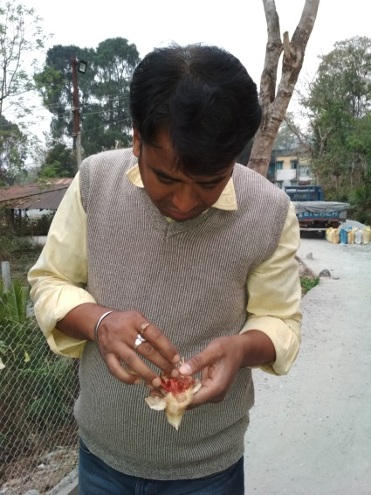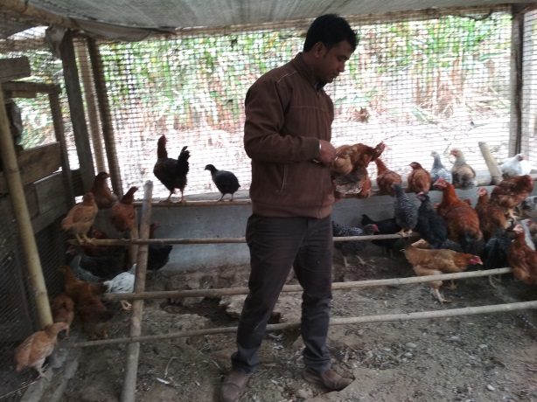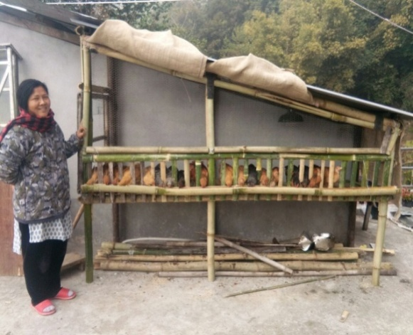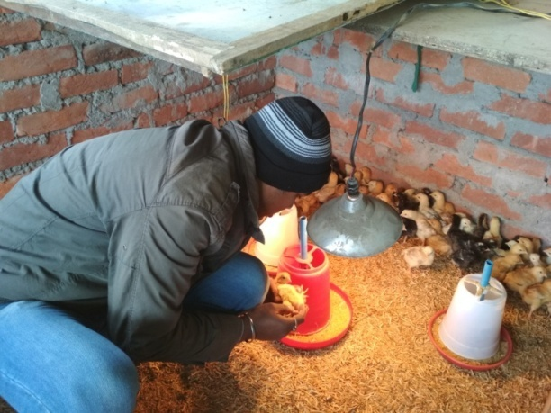

OFT-2: **Assessment of right heat sources for new born piglets during winter months to reduce mortality**

|  |  |  |
| --- | --- | --- |
| 1. | Problem area | High mortality of piglet during winters months under backyard farming system |
| 2. | Important cause | Non availability and unfamiliarity of giving heat sources to new born piglets during winters months under backyards system in hills. |
| 3. | Production system | Backyard system of farming |
| 4. | Micro-farming situation | Low hills farming situation |
| 5. | Technology for testing | Effect of providing heat sources to newborn piglets during winter months under backyard farming system in hills. |
| 6. | Farmers’ practices | No heat sources are provide to newborn piglets during winter months under backyard farming system |
| 7. | Objectives | To study the production performance and mortality rate and the B:C ratio |
| 8. | Hypothesis | Providing the heat sources to piglet will increase the growth rate in terms of meat production and may reduce piglet mortality under backyard farming system |
| 9. | Treatment details | **Farmers’ practice:** No heat sources are provide to newborn piglets during winter months under backyard farming system |
| **Tech. option I:** Providing heat with wood and coal to newborn piglets during winter months. |
| **Tech. option II:** Providing electric bulb to newborn piglets during winter months. |
| **Tech. option III:** Providing straw and gunny to newborn piglets during winter months. |
| 10. | Sources of Technology | ICAR-NEH |
| 11. | Critical inputs | Medicine and Heat sources |
| 12. | Unit size | 2 |
| 13. | No. of replication | 10 |
| 14. | Monitoring indicators | Growth rate, disease incidence and piglet mortality |

**Table: Data on parameter in relation to Technology demonstrated**

|  |  |  |  |  |  |  |  |  |  |
| --- | --- | --- | --- | --- | --- | --- | --- | --- | --- |
| **Technology option** | Growth rate (@1 months) | | Growth rate (@2 months) | | Growth rate (@3 months) | | Disease incidence (%) | Mortality rate (%) | C:B ratio |
| Male (Mean±SD) | Female (Mean±SD) | Male (Mean±SD) | Female (Mean±SD) | Male (Mean±SD) | Female (Mean±SD) |
| **Farmers’ practice** | 2.413±0.51 | 2.406±0.86 | 4.317±1.31 | 4.249±1.22 | 6.327±1.42 | 6.112±1.60 | 24 | 16 | 1:3.5 |
| **Tech. option I** | 2.538±1.07 | 2.503±0.64 | 4.591±1.19 | 4.303±1.23 | 7.339±0.83 | 7.235±0.72 | 18 | 5 | 1:5.8 |
| **Tech. option II** | 2.544±1.32 | 2.519±0.75 | 4.826±1.70 | 4.509±1.15 | 7.481±1.07 | 7.162±1.49 | 19 | 4 | 1:6.1 |
| **Tech. option III** | 2.423±1.09 | 2.414±0.87 | 4.472±1.94 | 4.185±0.36 | 6.615±0.20 | 6.308±1.48 | 12 | 12 | 1:4.2 |

**Results:** Technology Option II shows increase growth rate and reduce disease incidence rate and mortality rate among other Technology Options and thereby it has higher C:B ratio. Therefore, it can be concluded that Technology Option II is better than the other two options and farmers’ practices. So, it can be recommended to the farmers of this region.

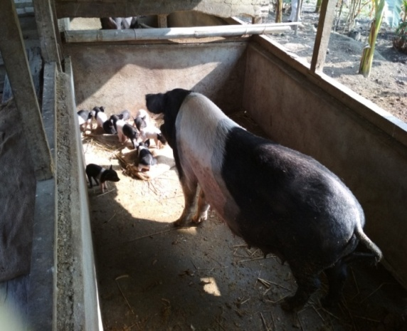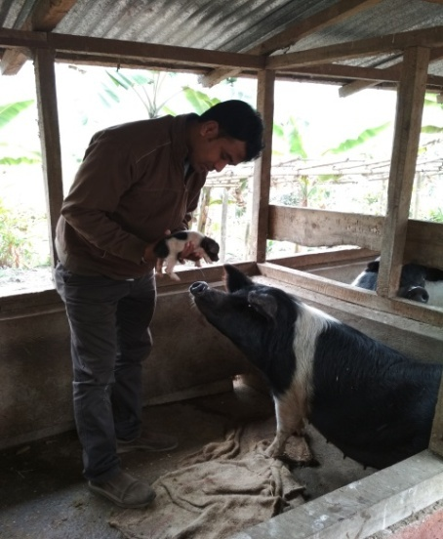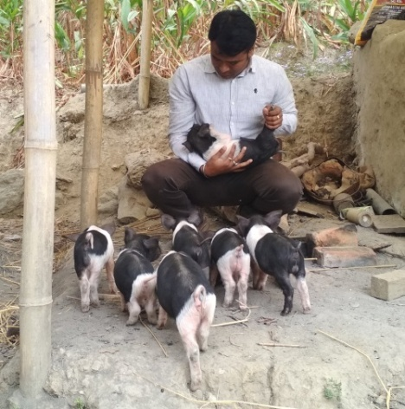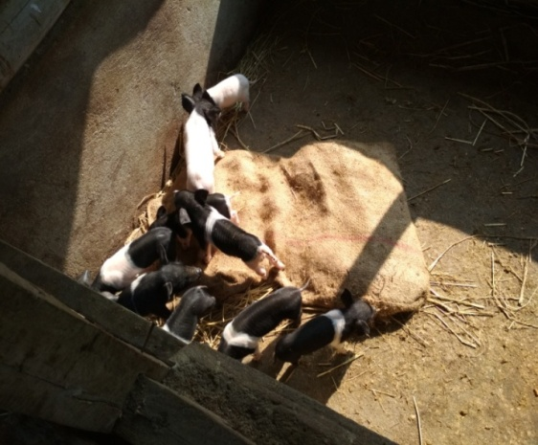

OFT-3: **- Eco-friendly management of diamond back moth in cauliflower grown in Darjeeling Hills**

|  |  |  |
| --- | --- | --- |
| 1. | Problem area | Poor yield |
| 2. | Important cause | No use of chemicals to control DBM |
| 3. | Production system | Vegetable based cropping system |
| 4. | Micro-farming situation | Rain-fed medium to low hills farming situation |
| 5. | Technology for testing | Integrated pest management |
| 6. | Farmers’ practice | Use of only farmyard manure @20t/ha |
| 7. | Objectives | To study the pest incidence, yield performance and B:C ratio |
| 8. | Hypothesis | Farmers are growing cauliflower by using only FYM @ 20 t/ha per year. Therefore, cauliflower crop are suffering from low yield, more disease pest attack etc. hence, a trail on eco-friendly pest management in this crop is scheduled |
| 9. | Treatment details | Farmers’ practice: Application of FYM @ 20 t/ha and manual practice |
|  |  | Tech. option I: Sow Indian mustard as a trap crop |
|  |  | Tech option II: T.O. I + Spray neem formulation Azadirachtin 1% @ 3ml/l of water |
|  |  | Tech. option III: T.O. I + Install light trap |
| 10. | Source of technology | IPM schedule for vegetables, NHM, Ministry of Agriculture |
| 11. | Critical inputs | Mustard seed, Azadirachtin 1%, light, light trap |
| 12. | Unit size | 0.50 ha |
| 13. | No. of replication | 6 (six) |
| 14. | Unit cost | Rs. 2000/- |
| 15. | Total cost | Rs. 12000/- |
| 16. | Monitoring indicators | Pest incidence, Yield and BC ratio |

**Table: Data on parameter in relation to Technology demonstrated**

|  |  |  |  |  |  |  |  |
| --- | --- | --- | --- | --- | --- | --- | --- |
| **Technology option** | **No. of trials** | **Mean no. of larvae /plant** | **Yield (q/ha)** | **Economic parameters** | | | **B C ratio** |
| **Input Cost** | **Gross return** | **Net return** |
| Farmers Practice | Application of FYM @ 20 t/ha and no use of chemicals | 5.3 | 177.85 | 237500 | 355700 | 118200 | 1.50 |
| T1 | Sow Indian mustard as a trap crop | 3.8 | 186.40 | 238700 | 372800 | 134100 | 1.56 |
| T2 | T1 + Spray neem formulation Azadirachtin 1% @ 3ml/l of water | 3.5 | 190.20 | 238800 | 380400 | 141600 | 1.59 |
| T3 | T1 + Install light trap | 1.5 | 195.40 | 238950 | 390800 | 151850 | 1.64 |

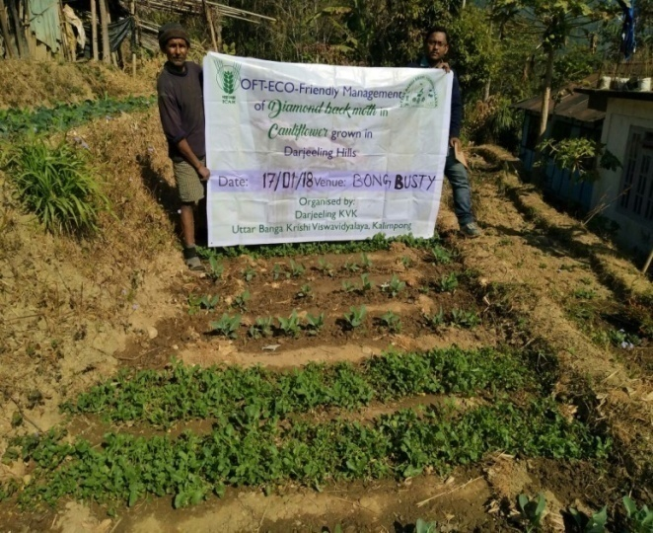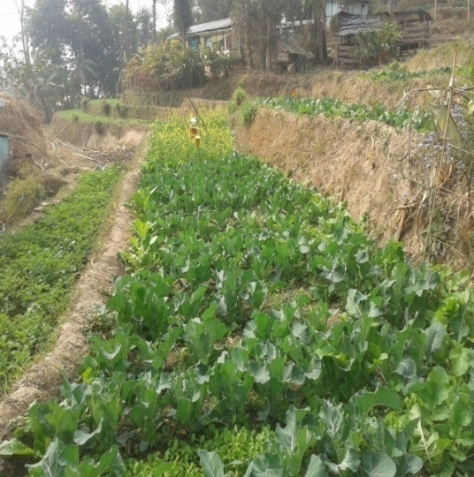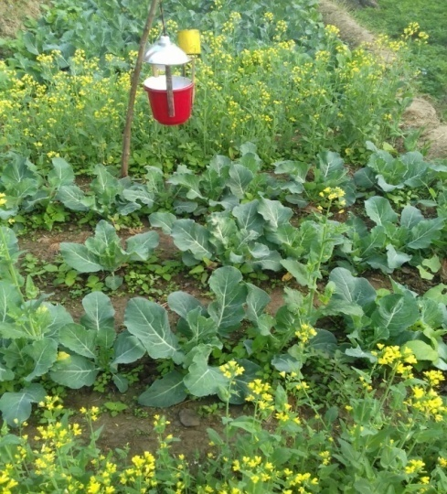

OFT-4: **- Varietal assessment of potato under Hill Agro-climatic situation**

|  |  |  |
| --- | --- | --- |
| 1. | Problem area | Poor quality potato tubers , low tuber yields |
| 2. | Important cause | Non-availability of quality seed tubers. |
| 3. | Production system | Vegetable based cropping systems |
| 4. | Micro-farming situation | Rain-fed medium to low hills farming situation |
| 5. | Technology for testing | Performance of different varieties under hill situation |
| 6. | Farmers’ practices | Use of local seed tuber for commercial cultivation . |
| 7. | Objectives | To study the yield performance and the B:C ratio |
| 8. | Hypothesis | Farmers of hill zone cultivate only local varieties which gives very low yield , poor quality tubers and the crop is also cultivated in a traditional ways Hence, a trial on varietal assestment of different potato varieties is conducted. |
| 9. | Treatment details | Farmers’ practice - use of seed tubers (Darjeeling Red Round) with FYM 5 tonnes/ha.  Tech. option I: Cultivation of Kufri Kanchan with FYM @ 20tonnes/ha and NPK @ 150:100:150 kg/ha (RDF)  Tech. option II: Cultivation of Kufri Himalini with FYM @ 20tonnes/ha and NPK @ 150:100:150.  Tech. option III: Cultivation of Kufri shailjia with FYM @ 20 tonnes/ha and NPK @ 150:100:150 kg/ha(RDF) |
|  | Critical inputs | Seeds, FYM, NPK |
|  | Source of technology | B.C.K.V |
|  | Unit size | 0.1 ha |
| 10. | No. of replication | 6 (six) |
| 11. | Unit cost | Rs. 3000/- |
| 12. | Total cost | Rs. 18000/- |
| 13. | Monitoring indicators | Tuber yield, comparative economics. |
| 14. | Problem area | Poor quality potato tubers , low tuber yields |
| 15. | Important cause | Non-availability of quality seed tubers. |
| 16. | Production system | Vegetable based cropping systems |

**Table: Data on parameter in relation to Technology demonstrated**

|  |  |  |  |  |  |  |  |  |
| --- | --- | --- | --- | --- | --- | --- | --- | --- |
| **Technology option** | **No. of trials** | **Production assessment parameters** | | **Increase in % in compared to Farmers Practice** | **Economic parameters** | | | **B C ratio** |
| **Yield (q/ha)** | **Average Weight (g)** | **Input Cost** | **Gross return** | **Net return** |
| Farmers Practice | 5 | 162.55 | 52.3 |  | 1,02,240/- | 1,30,103/- | 27,863/- | 1.27:1 |
| T1 : Kufri Himalini | 215.56 | 110.55 | 32.6 | 1,20,445/- | 1,63,520/- | 43,075/- | 1.35:1 |
| T2: Kufri Kanchan | 260.58 | 150.22 | 60.30 | 1,20,445/- | 2,02,775/- | 82,330/- | 1.68:1 |
| T3: Kufri Shailia | 240.56 | 132.15 | 47.99 | 1,20,445/- | 1,85,337/- | 64,892/- | 1.53:1 |

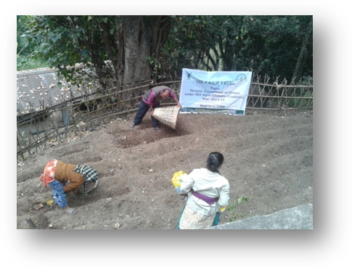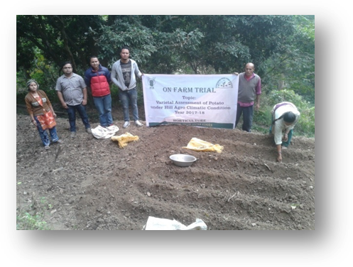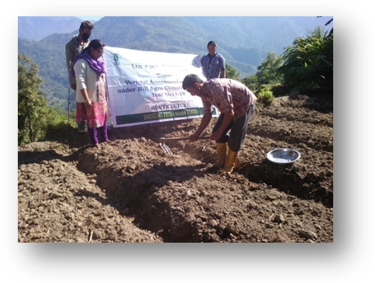

OFT-5: **-** Assessment of Integrated Nutrient Management of cauliflower (*Brassica oleraceae var botrytis*) in Darjeeling Hills..

|  |  |  |
| --- | --- | --- |
| 1. | Title of On farm Trial | Integrated Nutrient Management of cauliflower (*Brassica oleraceae var botrytis*) |
| 2. | Problem area | Decline in yield and poor quality curds |
| 3. | Important cause | Use of only FYM no use of balance chemical fertilizer |
| 4. | Technology for testing | Integrated nutrient management |
| 5. | Existing practice | User of only FYM @ 20 tons per ha |
| 6. | Objectives | To improve the quality of curds and also to increase the yield per ha |
| 7. | Hypothesis | Farmers of Darjeeling district are using only FYM and unaware about the balance dose of fertilizer. So the yield as well as the quality of the curds are low. So an OFT on the Integrated Nutrient Management of cauliflower has been conducted |
| 8. | Treatment details | **Farmers’ practice:** Application of FYM @20 t/ha  **Tech. option I:** Application of 50% NPK i.e. (75:50:50) (Basal Full P+K+1/2N, 30DAS1/4N,60 DAT 1/4N) + 50% FYM i.e. 5t/ha +Azospirillium @2kg/ha  **Tech. option II:** Application of 50% NPK i.e. (75:50:50)+50% FYM i.e. 5t/ha +Azospirillium @2kg/ha  **Tech. option III:** Application of 50% NPK i.e (75:50:50)+50% FYM i.e. 5t/ha +Azospirillium @2kg/ha +50% pig manure 10t/ha +Azospirillium @2kg/ha |
| 9. | Source of Technology | Nagaland University, Medziphema |
| 10 | Critical inputs | FYM, Urea, SSP, MOP, Azospirillium, Pig manure |
| 11 | Unit size | 5 Decimal |
| 12 | No. of replications | 4 |
| 13 | Unit cost | Rs. 1500/- |
| 14 | Total cost | Rs. 6000/- |
| 15 | Monitoring indicators | Average weight of curds, yield per ha |

**Table: Data on parameter in relation to Technology demonstrated**

|  |  |  |  |  |  |  |  |
| --- | --- | --- | --- | --- | --- | --- | --- |
| Technology option | No. of trials | Yield component | | Cost of cultivation  (Rs./unit) | Gross return (Rs/unit) | Net return  (Rs./Unit) | BC ratio |
| Average weight of curd (g) | Yield  (Ton/ha) |
| FP | 4 | 476.03 | 7.25 | 60,632 | 1,08,750 | 48,118 | 1:79:1 |
| T1 | 4 | 866.67 | 13.21 | 81,118 | 1,98,150 | 1,17,032 | 2:44:1 |
| T2 | 4 | 702.67 | 12.20 | 98,956 | 1,83,000 | 84,044 | 1:84:1 |
| T3 | 4 | 752.03 | 12.55 | 91,698 | 1,88,250 | 96,552 | 2:05:1 |

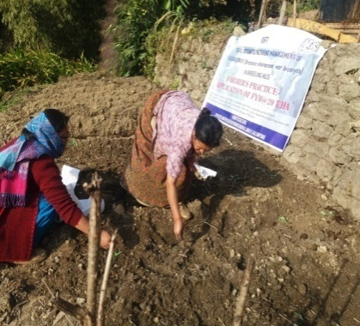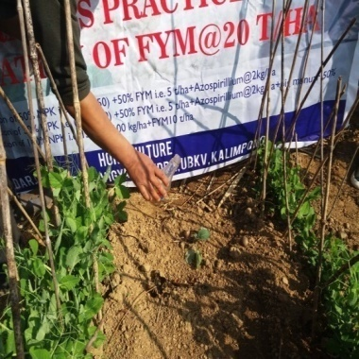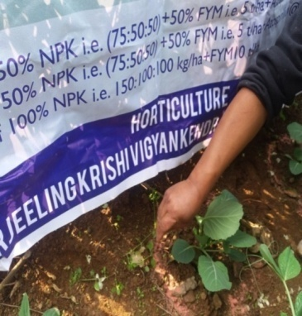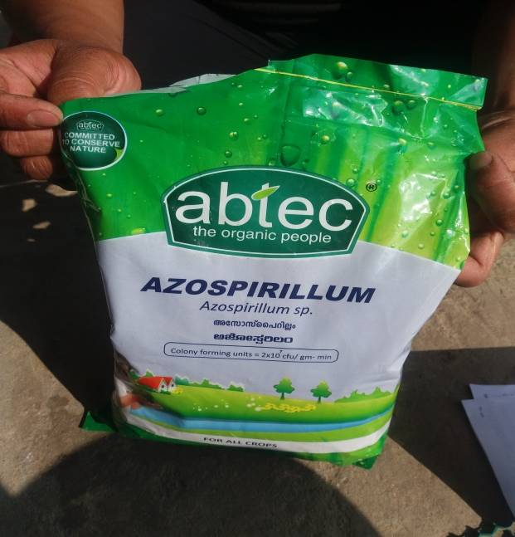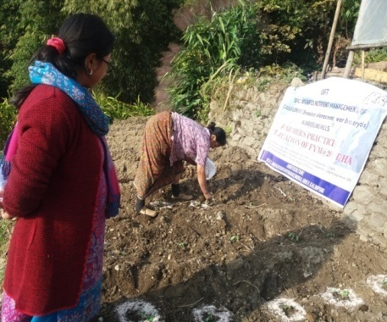

**OFT-6: -** An assessment on various Dehydration Technologies for preservation of flowers and foliage

|  |  |  |
| --- | --- | --- |
| **1** | Problem diagnosed | Traditional method of preservation of flowers and foliages |
| **2** | Details of technologies selected for assessment/refinement | Farmers practise : Sun /shade drying  TO1- Drying by use of melted wax  TO2- Drying by use of Silica gel powder/ crystals |
| **3** | Source of Technology | CSIR |
| **4** | Production system and thematic area | Value addition of cut flowers and foliages |
| **5** | Performance of the Technology with performance indicators | Technology option 1 seems to have resulted in a better dehydration of the three tested variety of flowers (Gerbera, Rose) in comparison with other two techniques. It resulted in good retention of colour and shape of flower. There was enhancement in Shelf life of the flower too. |
| **6** | Final recommendation for micro level situation | More trials to be undertaken with different types of flowers. |
| **7** | Constraints identified and feedback for research | As most flowers are seasonal and availability throughout the year is one of the main constrains. |
| **8** | Process of farmers participation and their reaction | It provided a new vision and arena for the interested participants. They are keen to take up further trials on various other types of flowers and foliage |
| **9** | **Thematic area** | Value addition in cut flowers and foliages |

**Table containing the assessment data related to the OFT on 5 point grading scale:**

|  |  |  |  |  |
| --- | --- | --- | --- | --- |
|  | **Colour** | **Shape** | **Size** | **Shelf life** |
| Farmers’ practice | 2.3 | 2.1 | 1.6 | 1.1 |
| Tech option1 | 3.9 | 4.2 | 4.5 | 4.6 |
| Tech option 2 | 3.1 | 2.2 | 3.1 | 3.8 |

|  |  |  |  |  |  |
| --- | --- | --- | --- | --- | --- |
| Legends | 4.1 to 5.0 - Very good | 3.1 to 4.0 - Good | 2.1 to 3.0 - Fair | * 1. to 2.0 - Unsatisfactory | 0 to 1.0 - Poor |

**Result:** Among the different technologies tested including farmers’ practice, Tech Option 1 (use of melted wax) has shown to have a better dehydration and drying in flowers. There was a good retention of color, shape and size of the flower with enhanced shelf life. The various indicating parameters of the samples were analysed through sensory evaluation (visual observation) and rated using 5- point grading scale. The trial needs to be further studied as the results may also vary depending upon the different samples (flowers) used for the testing of the technologies.

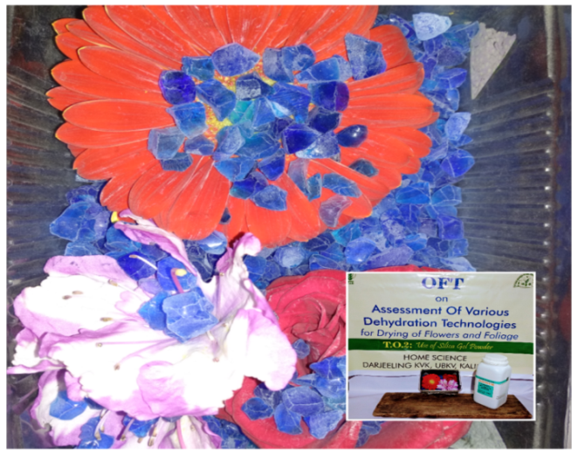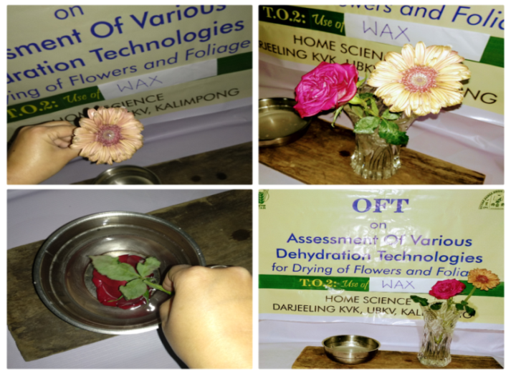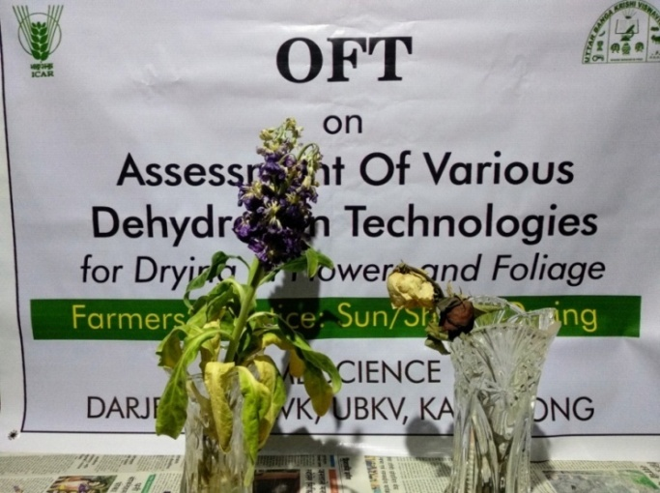

Farmers’ practice: Sun/shade drying TO1: Use of melted wax TO2: Use of silica gel powder/ crystal

* 1. Achievements of Frontline Demonstrations

1. Details of FLDs conducted during 2017-18

**FLD 1: Providing regular area specific mineral mixture to dairy cattle**

|  |  |  |  |  |  |  |  |  |
| --- | --- | --- | --- | --- | --- | --- | --- | --- |
| **Sl.**  **No.** | **Crop** | **Thematic area** | **Technology Demonstrated with detailed treatments** | **No of Animal** | | **No. of farmers/**  **demonstration** | | |
| **Proposed** | **Actual** | **SC/ST** | **Others** | **Total** |
| 1. | Dairy | Production performance | Area specific mineral mixture | 100 | 100 | 24 | 6 | 30 |

|  |  |  |  |  |  |  |  |  |  |  |  |  |
| --- | --- | --- | --- | --- | --- | --- | --- | --- | --- | --- | --- | --- |
| Crop | No. of units | Major parameters | | % change in major parameter | \*Economics of demonstration (Rs.) | | | | \*Economics of check (Rs.) | | | |
| Demons  tration | Check | Gross  Cost | Gross  Return | Net Return | \*\*  BCR | Gross  Cost | Gross  Return | Net Return | \*\*  BCR |
| Dairy | 100 | Milk production | Milk production | 18 | 45430 | 87200 | 41770 | 1.92:1 | 43800 | 79400 | 35600 | 1.81:1 |

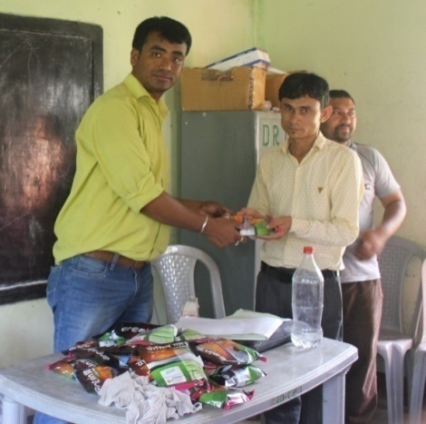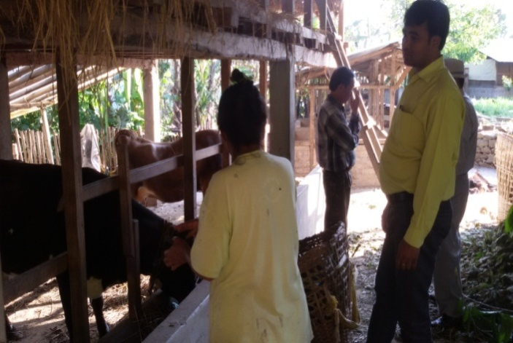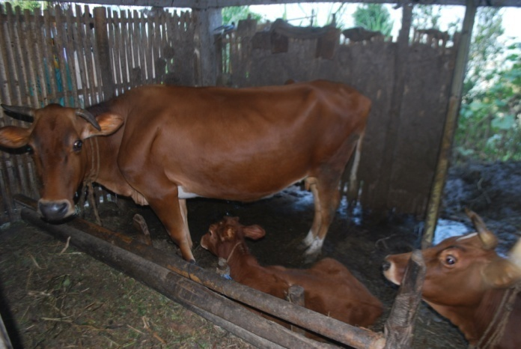

**FLD 2: Grading up of local poultry breeds by RIR cock**

|  |  |  |  |  |  |  |  |  |
| --- | --- | --- | --- | --- | --- | --- | --- | --- |
| **Sl.**  **No.** | **Crop** | **Thematic area** | **Technology Demonstrated with detailed treatments** | **No of Animal** | | **No. of farmers/**  **demonstration** | | |
| **Proposed** | **Actual** | **SC/ST** | **Others** | **Total** |
| 2 | Poultry | Production performance | RIR | 30 | 30 | 18 | 12 | 30 |

|  |  |  |  |  |  |  |  |  |  |  |  |  |  |  |
| --- | --- | --- | --- | --- | --- | --- | --- | --- | --- | --- | --- | --- | --- | --- |
| Crop | No. of units | Major parameters | | % change in major parameter | Other parameter | | \*Economics of demonstration (Rs.) | | | | \*Economics of check (Rs.) | | | |
| Demons  tration | Check | Demons  tration | Check | Gross  Cost | Gross  Return | Net Return | \*\*  BCR | Gross  Cost | Gross  Return | Net Return | \*\*  BCR |
| Poultry | 30 | Egg production | Egg production | 19 | Weight gain | Weight gain | 8650 | 39500 | 31850 | 4.57:1 | 7950 | 25700 | 17750 | 3.23:1 |

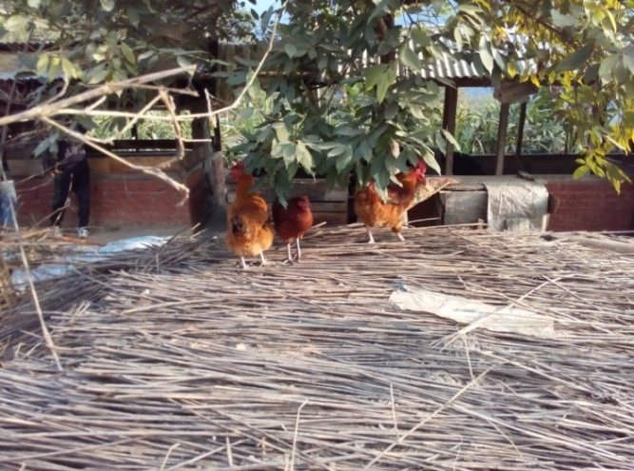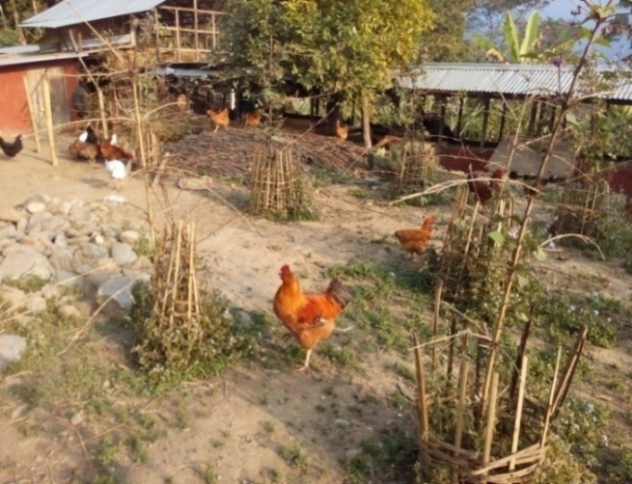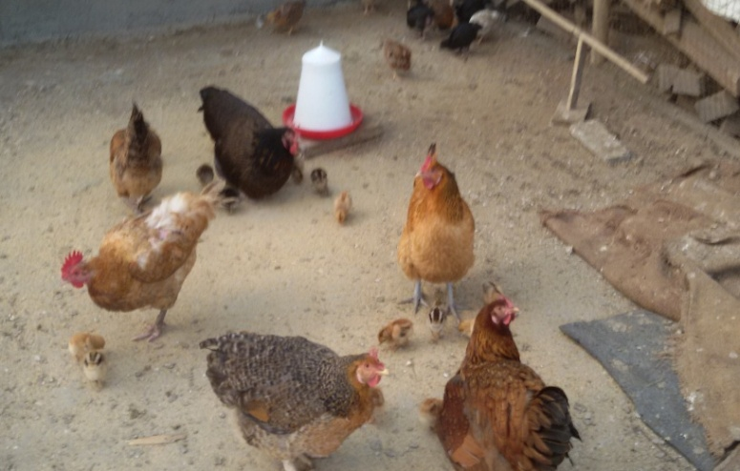

**FLD 3: Grading up of local pig breeds by Hampshire breed**

|  |  |  |  |  |  |  |  |  |
| --- | --- | --- | --- | --- | --- | --- | --- | --- |
| **Sl.**  **No.** | **Crop** | **Thematic area** | **Technology Demonstrated with detailed treatments** | **No of Animal** | | **No. of farmers/**  **demonstration** | | |
| **Proposed** | **Actual** | **SC/ST** | **Others** | **Total** |
| 3 | Piggery | Production performance | Hampshire | 30 | 30 | 30 | 0 | 30 |

|  |  |  |  |  |  |  |  |  |  |  |  |  |  |  |
| --- | --- | --- | --- | --- | --- | --- | --- | --- | --- | --- | --- | --- | --- | --- |
| Crop | No. of units | Major parameters | | % change in major parameter | Other parameter | | \*Economics of demonstration (Rs.) | | | | \*Economics of check (Rs.) | | | |
| Demons  tration | Check | Demons  tration | Check | Gross  Cost | Gross  Return | Net Return | \*\*  BCR | Gross  Cost | Gross  Return | Net Return | \*\*  BCR |
| Piggery | 30 | Growth rate | Growth rate | 15 | Litter size | Litter size | 8650 | 36800 | 28150 | 4.24:1 | 7640 | 24200 | 16560 | 3.16:1 |

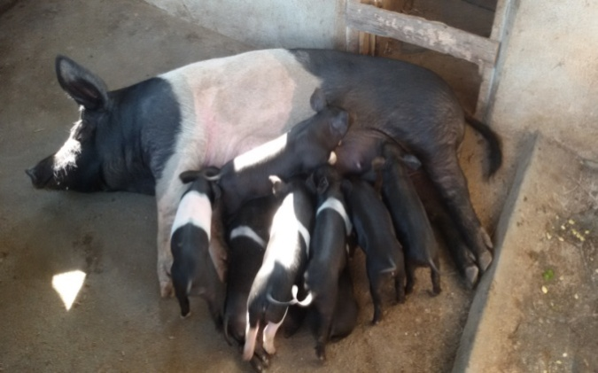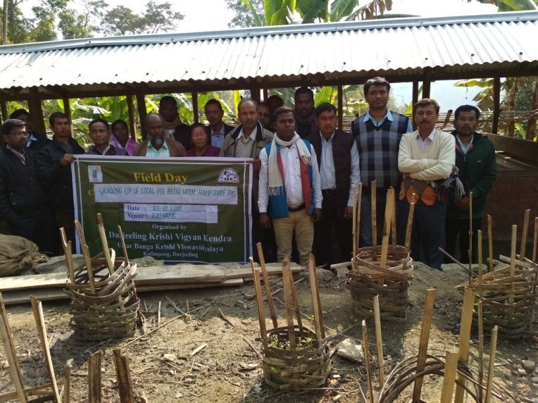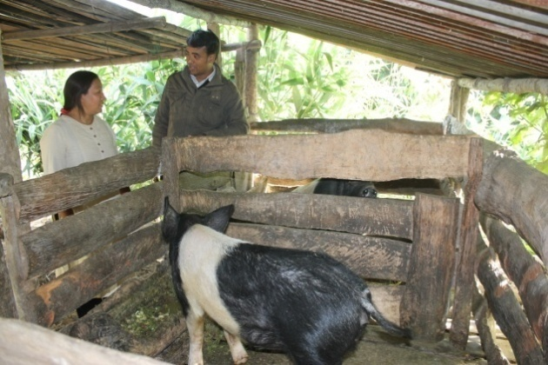

**FLD 4:- Supplementation of iron to newborn piglet to check mortality due to piglet anaemia**

|  |  |  |  |  |  |  |  |  |
| --- | --- | --- | --- | --- | --- | --- | --- | --- |
| **Sl.**  **No.** | **Crop** | **Thematic area** | **Technology Demonstrated with detailed treatments** | **No of Animal** | | **No. of farmers/**  **demonstration** | | |
| **Proposed** | **Actual** | **SC/ST** | **Others** | **Total** |
| 4 | Piggery | Mortality Check | Iron Supplementation | 100 | 100 | 30 | 0 | 30 |

|  |  |  |  |  |  |  |  |  |  |  |  |  |
| --- | --- | --- | --- | --- | --- | --- | --- | --- | --- | --- | --- | --- |
| **Crop** | **No. of units** | **Major parameters** | | **% change in major parameter** | **\*Economics of demonstration (Rs.)** | | | | **\*Economics of check (Rs.)** | | | |
| **Demons**  **tration** | **Check** | **Gross**  **Cost** | **Gross**  **Return** | **Net Return** | **\*\***  **BCR** | **Gross**  **Cost** | **Gross**  **Return** | **Net Return** | **\*\***  **BCR** |
| Piggery | 100 | Mortality rate | Mortality rate | 13 | 18000 | 325000 | 307000 |  | -- | 266500 | 266500 |  |

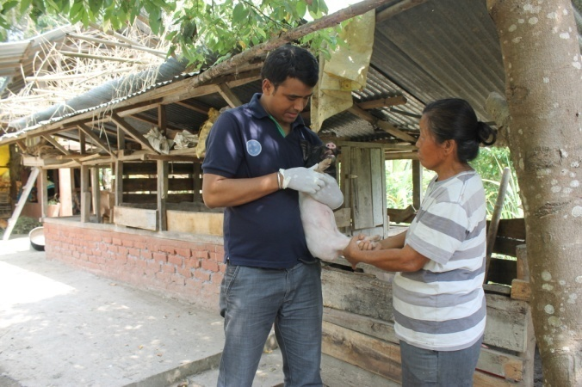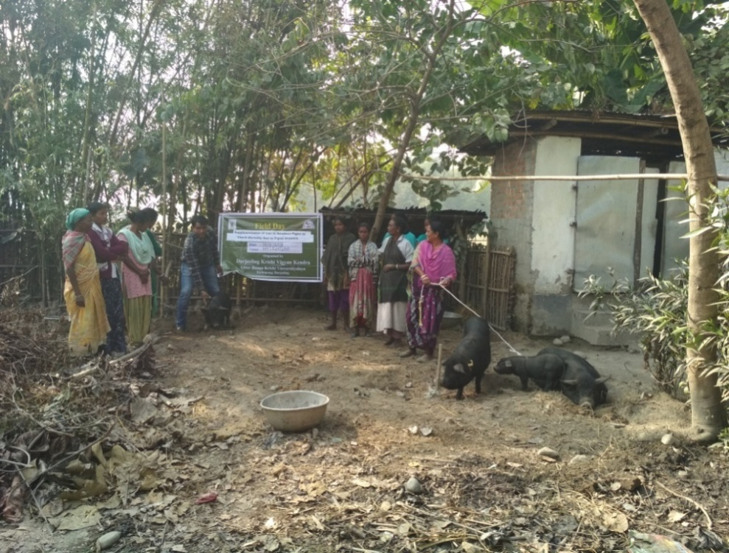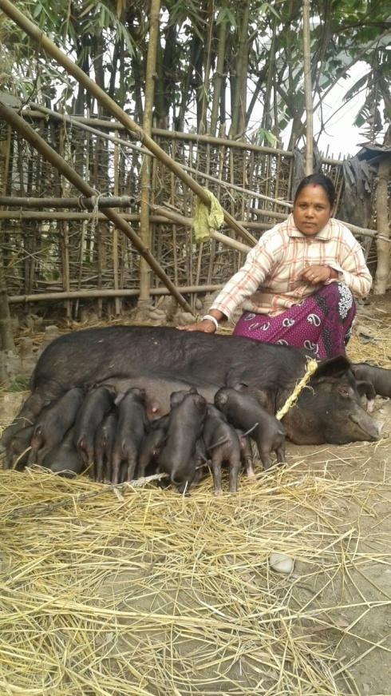

**FLD 5:- Disease management in ginger with Hot water treatment and application of bio agent**

|  |  |  |  |  |  |  |  |  |
| --- | --- | --- | --- | --- | --- | --- | --- | --- |
| **Sl.**  **No.** | **Crop** | **Thematic area** | **Technology Demonstrated with detailed treatments** | **Area in ha** | | **No. of farmers/**  **demonstration** | | |
| **Proposed** | **Actual** | **SC/ST** | **Others** | **Total** |
| 1 | Ginger | Diseases management | Hot water treatment of Ginger rhizome at 54 DC for 10 minute and application of Trichoderma @ 1Kg mixing with 100 Kg FYM | 1.5 acre | 1.5 acre | 8 | 6 | 14 |

|  |  |  |  |  |  |  |  |  |  |  |  |
| --- | --- | --- | --- | --- | --- | --- | --- | --- | --- | --- | --- |
| **Crop** | **Season** | **Farming situation (RF/Irrigated)** | **Soil type** | **Status of soil**  **(Kg/ha)** | | | **Previous crop** | **Sowing date** | **Harvest date** | **Seasonal rainfall (mm)** | **No. of rainy days** |
| **N** | **P2O5** | **K2O** |
| Ginger | Pre-Kharif | Rainfed | Brown forest soil | 328 | 83.1 | 109.4 | Rice | 21/02/2017 | 06/01/2018 | 3150 | 83 |

|  |  |  |  |  |  |  |  |  |  |  |
| --- | --- | --- | --- | --- | --- | --- | --- | --- | --- | --- |
| **Crop** | **Yield (q/ha)** | | **\*Economics of demonstration (Rs./ha)** | | | | **\*Economics of check**  **(Rs./ha)** | | | |
| **Demons**  **ration** | **Check** | **Gross**  **Cost** | **Gross**  **Return** | **Net Return** | **\*\***  **BCR** | **Gross**  **Cost** | **Gross**  **Return** | **Net Return** | **\*\***  **BCR** |
| Ginger | 44.56 | 36.38 | 76500 | 133700 | 57200 | 1.75 | 73000 | 109150 | 36150 | 1.49 |

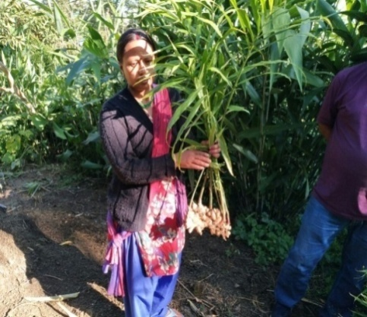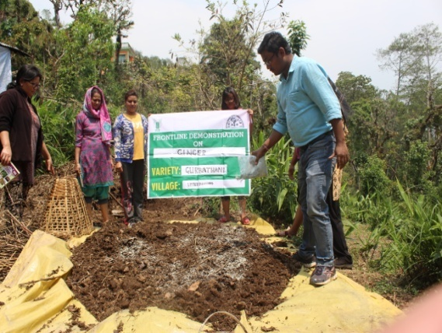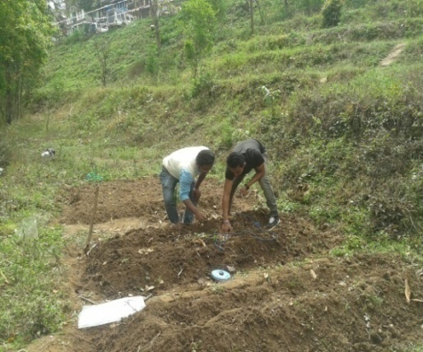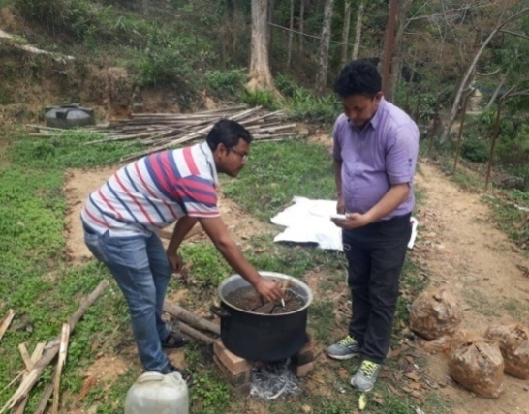

**FLD 6:- Application of micronutrient and PGPR strain of *Bacillus amyloliquifaciens* (GRB 35) for growth promotion and disease control in ginger**

|  |  |  |  |  |  |  |  |  |
| --- | --- | --- | --- | --- | --- | --- | --- | --- |
| **Sl.**  **No.** | **Crop** | **Thematic area** | **Technology Demonstrated with detailed treatments** | **Area in ha** | | **No. of farmers/**  **demonstration** | | |
| **Proposed** | **Actual** | **SC/ST** | **Others** | **Total** |
| 1 | Ginger | Diseases management | Use of micronutrient and PGPR strain of *Bacillus amyloliquifaciens* (GRB 35) for growth promotion and disease management in ginger | 1.5 acre | 1.5 acre | 4 | 2 | 6 |

|  |  |  |  |  |  |  |  |  |  |  |  |
| --- | --- | --- | --- | --- | --- | --- | --- | --- | --- | --- | --- |
| **Crop** | **Season** | **Farming situation (RF/Irrigated)** | **Soil type** | **Status of soil**  **(Kg/ha)** | | | **Previous crop** | **Sowing date** | **Harvest date** | **Seasonal rainfall (mm)** | **No. of rainy days** |
| **N** | **P2O5** | **K2O** |
| Ginger | Pre-Kharif | Rainfed | Brown forest soil | 287 | 92.1 | 92.5 | Rice | 24/02/2017 | 13/01/2018 | 3150 | 83 |

|  |  |  |  |  |  |  |  |  |  |  |
| --- | --- | --- | --- | --- | --- | --- | --- | --- | --- | --- |
| **Crop** | **Yield (q/ha)** | | **\*Economics of demonstration (Rs./ha)** | | | | **\*Economics of check**  **(Rs./ha)** | | | |
| **Demons**  **ration** | **Check** | **Gross**  **Cost** | **Gross**  **Return** | **Net Return** | **\*\***  **BCR** | **Gross**  **Cost** | **Gross**  **Return** | **Net Return** | **\*\***  **BCR** |
| Ginger | 40.55 | 35.75 | 76500 | 121650 | 45150 | 1.59 | 73000 | 107250 | 34250 | 1.47 |

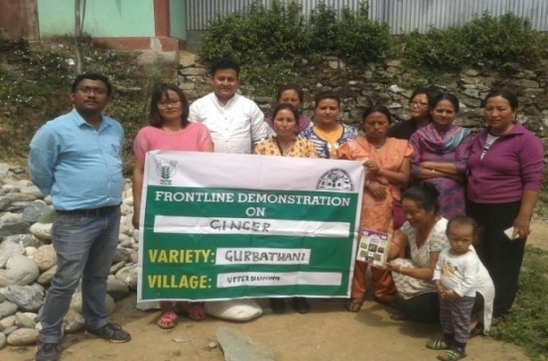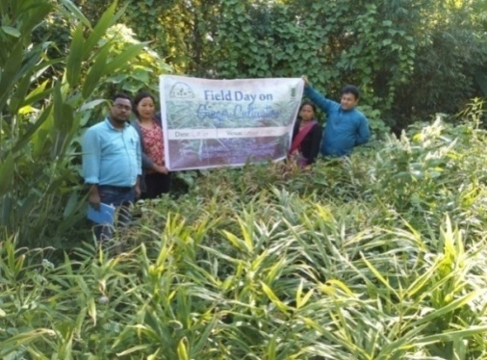

**FLD 7:- Application of micronutrient and PGPR strain of *Bacillus amyloliquifaciens* (GRB 35) for growth promotion and disease control in Turmeric**

|  |  |  |  |  |  |  |  |  |
| --- | --- | --- | --- | --- | --- | --- | --- | --- |
| **Sl.**  **No.** | **Crop** | **Thematic area** | **Technology Demonstrated with detailed treatments** | **Area in ha** | | **No. of farmers/**  **demonstration** | | |
| **Proposed** | **Actual** | **SC/ST** | **Others** | **Total** |
| 1 | Turmeric | Diseases management | Use of micronutrient and PGPR strain of *Bacillus amyloliquifaciens* (GRB 35) for  growth promotion and disease management in turmeric | 1.5 acre | 1.5 acre | 3 | 3 | 6 |

|  |  |  |  |  |  |  |  |  |  |  |  |
| --- | --- | --- | --- | --- | --- | --- | --- | --- | --- | --- | --- |
| **Crop** | **Season** | **Farming situation (RF/Irrigated)** | **Soil type** | **Status of soil**  **(Kg/ha)** | | | **Previous crop** | **Sowing date** | **Harvest date** | **Seasonal rainfall (mm)** | **No. of rainy days** |
| **N** | **P2O5** | **K2O** |
| Turmeric | Pre-Kharif | Rainfed | Brown forest soil | 297 | 92.1 | 83.2 | Winter Vegetable | 07/03/2017 | 24/01/2018 | 3150 | 83 |

|  |  |  |  |  |  |  |  |  |  |  |
| --- | --- | --- | --- | --- | --- | --- | --- | --- | --- | --- |
| **Crop** | **Yield (q/ha)** | | **\*Economics of demonstration (Rs./ha)** | | | | **\*Economics of check**  **(Rs./ha)** | | | |
| **Demons**  **ration** | **Check** | **Gross**  **Cost** | **Gross**  **Return** | **Net Return** | **\*\***  **BCR** | **Gross**  **Cost** | **Gross**  **Return** | **Net Return** | **\*\***  **BCR** |
| Turmeric | 40.55 | 35.75 | 69200 | 89210 | 20010 | 1.29 | 67500 | 78650 | 11150 | 1.16 |

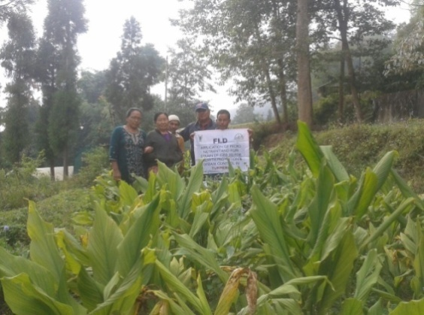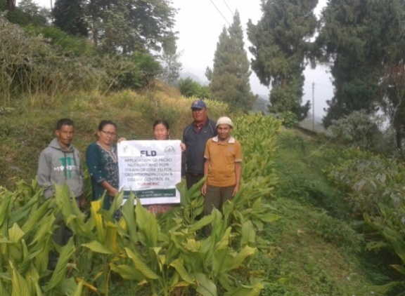

**FLD-8 (Horticulture): Nutritional Management of Darjeeling Mandarin (*Citrus reticulata*)**

|  |  |  |  |  |  |  |  |  |
| --- | --- | --- | --- | --- | --- | --- | --- | --- |
| **Sl.**  **No.** | **Crop** | **Thematic area** | **Technology Demonstrated with detailed treatments** | **Area in ha** | | **No. of farmers/**  **demonstration** | | |
| **Proposed** | **Actual** | **SC/ST** | **Others** | **Total** |
| 9 | Mandarin orange | Nutritional Management | N:P:K@300:250:300 g, B 50 g, Z 250g, Vermicompost 12.5kg,Pig Manure 6.25kg and FYM 25 kg/tree | 1 | 1 | 2 | 3 | 5 |

|  |  |  |  |  |  |  |  |  |  |  |  |
| --- | --- | --- | --- | --- | --- | --- | --- | --- | --- | --- | --- |
| **crop** | **Season** | **Farming situation (RF/Irrigated)** | **Soil type** | **Status of soil**  **(Kg/ha)** | | | **Previous crop** | **Sowing date** | **Harvest date** | **Seasonal rainfall (mm)** | **No. of rainy days** |
| **N** | **P2O5** | **K2O** |
| Mandarin orange | Perennial | RF | Acidic | 271.6 | 91.56 | 137.9 | Perennial | 30/03/2017 and 25/10/2017 | Nov 20-December 10,2017 | 3150 | 83 |

|  |  |  |  |  |  |  |  |  |  |  |
| --- | --- | --- | --- | --- | --- | --- | --- | --- | --- | --- |
| **Crop** | **Yield (q/ha)** | | **\*Economics of demonstration (Rs./ha)** | | | | **\*Economics of check**  **(Rs./ha)** | | | |
| **Demons**  **ration** | **Check** | **Gross**  **Cost** | **Gross**  **Return** | **Net Return** | **\*\***  **BCR** | **Gross**  **Cost** | **Gross**  **Return** | **Net Return** | **\*\***  **BCR** |
| Mandarin orange | 345 | 175 | 1,97,895 | 5,03,880 | 3,05,985 | 2.5:1 | 1,11,850 | 2,59,350 | 1,47,500 | 2.3:1 |

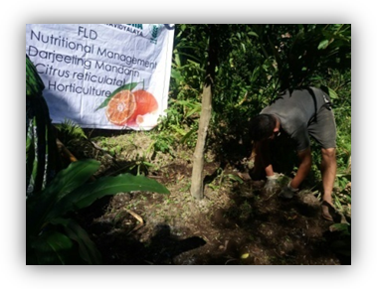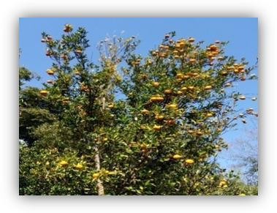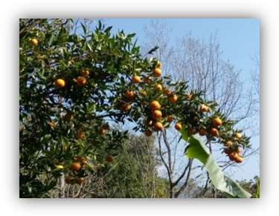

**FLD-9 (Horticulture)**: Varietal management of Gladiolus – Variety Candiman

|  |  |  |  |  |  |  |  |  |
| --- | --- | --- | --- | --- | --- | --- | --- | --- |
| **Sl.**  **No.** | **Crop** | **Thematic area** | **Technology Demonstrated with detailed treatments** | **Area in ha** | | **No. of farmers/**  **demonstration** | | |
| **Proposed** | **Actual** | **SC/ST** | **Others** | **Total** |
| 10 | Gladiolus | Varietal Management | Candiman | 1 | 1 | - | 5 | 5 |

|  |  |  |  |  |  |  |  |  |  |  |  |
| --- | --- | --- | --- | --- | --- | --- | --- | --- | --- | --- | --- |
| **crop** | **Season** | **Farming situation (RF/Irrigated)** | **Soil type** | **Status of soil**  **(Kg/ha)** | | | **Previous crop** | **Sowing date** | **Harvest date** | **Seasonal rainfall (mm)** | **No. of rainy days** |
| **N** | **P2O5** | **K2O** |
| Gladiolus | Rabi | RF | Acidic | 284 | 94.1 | 123.5 | Paddy | 20/12/2017 | Standing crop | 10 | 1 |

|  |  |  |  |  |  |  |  |  |  |  |  |  |  |  |
| --- | --- | --- | --- | --- | --- | --- | --- | --- | --- | --- | --- | --- | --- | --- |
| **Crop** | **Yield (Stick/ha)** | | | | | | **\*Economics of demonstration (Rs./ha)** | | | | **\*Economics of check**  **(Rs./ha)** | | | |
| **Demons**  **ration** | | | **Check** | | | **Gross**  **Cost** | **Gross**  **Return** | **Net Return** | **\*\***  **BCR** | **Gross**  **Cost** | **Gross**  **Return** | **Net Return** | **\*\***  **BCR** |
| Gladiolus | Cut flower | corms | cormlet | Cut flower | corm | cormlet | 5,39,521 | 14,64,589 | 9,25,068 | 2.71:1 | 3,70354 | 5,70,632 | 2,00,278 | 1.54:1 |
| 1,74,167 | 1,58,334 | 47,50,009 | 1,16,667 | 1,10,834 | 12,83,337 |

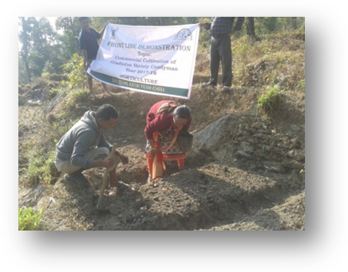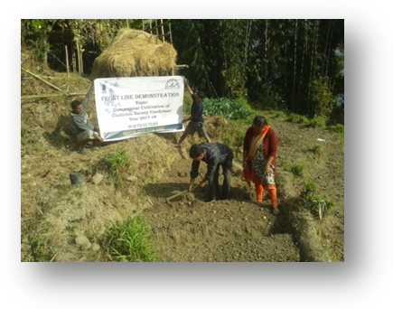

**FLD-10 (Horticulture):** Nutritional management of Alstromeria

|  |  |  |  |  |  |  |  |  |
| --- | --- | --- | --- | --- | --- | --- | --- | --- |
| **Sl.**  **No.** | **Crop** | **Thematic area** | **Technology Demonstrated with detailed treatments** | **Area in ha** | | **No. of farmers/**  **demonstration** | | |
| **Proposed** | **Actual** | **SC/ST** | **Others** | **Total** |
| 11 | Alistomeria | Nutritional Management | Use of sand +soil+ FYM+ vermicompost + coco peat (2:2:2:1:1; v/v) | 0.10 | 0.10 | - | 3 | 3 |

|  |  |  |  |  |  |  |  |  |  |  |  |
| --- | --- | --- | --- | --- | --- | --- | --- | --- | --- | --- | --- |
| **crop** | **Season** | **Farming situation (RF/Irrigated)** | **Soil type** | **Status of soil**  **(Kg/ha)** | | | **Previous crop** | **Sowing date** | **Harvest date** | **Seasonal rainfall (mm)** | **No. of rainy days** |
| **N** | **P2O5** | **K2O** |
| Alistomeria | Perennial | Irrigated | Acidic | 284.86 | 95.9 | 73.3 | Perennial | 09/11/2017 | Standing crop | 10 | 1 |

|  |  |  |  |  |  |  |  |  |  |  |
| --- | --- | --- | --- | --- | --- | --- | --- | --- | --- | --- |
| **Crop** | **Yield (stick/pot)** | | **\*Economics of demonstration (Rs./ha)** | | | | **\*Economics of check**  **(Rs./ha)** | | | |
| **Demons**  **ration** | **Check** | **Gross**  **Cost** | **Gross**  **Return** | **Net Return** | **\*\***  **BCR** | **Gross**  **Cost** | **Gross**  **Return** | **Net Return** | **\*\***  **BCR** |
| Alistomeria | 8.1 | 3.2 | 8.3 | 16.2 | 7.9 | 1.95:1 | 4.2 | 6.4 | 2.2 | 1.47:1 |

**FLD-11 (Home Science)**: **Kitchen gardening for nutrition & food security**

|  |  |  |
| --- | --- | --- |
| 1. | Problem Area | Poor nutritional status and health of rural women and adolescents  Low purchasing capacity of nutritious vegetables |
| 2. | Important cause | * Poor purchasing capacity * Lack of knowledge on importance of nutrition and health |
| 3. | Technology for demonstration | Multiple vegetables in crop rotation |
| 4. | Unit of demonstration | 25 |
| 5. | Monitoring indicator | * Availability of more varieties of vegetables leading to improved intake of good quality foods * Improved health status * Reduced incidences of deficiencies and illnesses |
| 6. | Proposed block of demonstration | Kalimpong I & II |
| 7. | Inputs | Season based vegetables |
| 8. | No. of demonstration | 5 (No. of crops) |
| 9. | Total cost of demonstration | 10,000 |

|  |  |  |  |  |  |  |  |  |  |
| --- | --- | --- | --- | --- | --- | --- | --- | --- | --- |
| **Sl.**  **No.** | **Crop** | **Thematic area** | **Technology Demonstrated with detailed treatments** | **Area (ha)** | | **No. of farmers/**  **demonstration** | | | **Reasons for shortfall in achievement** |
| **Proposed** | **Actual** | **SC/ST** | **Others** | **Total** |
| **1.** | Season based vegetables | Food security and nutrition | Kitchen garden | 0.10 | 0.1207 | 18 | 7 | 25 |  |

|  |  |  |  |  |  |  |  |  |
| --- | --- | --- | --- | --- | --- | --- | --- | --- |
| **Crop** | **Thematic Area** | **Name of the technology demonstrated** | **No. of Farmers** | **Area**  **(ha)** | **\*Economics of check**  **(Rs./ha)** | | | |
| **Gross**  **Cost** | **Gross**  **Return** | **Net Return** | **\*\***  **BCR** |
| Vegetables | Food security and nutrition | Kitchen garden | 25 | 0.1207 | 6820 | 19440 | 12620 | 2.85:1 |

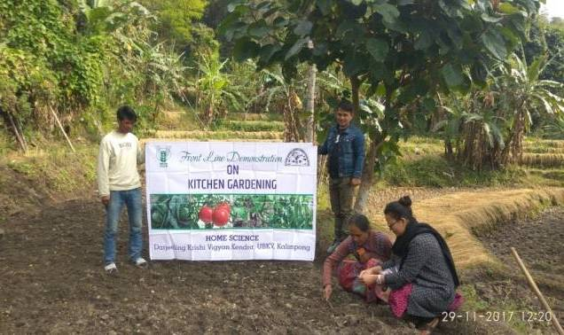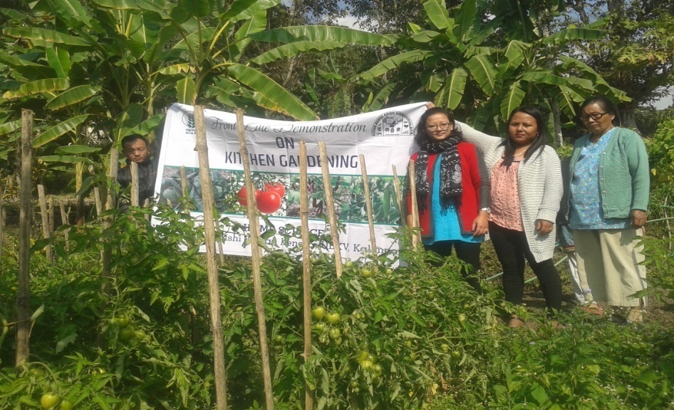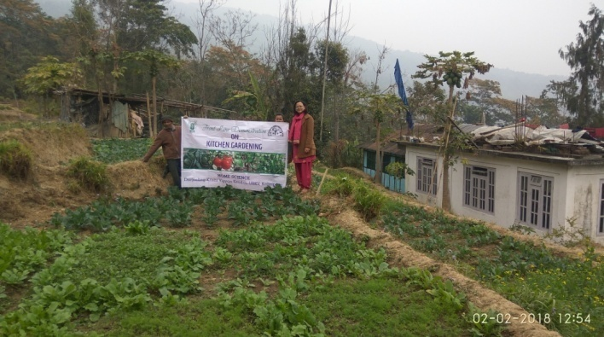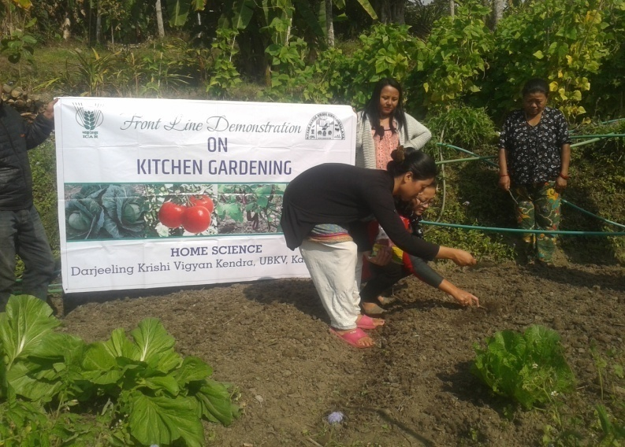

**FLD-12 (Home Science)**: **Cultivation of oyster mushroom on hot water treated substrate (straw)**

|  |  |  |
| --- | --- | --- |
| 1. | Problem Area | Poor quality and quantity of mushroom production |
| 2. | Important cause | * Indiscriminate treatment methods on substrate by various chemicals * No alternative substitute of substrate apart from rice/wheat straw |
| 3. | Technology for demonstration | Cultivation of oyster mushroom on hot water treated substrate |
| 4. | Unit of demonstration | 5 |
| 5. | Monitoring indicator | * Yield of mushroom * Quality of the mushroom (size, colour, shape ) * Taste and organoleptic evaluation |
| 6. | Proposed block of demonstration | Kalimpong I & II |
| 7. | Inputs | Mushroom spawn, Mushroom bags, plastic sheet |
| 8. | No. of demonstration | 12 (No. of cylinder) |
| 9. | Total cost of demonstration | 5000/- |
| 1. | Problem Area | Poor quality and quantity of mushroom production |

|  |  |  |  |  |  |  |  |  |  |
| --- | --- | --- | --- | --- | --- | --- | --- | --- | --- |
| **Sl.**  **No.** | **Crop** | **Thematic area** | **Technology Demonstrated with detailed treatments** | **No. of cylinders** | | **No. of farmers/**  **demonstration** | | | **Reasons for shortfall in achievement** |
| **Proposed** | **Actual** | **SC/ST** | **Others** | **Total** |
| **1.** | Oyster mushroom | Cultivation of mushrooms | Hot water treatment for substrates | 60  (no.) | 60 (no.) | 2 | 3 | 5 |  |

|  |  |  |  |  |  |  |  |  |  |  |
| --- | --- | --- | --- | --- | --- | --- | --- | --- | --- | --- |
| **Crop** | **Thematic Area** | **Name of the technology demonstrated** | **\*Economics of check**  **(Rs./ha)** | **\*Economics of check**  **(Rs./unit)** | | | **\*Economics of demonstration**  **(Rs./unit)** | | | |
| **Gross**  **Cost** | **Gross**  **Return** | **Net Return** | **\*\***  **BCR** | **Gross**  **Cost** | **Gross**  **Return** | **Net Return** | **\*\***  **BCR** |
| Oyster mushroom | Cultivation of mushrooms | Hot water treatment for substrates | 2000 | 4400 | 2400 | 2.20:1 | 2000 | 5500 | 3500 | 2.75:1 |

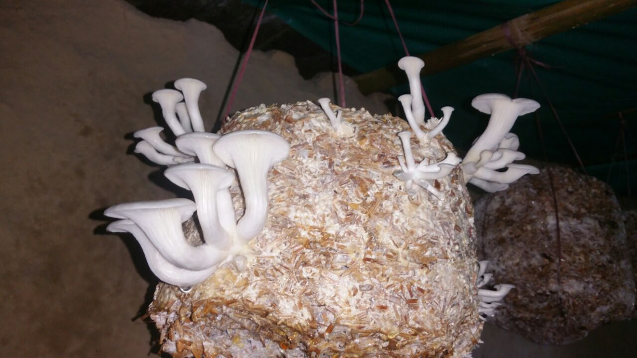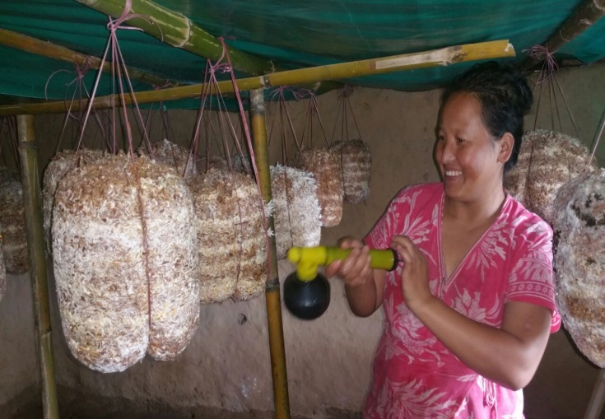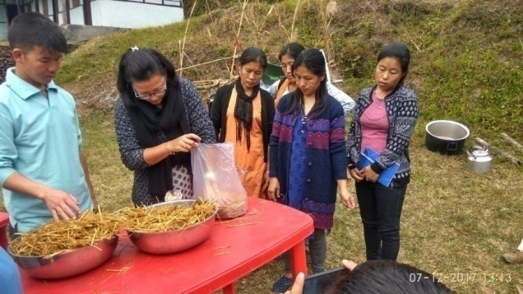

Performance of FLD

Oilseeds:

Frontline demonstrations on oilseed crops

|  |  |  |  |  |  |  |  |  |  |  |  |  |  |  |  |
| --- | --- | --- | --- | --- | --- | --- | --- | --- | --- | --- | --- | --- | --- | --- | --- |
| Crop | Thematic Area | Name of the technology demonstrated | No. of Farmers | Area  (ha) | Yield (q/ha) | | % Increase | \*Economics of demonstration (Rs./ha) | | | | \*Economics of check  (Rs./ha) | | | |
| Demo | Check | Gross  Cost | Gross  Return | Net Return | \*\*  BCR | Gross  Cost | Gross  Return | Net Return | \*\*  BCR |
| Mustard | Varietal performance | Improved variety PS-28 compared with check B9 | 30 | 1 | 14.51 | 11.02 | 31.6 | 12153 | 56589 | 44436 | 4.65 | 12154 | 42978 | 30824 | 3.5 |
| Improved variety Piloo NG compared with check B9 | 30 | 1 | 14.8 | 11.02 | 34.3 | 12151 | 53280 | 41129 | 4.3 | 12154 | 42978 | 30824 | 3.5 |

\* Economics to be worked out based on total cost of production per unit area and not on critical inputs alone.

\*\* BCR= GROSS RETURN/GROSS COST

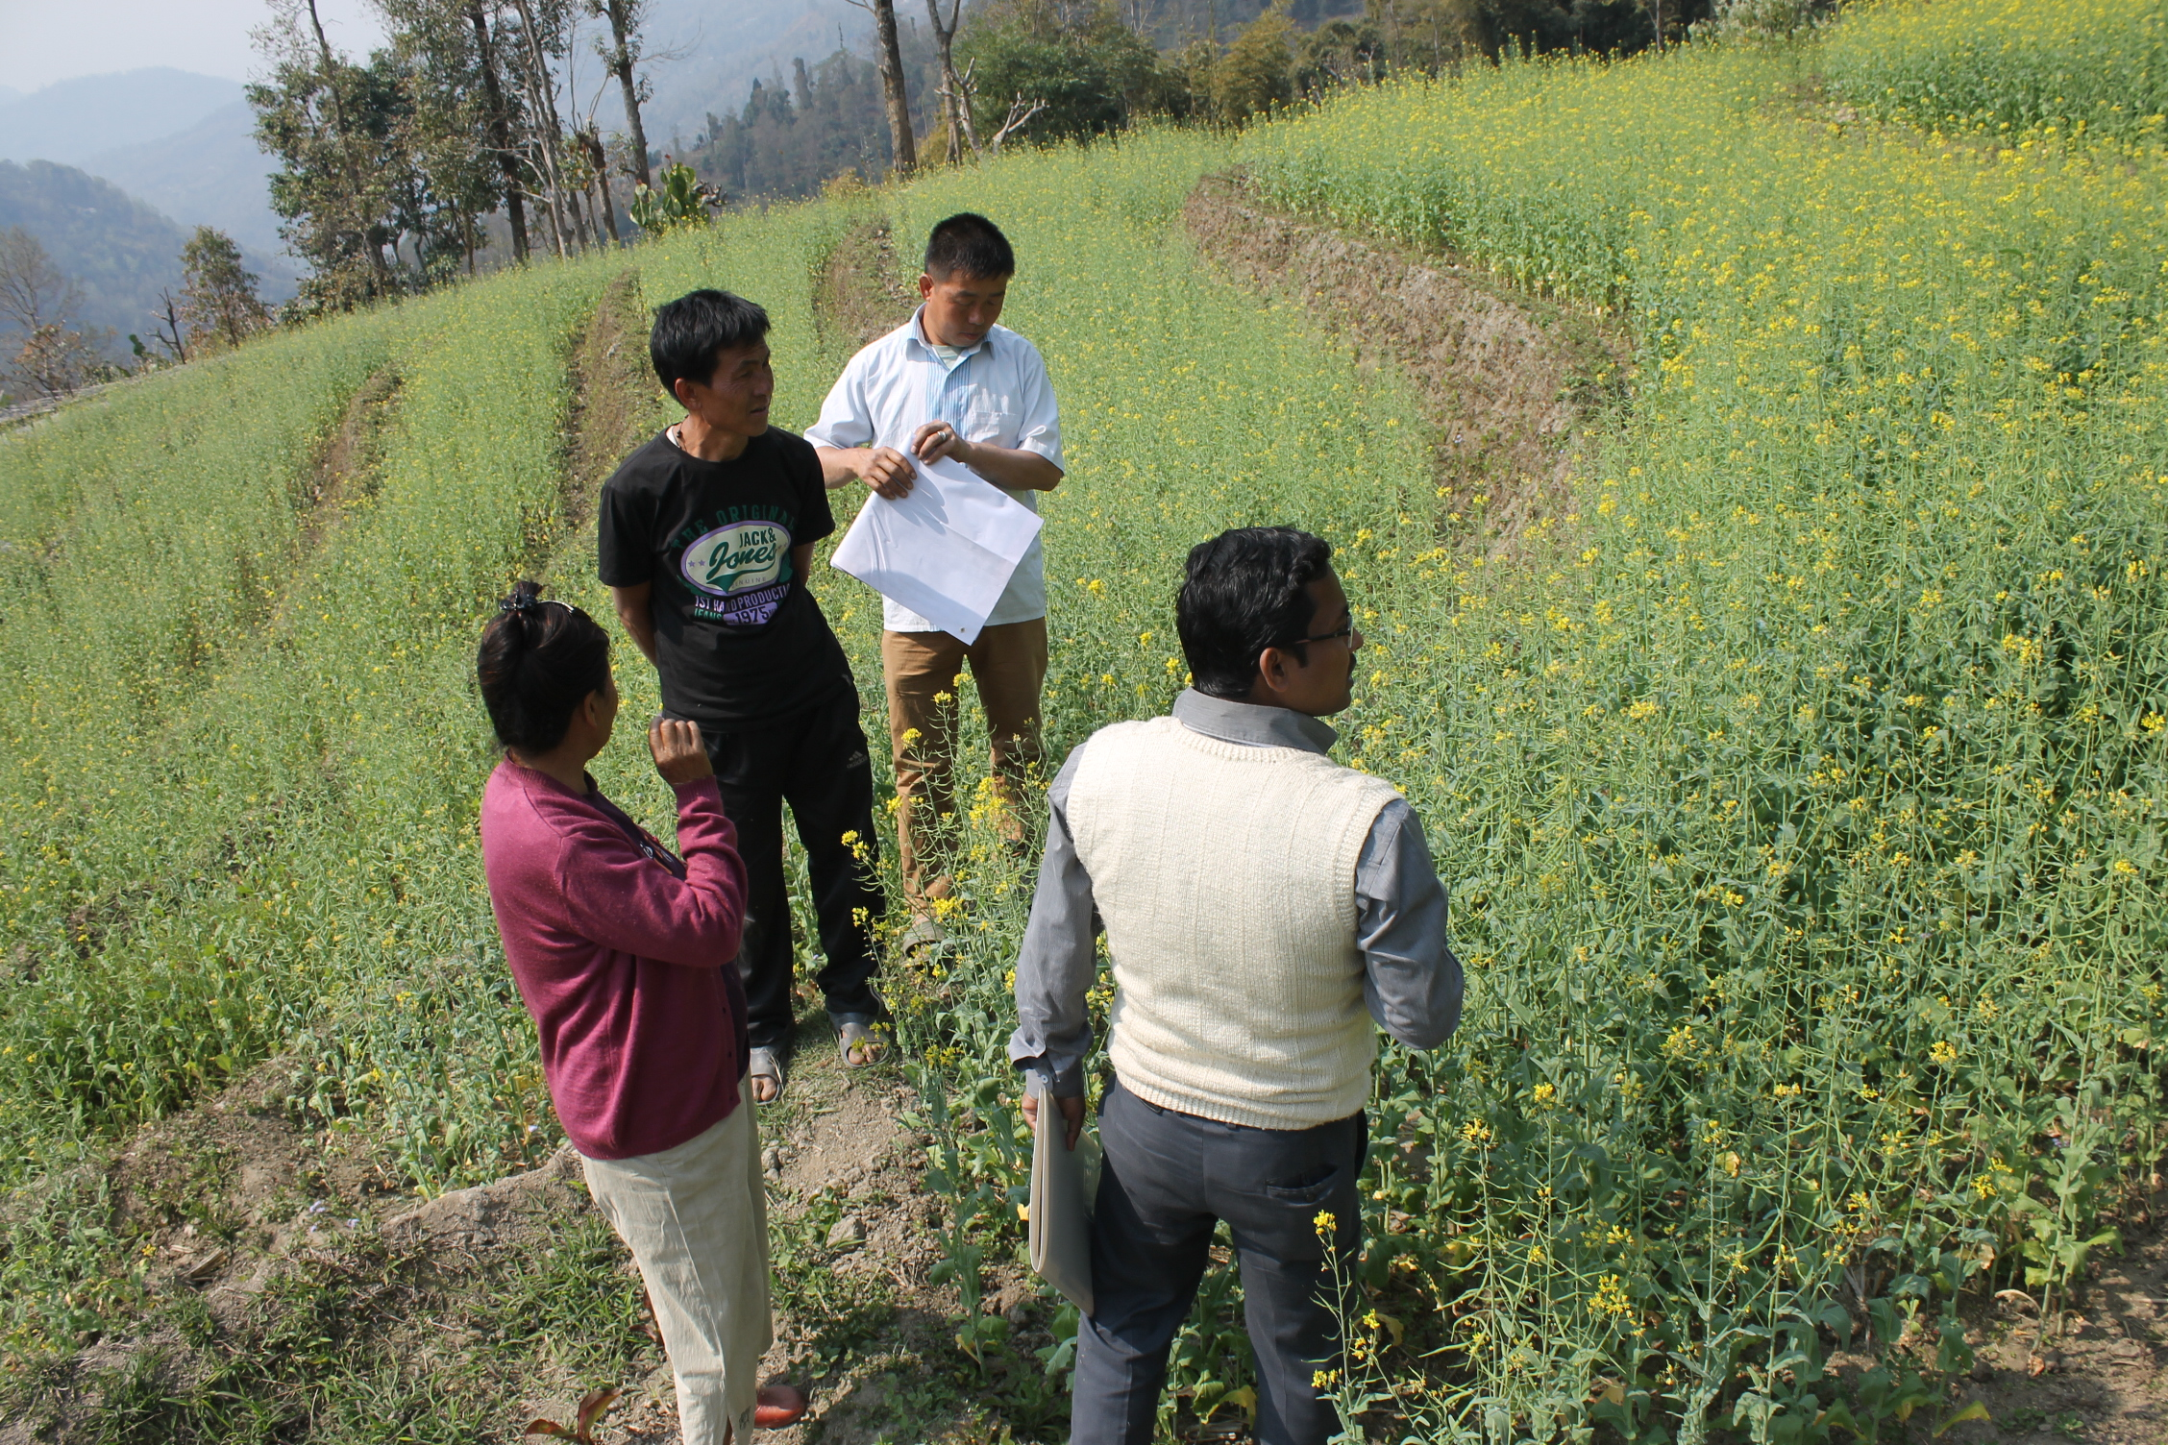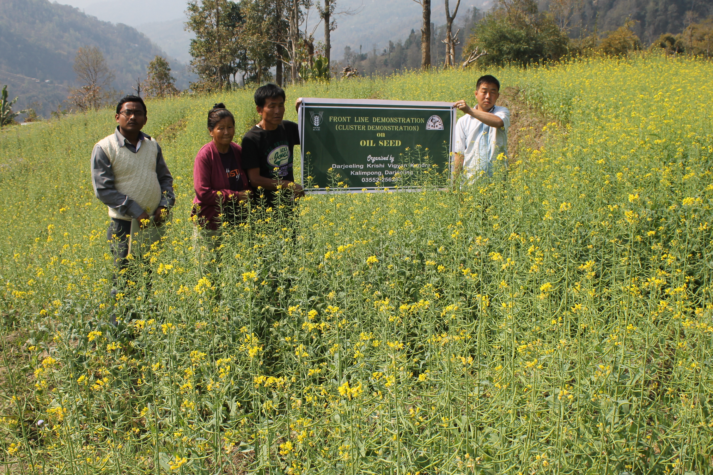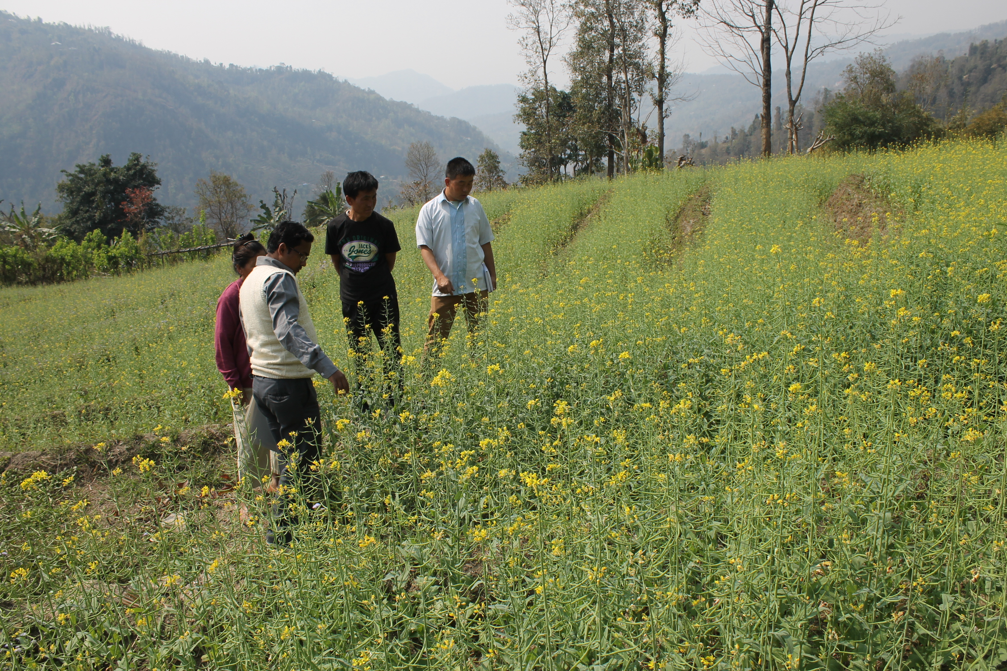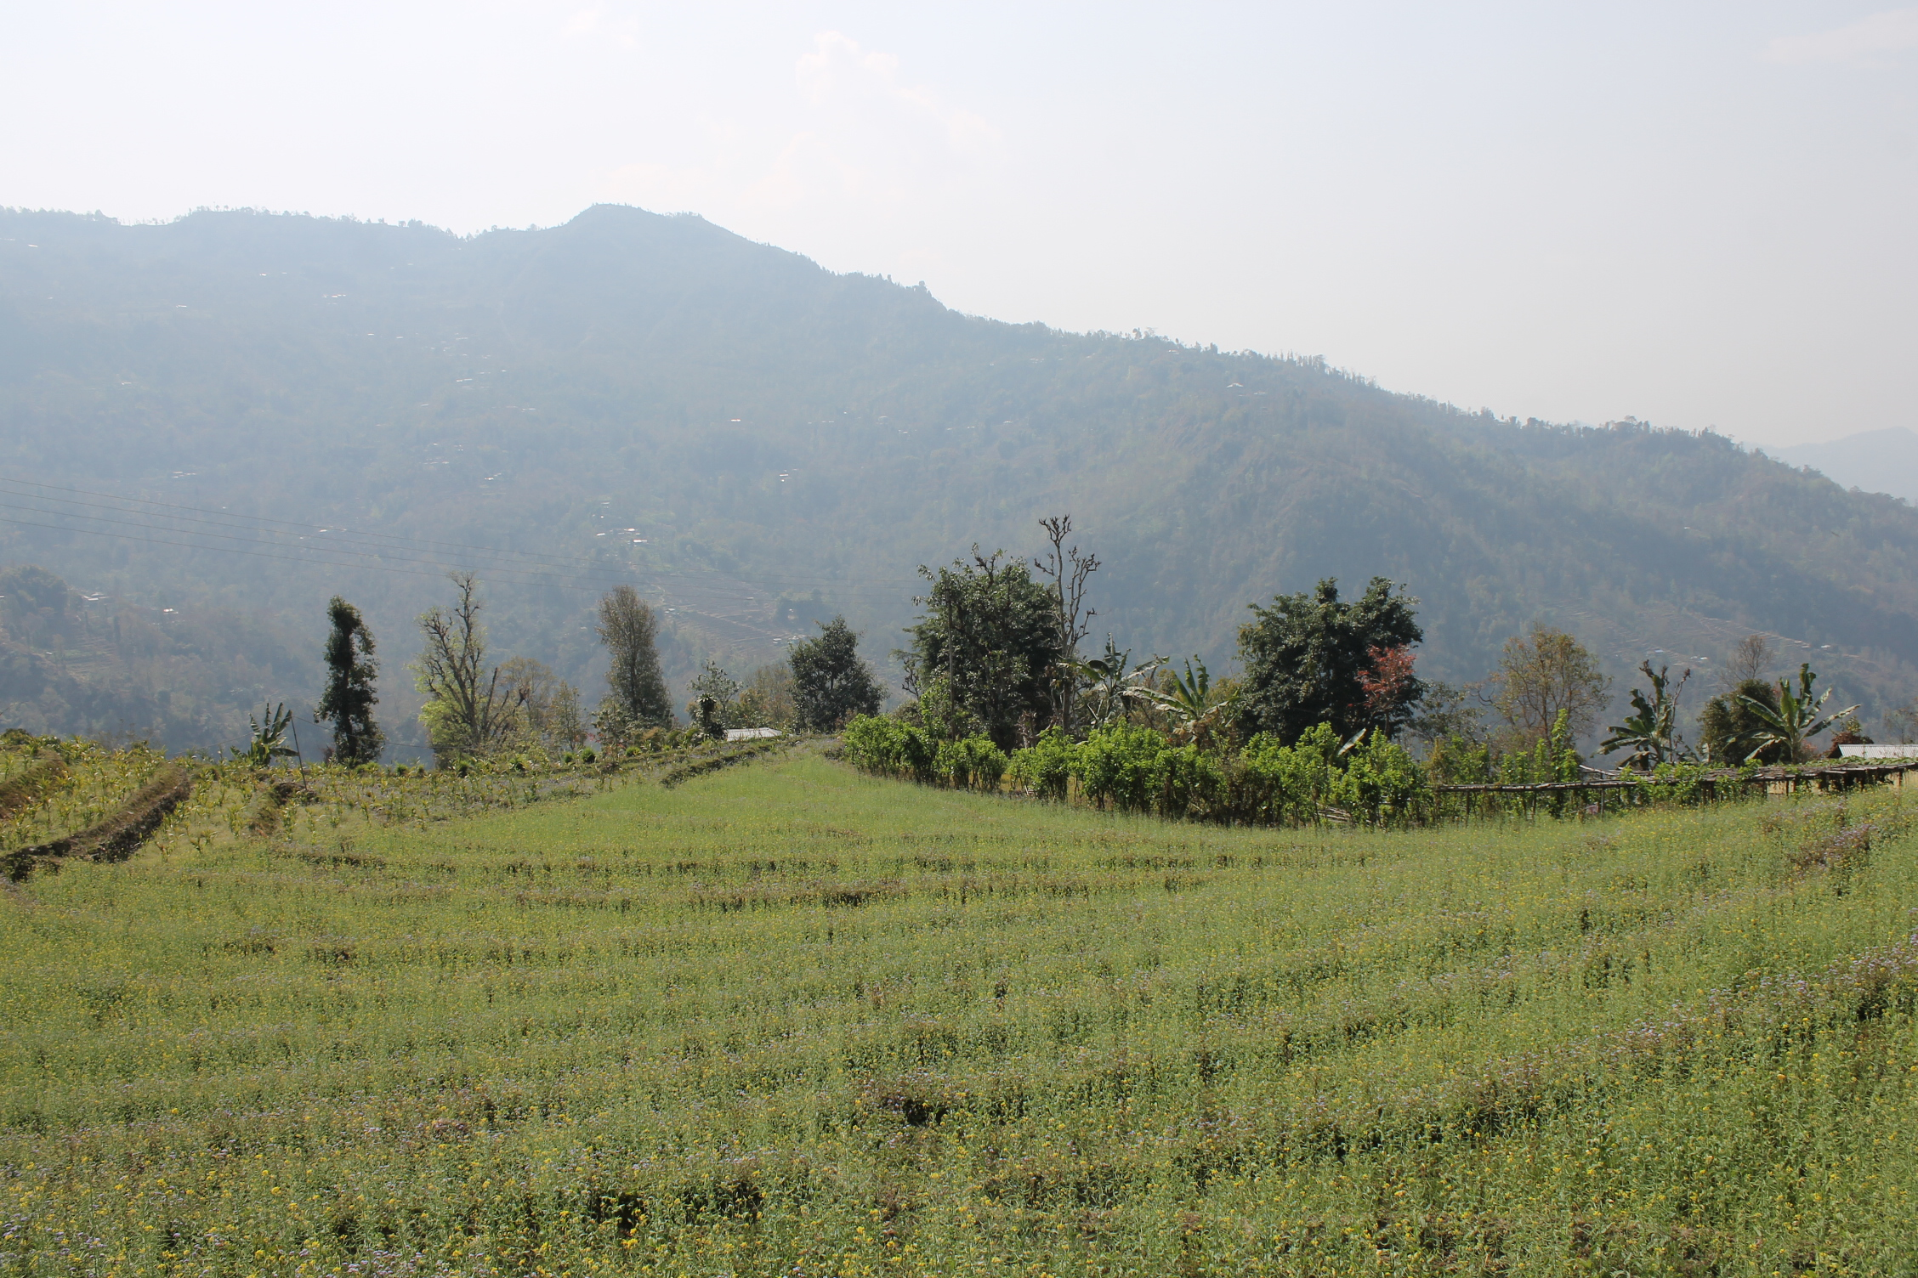

Other crops

|  |  |  |  |  |  |  |  |  |  |  |  |  |  |  |  |
| --- | --- | --- | --- | --- | --- | --- | --- | --- | --- | --- | --- | --- | --- | --- | --- |
| Crop | Thematic area | Name of the technology demonstrated | No. of Farmer | Area  (ha) | Yield (q/ha) | | % change in yield | \*Economics of demonstration (Rs./ha) | | | | \*Economics of check  (Rs./ha) | | | |
| Demons  ration | Check | Gross  Cost | Gross  Return | Net Return | \*\*  BCR | Gross  Cost | Gross  Return | Net Return | \*\*  BCR |
| Paddy | Varietal performance | IARI released improved variety PS-5 | 20 | 0.5 | 2.01 | 1.33 | 51.12 | 25721 | 31155 | 5434 | 1.21 | 20974 | 23940 | 2966 | 1.14 |

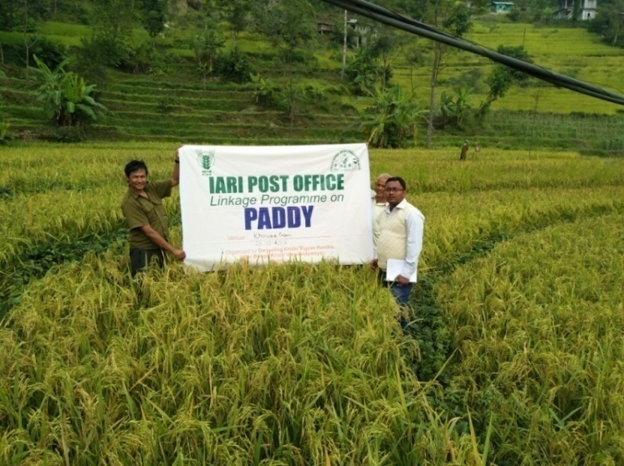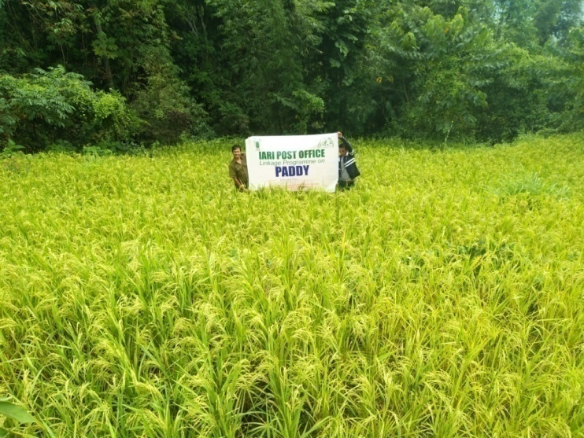

Women empowerment

|  |  |  |  |  |  |
| --- | --- | --- | --- | --- | --- |
| Category | Name of technology | No. of demonstrations | Observations | | Remarks |
| Demonstration | Check |
| Farm Women | Cultivation of Oyster Mushroom | 6 | 2.5-3 kg/barrel | 1-1.5 kg/barrel | The yield of mushrooms increased by 1 to 2 kg/barrel after being given the demonstration on proper technique of mushroom cultivation |
| Other women | Kitchen Gardening for nutrition and food security | 4 | Rs. 500-2500/- | 0 | Apart from giving food and nutritional security women are able to make additional income ranging from Rs. 500 to 2500 for their families by selling the crops |
| Infants | Preparation of low cost Malted Supplements | 2 | 13.5-20.5 | >13.5 | Improvement in BMI |

Technical Feedback on the demonstrated technologies

|  |  |  |
| --- | --- | --- |
| S. No | Crop | Feed Back |
| 1 | Mandarin Orange | After nutritional management size and yield of fruits were increased. |
| 2 | Mustard | Yield of Piloo NG and PS-28 was higher in compare with B9. |
| 3 | Paddy –PS-5 | Production of this scented rice is satisfactory, but the milling performance is not at per due to the long grain |
| 4 | Ginger | Disease infestation reduced with the application of hot water treatment and bioagent. |
| 5 | Ginger | Production increases and reduction of rhizome rot complex of ginger with the application of PGPR and micronutrient. |
|  | Turmeric | Production increases with the application of PGPR and micronutrient. |
| 6 | Kitchen Garden | It is well accepted among rural family with horizontal expansion |
|  | Mushroom | Production as well as quality increased |
| 7 | Dairy cattle | Production of milk was increased |
|  | Pig | Mortality rate decreases due to feeding of iron suppliment |
| 8 | Hampshire pig | Hampshire pig have good litter size and growth rate compared to desi pig |
| 9 | RIR poultry | Vanaraja poultry have high weight gain and egg laying efficiency compared to desi poultry birds |

**Performance of the demonstration under**

**on Pulse during Rabi 2017-18:**

1. **Technical Parameters:**

|  |  |  |  |  |  |  |  |  |  |  |  |  |  |  |  |
| --- | --- | --- | --- | --- | --- | --- | --- | --- | --- | --- | --- | --- | --- | --- | --- |
| Sl.  No. | Crop demonstrated | Existing (Farmer's) variety name | Existing yield  (q/ha) | Yield gap (q/ha)  w.r.to | | | Name of Variety + Technology  demonstrated | Number of farmers | Area in ha | Yield obtained (q/ha) | | | Yield gap minimized  (%) | | |
| District  yield (D) | State  yield (S) | Potential  yield (P) |
| Max. | Min. | Av. | D | S | P |
| 1 | Field Pea | Local | 18.7 | 22 | 35 |  | Sweet Pearl  KSP-10  Green Master  Pusa Pragati | 146 | 10 | 24.88  23.41  20.80  26.87 | 21.87  20.45  19.27  22.46 | 23.37  21.93  20.04  24.66 | 6.22  -  -  12.09 | -  -  -  - |  |

1. **Economic parameters**

|  |  |  |  |  |  |  |  |  |  |
| --- | --- | --- | --- | --- | --- | --- | --- | --- | --- |
| Sl.  No. | Variety demonstrated & Technology demonstrated | Farmer’s Existing plot | | | | Demonstration plot | | | |
| Gross Cost  (Rs/ha) | Gross return  (Rs/ha) | Net Return  (Rs/ha) | B:C  ratio | Gross Cost  (Rs/ha) | Gross return  (Rs/ha) | Net Return  (Rs/ha) | B:C  ratio |
| 1 | Local  Sweet Pearl  KSP-10  Green Master  Pusa Pragati | 33675 | 50490 | 16815 | 1.53 | 33675  33582  32588  33447 | 67176  63207  56160  72549 | 32399  29625  23572  39102 | 1.93  1.88  1.72  2.16 |

1. **Socio-economic impact parameters**

|  |  |  |  |  |  |  |  |  |
| --- | --- | --- | --- | --- | --- | --- | --- | --- |
| Sl.  No. | Crop and variety  Demonstrated | Total Produce  Obtained (kg) | Produce sold  (Kg/household) | Selling  Rate  (Rs/Kg) | Produce used for own sowing (Kg) | Produce distributed to other farmers (Kg) | Purpose for which income gained was utilized | Employment Generated (Mandays/house hold) |
| 1 | Field Pea | 9155 | 9125 | 15 | 30 | 363 | Household activity and Children education | 12 |

1. **Pulse Farmers’ perception of the intervention demonstrated**

|  |  |  |  |  |  |  |  |
| --- | --- | --- | --- | --- | --- | --- | --- |
| Sl.  No. | Technologies demonstrated  (with name) | Farmers' Perception parameters | | | | | |
| Suitability to their farming system | Likings  (Preference) | Affordability | Any negative effect | Is Technology acceptable to all in the group/village | Suggestions, for change/improvement, if any |
| 1 | -Variety - Sweet Pearl, KSP-10, Green Master,  Pusa Pragati  -Seed treatment with bio fertilizer Rhizobium @ 10gm/kg of seed  -Seed treatment with Pseudomonas @ 10gm/kg of seed  -Application of organic manure spectrum @ 500gm/bigha with FYM | Yes | Good | Affordable | No | Yes | Availability of these type of seeds are required for better production |

1. **Specific Characteristics of Technology and Performance**

|  |  |  |  |
| --- | --- | --- | --- |
| Specific Characteristic | Performance | Performance of Technology vis-a vis Local Check | Farmers Feedback |
| Field Pea | Pod formation and seed per pod is higher | Line sowing with application of Bio fertilizer (Rhizobium) performed well than the local practice | Produce higher yield than the local one. Infestation of pest and diseases was lower. |

1. **Extension activities under FLD conducted till dates:**

|  |  |  |
| --- | --- | --- |
| **Extension Activities organized** | **Date and place of activity** | **Number of farmer attended** |
| Training | 03/11/17, Fikalay | 50 |
|  | 07/11/17, Namdong | 10 |
|  | 10/11/17, Arikyung, | 10 |
|  | 13/11/17, Samalbong | 20 |
|  | 15/11/17, Tanayang | 22 |
|  | 17/11/17, Khawas gaon | 16 |
|  | 21/11/17, Sangsey | 18 |
| Demonstration | 03/11/17, Fikalay | 50 |
|  | 07/11/17, Namdong | 10 |
|  | 10/11/17, Arikyung, | 10 |
|  | 13/11/17, Samalbong | 20 |
|  | 15/11/17, Tanayang | 22 |
|  | 17/11/17, Khawas gaon | 16 |
|  | 21/11/17, Sangsey | 18 |
| Field Visit | 12/12/17, Fikalay | 9 |
|  | 18/12/17, Namdong | 2 |
|  | 22/12/17, Arikyung, | 3 |
|  | 27/12/17, Samalbong | 5 |
|  | 29/12/17, Tanayang | 6 |
|  | 08/02/18, Khawas gaon | 3 |
|  | 10/02/18, Sangsey | 4 |

1. **Sequential good quality photographs (as per crop stages i.e. growth & development) and field visit**

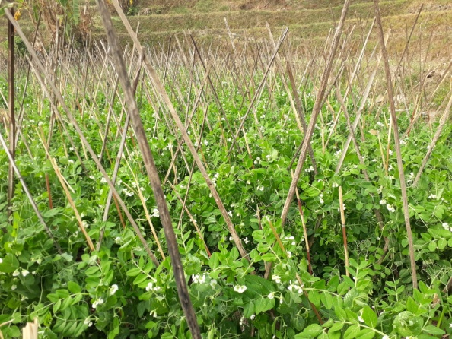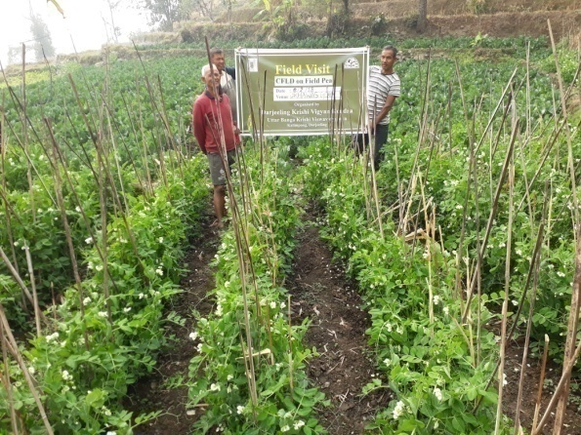

1. **Farmers' training photographs**

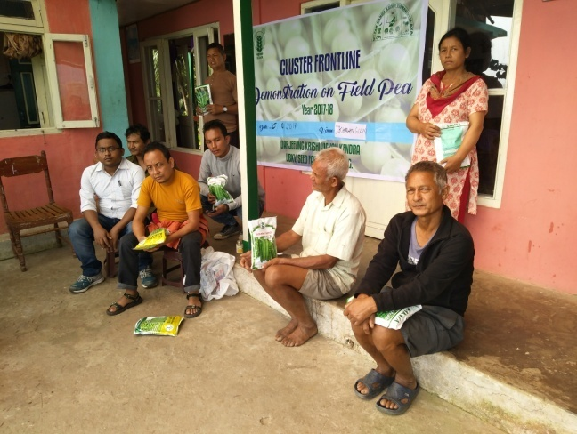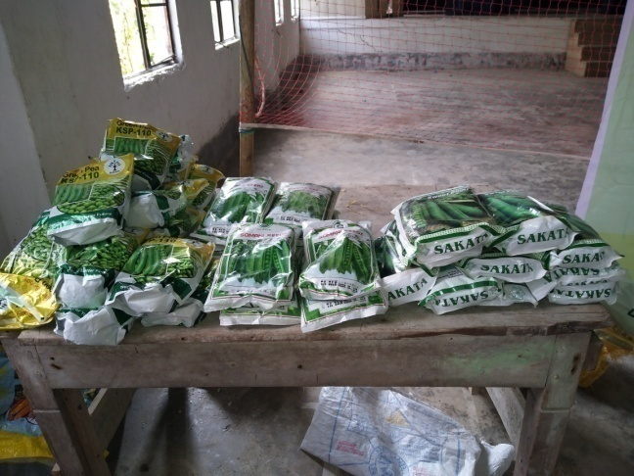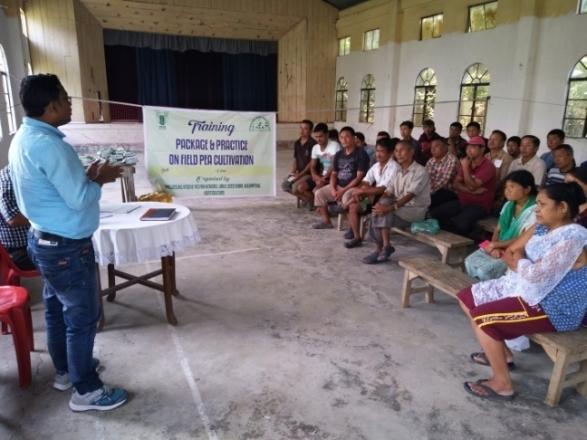

Livestock

|  |  |  |  |  |  |  |  |  |  |  |  |  |  |  |  |  |  |
| --- | --- | --- | --- | --- | --- | --- | --- | --- | --- | --- | --- | --- | --- | --- | --- | --- | --- |
| Category | Thematic  area | Name of the technology demonstrated | No. of Farmer | No.of units | Major parameters | | % change in major parameter | Other parameter | | \*Economics of demonstration (Rs.) | | | | \*Economics of check  (Rs.) | | | |
| Demons  ration | Check | Demons  ration | Check | Gross  Cost | Gross  Return | Net Return | \*\*  BCR | Gross  Cost | Gross  Return | Net Return | \*\*  BCR |
| Dairy | Production Performance | Area specific mineral mixture | 30 | 100 | Milk production | Milk production | 18 |  |  | 45430 | 87200 | 41770 | 1.92:1 | 43800 | 79400 | 35600 | 1.81:1 |
| Cow |  |  |  |  |  |  |  |  |  |  |  |  |  |  |  |  |  |
| Buffalo |  |  |  |  |  |  |  |  |  |  |  |  |  |  |  |  |  |
| Poultry | Production performance | RIR | 30 | 30 | Egg production | Egg production | 19 | Weight gain | Weight gain | 8650 | 39500 | 31850 | 4.57:1 | 7950 | 25700 | 17750 | 3.23:1 |
| Rabbitry |  |  |  |  |  |  |  |  |  |  |  |  |  |  |  |  |  |
| Piggery  1 | Production performance | Hampshire | 30 | 30 | Growth rate | Growth rate | 15 | Litter size | Litter size | 8650 | 36800 | 28150 | 4.24:1 | 7640 | 24200 | 16560 | 3.16:1 |
| Piggery  2 | Mortality Check | Iron Supplementation | 30 | 100 | Mortality rate | Mortality rate | 13 |  |  | 18000 | 325000 | 307000 |  | -- | 266500 | 266500 |  |
| Sheep and goat |  |  |  |  |  |  |  |  |  |  |  |  |  |  |  |  |  |
| Duckery |  |  |  |  |  |  |  |  |  |  |  |  |  |  |  |  |  |
| Others (pl.specify) |  |  |  |  |  |  |  |  |  |  |  |  |  |  |  |  |  |
| Total |  |  |  |  |  |  |  |  |  |  |  |  |  |  |  |  |  |

\* Economics to be worked out based on total cost of production per unit area and not on critical inputs alone.

\*\* BCR= GROSS RETURN/GROSS COST

Fisheries

|  |  |  |  |  |  |  |  |  |  |  |  |  |  |  |  |  |  |
| --- | --- | --- | --- | --- | --- | --- | --- | --- | --- | --- | --- | --- | --- | --- | --- | --- | --- |
| Category | Thematic area | Name of the technology demonstrated | No. of Farmer | No.of units | Major parameters | | % change in major parameter | Other parameter | | \*Economics of demonstration (Rs.) | | | | \*Economics of check  (Rs.) | | | |
| Demons  ration | Check | Demons  ration | Check | Gross  Cost | Gross  Return | Net Return | \*\*  BCR | Gross  Cost | Gross  Return | Net Return | \*\*  BCR |
| Common carps |  |  |  |  |  |  |  |  |  |  |  |  |  |  |  |  |  |
| Mussels |  |  |  |  |  |  |  |  |  |  |  |  |  |  |  |  |  |
| Ornamental fishes |  |  |  |  |  |  |  |  |  |  |  |  |  |  |  |  |  |
| Others (pl.specify) |  |  |  |  |  |  |  |  |  |  |  |  |  |  |  |  |  |
|  | Total | |  |  |  | | | | | | | | | | | | |

\* Economics to be worked out based on total cost of production per unit area and not on critical inputs alone.

\*\* BCR= GROSS RETURN/GROSS COST

Other enterprises

|  |  |  |  |  |  |  |  |  |  |  |  |  |  |  |  |  |
| --- | --- | --- | --- | --- | --- | --- | --- | --- | --- | --- | --- | --- | --- | --- | --- | --- |
| Category | Name of the technology demonstrated | No. of Farmer | No.of units | Major parameters | | % change in major parameter | Other parameter | | \*Economics of demonstration (Rs.) or Rs./unit | | | | \*Economics of check  (Rs.) or Rs./unit | | | |
| Demons  ration | Check | Demons  ration | Check | Gross  Cost | Gross  Return | Net Return | \*\*  BCR | Gross  Cost | Gross  Return | Net Return | \*\*  BCR |
| Oyster mushroom | Enterprise development |  |  |  |  |  |  |  |  |  |  |  |  |  |  |  |
| Button mushroom |  |  |  |  |  |  |  |  |  |  |  |  |  |  |  |  |
| Vermicompost |  |  |  |  |  |  |  |  |  |  |  |  |  |  |  |  |
| Sericulture |  |  |  |  |  |  |  |  |  |  |  |  |  |  |  |  |
| Apiculture |  |  |  |  |  |  |  |  |  |  |  |  |  |  |  |  |
| Others (pl.specify) |  |  |  |  |  |  |  |  |  |  |  |  |  |  |  |  |
| Total | |  |  |  | | | | | | | | | | | | |

\* Economics to be worked out based on total cost of production per unit area and not on critical inputs alone.

\*\* BCR= GROSS RETURN/GROSS COST

Women empowerment

|  |  |  |  |  |  |
| --- | --- | --- | --- | --- | --- |
| Category | Name of technology | No. of demonstrations | Observations | | Remarks |
| Demonstration | Check |
| Farm Women 1 |  |  |  |  |  |
| Farm Women 2 |  |  |  |  |  |
| Pregnant women |  |  |  |  |  |
| Adolescent Girl |  |  |  |  |  |
| Other women |  |  |  |  |  |
| Children |  |  |  |  |  |
| Neonatal |  |  |  |  |  |
| Infants |  |  |  |  |  |

Farm implements and machinery

|  |  |  |  |  |  |  |  |  |  |  |  |  |  |  |  |
| --- | --- | --- | --- | --- | --- | --- | --- | --- | --- | --- | --- | --- | --- | --- | --- |
| Name of the implement | Crop | Name of the technology demonstrated | No. of Farmer | Area (ha) | Filed observation (output/man hour) | | % change in major parameter | Labor reduction (man days) | | | | Cost reduction (Rs./ha or Rs./Unit) | | | |
| Demons  ration | Check |  |  |  |  |  |  |  |  |
|  |  |  |  |  |  |  |  |  |  |  |  |  |  |  |  |

**\* Economics to be worked out based on total cost of production per unit area and not on critical inputs alone.**

**\*\* BCR= GROSS RETURN/GROSS COST**

Demonstration details on crop hybrids

|  |  |  |  |  |  |  |  |  |  |  |
| --- | --- | --- | --- | --- | --- | --- | --- | --- | --- | --- |
| Crop | Name of the Hybrid | No. of  farmers | Area  (ha) | Yield (kg/ha) / major parameter | | | Economics (Rs./ha) | | | |
| Cereals |  |  |  | Demo | Local check | % change | Gross  Cost | Gross  Return | Net  Return | BCR |
| Bajra |  |  |  |  |  |  |  |  |  |  |
| Maize |  |  |  |  |  |  |  |  |  |  |
| Paddy |  |  |  |  |  |  |  |  |  |  |
| Sorghum |  |  |  |  |  |  |  |  |  |  |
| Wheat |  |  |  |  |  |  |  |  |  |  |
| Others (pl.specify) |  |  |  |  |  |  |  |  |  |  |
| Total |  |  |  |  |  |  |  |  |  |  |
| Oilseeds |  |  |  |  |  |  |  |  |  |  |
| Castor |  |  |  |  |  |  |  |  |  |  |
| Mustard |  |  |  |  |  |  |  |  |  |  |
| Safflower |  |  |  |  |  |  |  |  |  |  |
| Sesame |  |  |  |  |  |  |  |  |  |  |
| Sunflower |  |  |  |  |  |  |  |  |  |  |
| Groundnut |  |  |  |  |  |  |  |  |  |  |
| Soybean |  |  |  |  |  |  |  |  |  |  |
| Others (pl.specify) |  |  |  |  |  |  |  |  |  |  |
| Total |  |  |  |  |  |  |  |  |  |  |
| Pulses |  |  |  |  |  |  |  |  |  |  |
| Greengram |  |  |  |  |  |  |  |  |  |  |
| Blackgram |  |  |  |  |  |  |  |  |  |  |
| Bengalgram |  |  |  |  |  |  |  |  |  |  |
| Redgram |  |  |  |  |  |  |  |  |  |  |
| Total |  |  |  |  |  |  |  |  |  |  |
| Vegetable crops |  |  |  |  |  |  |  |  |  |  |
| Bottle gourd |  |  |  |  |  |  |  |  |  |  |
| Capsicum |  |  |  |  |  |  |  |  |  |  |
| Cucumber |  |  |  |  |  |  |  |  |  |  |
| Tomato |  |  |  |  |  |  |  |  |  |  |
| Brinjal |  |  |  |  |  |  |  |  |  |  |
| Okra |  |  |  |  |  |  |  |  |  |  |
| Onion |  |  |  |  |  |  |  |  |  |  |
| Potato |  |  |  |  |  |  |  |  |  |  |
| Field bean |  |  |  |  |  |  |  |  |  |  |
| **Field Pea** | Local | 146 | 10 | 18.7 |  |  |  |  |  |  |
| Sweet Pearl | 23.37 |  |  | 33675 | 67176 | 32399 | 1.93 |
| KSP-10 | 21.93 |  |  | 33582 | 63207 | 29625 | 1.88 |
| Green Master | 20.04 |  |  | 32588 | 56160 | 23572 | 1.72 |
| Pusa Pragati | 24.66 |  |  | 33447 | 72549 | 39102 | 2.16 |
| Total |  |  |  |  |  |  |  |  |  |  |
| Commercial crops |  |  |  |  |  |  |  |  |  |  |
| Cotton |  |  |  |  |  |  |  |  |  |  |
| Coconut |  |  |  |  |  |  |  |  |  |  |
| Others (pl.specify) |  |  |  |  |  |  |  |  |  |  |
| Total |  |  |  |  |  |  |  |  |  |  |
| Fodder crops |  |  |  |  |  |  |  |  |  |  |
| Napier (Fodder) |  |  |  |  |  |  |  |  |  |  |
| Maize (Fodder) |  |  |  |  |  |  |  |  |  |  |
| Sorghum (Fodder) |  |  |  |  |  |  |  |  |  |  |
| Others (pl.specify) |  |  |  |  |  |  |  |  |  |  |
| Total |  |  |  |  |  |  |  |  |  |  |

Technical Feedback on the demonstrated technologies

|  |  |  |
| --- | --- | --- |
| **Sl. No** | **Crop** | **Feed Back** |
| 1 | Mandarin Orange | After nutritional management size and yield of fruits were increased. |
| 2 | Mustard | Yield of Piloo NG and PS-28 was higher in compare with B9. |
| 3 | Paddy –PS-5 | Production of this scented rice is satisfactory, but the milling performance is not at per due to the long grain |
| 4 | Ginger | Disease infestation reduced with the application of hot water treatment and bioagent. |
| 5 | Ginger | Production increases and reduction of rhizome rot complex of ginger with the application of PGPR and micronutrient. |
|  | Turmeric | Production increases with the application of PGPR and micronutrient. |
| 6 | Kitchen Garden | It is well accepted among rural family with horizontal expansion |
|  | Mushroom | Production as well as quality increased |
| 7 | Dairy cattle | Production of milk was increased |
|  | Pig | Mortality rate decreases due to feeding of iron suppliment |
| 8 | Hampshire pig | Hampshire pig have good litter size and growth rate compared to desi pig |
| 9 | RIR poultry | Vanaraja poultry have high weight gain and egg laying efficiency compared to desi poultry birds |
| 10 | Field Pea | Pod formation and seed per pod is higher. Produce higher yield than the local one. Infestation of pest and diseases was low. |

Extension and Training activities under FLD

|  |  |  |  |  |  |
| --- | --- | --- | --- | --- | --- |
| Sl.No. | Activity | Date | No. of activities organized | Number of participants | Remarks |
| 1. | Field days |  | 2 |  |  |
| 2. | Farmers Training | 03/11/17, Fikalay | 2 | 50 |  |
|  |  | 07/11/17, Namdong | 1 | 10 |  |
|  |  | 10/11/17, Arikyung, | 1 | 10 |  |
|  |  | 13/11/17, Samalbong | 1 | 20 |  |
|  |  | 15/11/17, Tanayang | 1 | 22 |  |
|  |  | 17/11/17, Khawas gaon | 1 | 16 |  |
|  |  | 21/11/17, Sangsey | 1 | 18 |  |
| 3. | Media coverage |  | 3 |  |  |
| 4. | Training for extension functionaries |  |  |  |  |

1. **Socio-economic impact parameters**

|  |  |  |  |  |  |  |  |  |
| --- | --- | --- | --- | --- | --- | --- | --- | --- |
| Sl.  No. | Crop and variety  Demonstrated | Total Produce  Obtained (kg) | Produce sold  (Kg/household) | Selling  Rate  (Rs/Kg) | Produce used for own sowing (Kg) | Produce distributed to other farmers (Kg) | Purpose for which income gained was utilized | Employment Generated (Mandays/house hold) |
| 1 | Field Pea | 9155 | 9125 | 15 | 30 | 363 | Household activity and Children education | 12 |

1. **Oilseed Farmers’ perception of the intervention demonstrated**

|  |  |  |  |  |  |  |  |
| --- | --- | --- | --- | --- | --- | --- | --- |
| Sl.  No. | Technologies demonstrated  (with name) | Farmers' Perception parameters | | | | | |
| Suitability to their farming system | Likings  (Preference) | Affordability | Any negative effect | Is Technology acceptable to all in the group/village | Suggestions, for change/improvement, if any |
|  |  |  |  |  |  |  |  |

1. **Specific Characteristics of Technology and Performance**

|  |  |  |  |
| --- | --- | --- | --- |
| Specific Characteristic | Performance | Performance of Technology vis-a vis Local Check | Farmers Feedback |
| Field Pea | Pod formation and seed per pod is higher | Line sowing with application of Bio fertilizer (Rhizobium) performed well than the local practice | Produce higher yield than the local one. Infestation of pest and diseases was lower. |

1. **Extension activities under FLD conducted:**

|  |  |  |  |
| --- | --- | --- | --- |
| Sl. No. | Extension Activities organized | Date and place of activity | Number of farmer attended |
| **1** | Training | 03/11/17, Fikalay | 50 |
|  |  | 07/11/17, Namdong | 10 |
|  |  | 10/11/17, Arikyung, | 10 |
|  |  | 13/11/17, Samalbong | 20 |
|  |  | 15/11/17, Tanayang | 22 |
|  |  | 17/11/17, Khawas gaon | 16 |
|  |  | 21/11/17, Sangsey | 18 |
| **2** | Demonstration | 03/11/17, Fikalay | 50 |
|  |  | 07/11/17, Namdong | 10 |
|  |  | 10/11/17, Arikyung, | 10 |
|  |  | 13/11/17, Samalbong | 20 |
|  |  | 15/11/17, Tanayang | 22 |
|  |  | 17/11/17, Khawas gaon | 16 |
|  |  | 21/11/17, Sangsey | 18 |
| **3** | Field Visit | 12/12/17, Fikalay | 9 |
|  |  | 18/12/17, Namdong | 2 |
|  |  | 22/12/17, Arikyung, | 3 |
|  |  | 27/12/17, Samalbong | 5 |
|  |  | 29/12/17, Tanayang | 6 |
|  |  | 08/02/18, Khawas gaon | 3 |
|  |  | 10/02/18, Sangsey | 4 |

1. **Sequential good quality photographs (as per crop stages i.e. growth & development)**
2. **Farmers' training photographs**
3. **Quality ActionPhotographs of field visits/field days and technology demonstrated.**

**J. Details of budget utilization**

|  |  |  |  |  |
| --- | --- | --- | --- | --- |
| Crop  (provide crop wise information ) | Items | Budget  Received  (Rs.) | Budget  Utilization  (Rs.) | Balance  (Rs.) |
|  | i) Critical input |  |  |  |
| ii) TA/DA/POL etc. for monitoring |  |  |  |
| iii) Extension Activities (Field day) |  |  |  |
| iv)Publication of literature |  |  |  |
|  | Total | 2,80,000/- | 2,79,978/- | 22/- |

1. **List of Farmer under FLD (Crop wise)**

**Crop1 : Mustard**

|  |  |  |  |  |  |  |  |  |  |  |  |  |  |  |  |  |  |
| --- | --- | --- | --- | --- | --- | --- | --- | --- | --- | --- | --- | --- | --- | --- | --- | --- | --- |
| Name of farmer | Father’sname | Village | Block | Mobile No. | Email ID | GPS Coordinates (DDMMSS format) | | Soil testing done (Yes/No) | Recommendations based on soil test value | Brief technology intervention | Variety | Seed quantity used | Demo. Yield (q/ha) | | | Yield of local check q/ha | % increase |
|  |  |  |  |  |  | Latitude | Longitude |  |  |  |  |  | H | L | A |  |  |
| Laxmi Baraik |  | Gorubathan | Gorubathan |  |  | 26.95° N | 88.69° E |  |  | INM and IPM | Piatambari | 200 gm | 15.48 | 13.54 | 14.51 | 11.02 | 31.6 |
| Joshila Thapa |  | -do- | -do- |  |  | 26.95° N | 88.69° E |  |  |  | -do- |  |
| Deepty Thapa |  | -do- | -do- |  |  | 26.95° N | 88.69° E |  |  |  | -do- |  |
| Sorojini Pradhan |  | -do- | -do- |  |  | 26.95° N | 88.69° E |  |  |  | -do- |  |
| Soney Pradhan (Thapa) |  | -do- | -do- |  |  | 26.95° N | 88.69° E |  |  |  | -do- |  |
| Sima Bhujel Khawas |  | -do- | -do- |  |  | 26.95° N | 88.69° E |  |  |  | -do- |  |
| Sumanta Rai |  | -do- | -do- |  |  | 26.95° N | 88.69° E |  |  |  | -do- |  |
| Sanjita Thapa |  | -do- | -do- |  |  | 26.95° N | 88.69° E |  |  |  | -do- |  |
| Sujata Giri |  | -do- | -do- |  |  | 26.95° N | 88.69° E |  |  |  | -do- |  |
| Sabita Chhetri |  | -do- | -do- |  |  | 26.95° N | 88.69° E |  |  |  | -do- |  |
| Karsong Tamang |  | -do- | -do- |  |  | 26.95° N | 88.69° E |  |  |  | -do- |  |
| Bima Tamang |  | -do- | -do- |  |  | 26.95° N | 88.69° E |  |  |  | -do- |  |
| Harimaya Gugung |  | -do- | -do- |  |  | 26.95° N | 88.69° E |  |  |  | -do- |  |
| Sita Biswa |  | -do- | -do- |  |  | 26.95° N | 88.69° E |  |  |  | -do- |  |
| Roshni Rai |  | -do- | -do- |  |  | 26.95° N | 88.69° E |  |  |  | -do- |  |
| Bimala Rai |  | -do- | -do- |  |  | 26.95° N | 88.69° E |  |  |  | -do- |  |
| Sita Maya Tamang |  | -do- | -do- |  |  | 26.95° N | 88.69° E |  |  |  | -do- |  |
| Pramia Biswakarma |  | -do- | -do- |  |  | 26.95° N | 88.69° E |  |  |  | -do- |  |
| Jeena Rai |  | -do- | -do- |  |  | 26.95° N | 88.69° E |  |  |  | -do- |  |
| Sarmila Rai |  | Paten Godak | Gorubathan |  |  | 27.06° N | 88.87° E |  |  |  | NC1 |  |
| Tulsi Rai |  | -do- | -do- |  |  | 27.06° N | 88.87° E |  |  |  | -do- |  |
| Aaity Mukhia |  | -do- | -do- |  |  | 27.06° N | 88.87° E |  |  |  | -do- |  |
| Mona Sharma |  | -do- | -do- |  |  | 27.06° N | 88.87° E |  |  |  | -do- |  |
| Ramala Rai |  | -do- | -do- |  |  | 27.06° N | 88.87° E |  |  |  | -do- |  |
| Mamitra Rai |  | -do- | -do- |  |  | 27.06° N | 88.87° E |  |  |  | -do- |  |
| Aitu Rai |  | -do- | -do- |  |  | 27.06° N | 88.87° E |  |  |  | -do- |  |
| Sanjita Rai |  | -do- | -do- |  |  | 27.06° N | 88.87° E |  |  |  | -do- |  |
| Kumari Sharma |  | -do- | -do- |  |  | 27.06° N | 88.87° E |  |  |  | -do- |  |
| Tara Rai |  | -do- | -do- |  |  | 27.06° N | 88.87° E |  |  |  | -do- |  |
| Soma Tamang |  | -do- | -do- |  |  | 27.06° N | 88.87° E |  |  |  | -do- |  |
| Rojika Rai |  | -do- | -do- |  |  | 27.06° N | 88.87° E |  |  |  | -do- |  |
| Sunita Rai |  | -do- | -do- |  |  | 27.06° N | 88.87° E |  |  |  | -do- |  |
| Rekha Rai |  | -do- | -do- |  |  | 27.06° N | 88.87° E |  |  |  | -do- |  |
| Sabnam Rai |  | -do- | -do- |  |  | 27.06° N | 88.87° E |  |  |  | -do- |  |
| Sarika Gurung |  | Kumai | Gorubathan |  |  | 27.01° N | 88.81° E |  |  |  | NC1 |  |
| Sushma Rai |  | -do- | -do- |  |  | 27.01° N | 88.81° E |  |  |  | -do- |  |
| Ashika Gurung |  | -do- | -do- |  |  | 27.01° N | 88.81° E |  |  |  | -do- |  |
| Debi Chhetri |  | -do- | -do- |  |  | 27.01° N | 88.81° E |  |  |  | -do- |  |
| Ashta Chhetri |  | -do- | -do- |  |  | 27.01° N | 88.81° E |  |  |  | -do- |  |
| Devika Chhetri |  | -do- | -do- |  |  | 27.01° N | 88.81° E |  |  |  | -do- |  |
| Sara Rai |  | -do- | -do- |  |  | 27.01° N | 88.81° E |  |  |  | -do- |  |
| Yanki Sherpa |  | -do- | -do- |  |  | 27.01° N | 88.81° E |  |  |  | -do- |  |
| Sonam Sherpa |  | -do- | -do- |  |  | 27.01° N | 88.81° E |  |  |  | -do- |  |
| Sova Rai |  | -do- | -do- |  |  | 27.01° N | 88.81° E |  |  |  | -do- |  |
| Srijana Chhetri |  | -do- | -do- |  |  | 27.01° N | 88.81° E |  |  |  | -do- |  |
| Roshna Bhujel |  | -do- | -do- |  |  | 27.01° N | 88.81° E |  |  |  | -do- |  |
| Prativa Pradhan |  | -do- | -do- |  |  | 27.01° N | 88.81° E |  |  |  | -do- |  |
| Kripa Bhujel |  | -do- | -do- |  |  | 27.01° N | 88.81° E |  |  |  | -do- |  |
| Merina Rai |  | -do- | -do- |  |  | 27.01° N | 88.81° E |  |  |  | -do- |  |
| Kabita Khawas |  | -do- | -do- |  |  | 27.01° N | 88.81° E |  |  |  | -do- |  |
| Mahesh Chhetri |  | Nimbong | Algarah |  |  | 26.96° N | 88.59° E |  |  |  | B9 |  |
| Gloria Vairung |  | -do- | -do- |  |  | 26.96° N | 88.59° E |  |  |  | B9 |  |
| Purnimaya Subba |  | -do- | -do- |  |  | 26.96° N | 88.59° E |  |  |  | -do- |  |
| Padam maya Chettri |  | -do- | -do- |  |  | 26.96° N | 88.59° E |  |  |  | -do- |  |
| Uma Subba |  | -do- | -do- |  |  | 26.96° N | 88.59° E |  |  |  | NC1 |  |
| Kulpati Lepcha |  | -do- | -do- |  |  | 26.96° N | 88.59° E |  |  |  | -do- |  |
| Rajen Mukhia |  | -do- | -do- |  |  | 26.96° N | 88.59° E |  |  |  | -do- |  |
| Krishna maya Sharma |  | -do- | -do- |  |  | 26.96° N | 88.59° E |  |  |  | -do- |  |
| Bhim Bdr.Subba |  | -do- | -do- |  |  | 26.96° N | 88.59° E |  |  |  | -do- |  |

**Crop2 (Rice)**

|  |  |  |  |  |  |  |  |  |  |  |  |  |  |  |  |  |  |
| --- | --- | --- | --- | --- | --- | --- | --- | --- | --- | --- | --- | --- | --- | --- | --- | --- | --- |
| Name of farmer | Father’sname | Village | Block | Mobile No. | Email ID | GPS Coordinates (DDMMSS format) | | Soil testing done (Yes/No) | Recommendations based on soil test value | Brief technology intervention | Variety | Seed quantity used | Demo. Yield (q/ha) | | | Yield of local check q/ha | % increase |
|  |  |  |  |  |  | Latitude | Longitude |  |  |  |  |  | H | L | A |  |  |
| Ram Bahadur Basned |  | Bong Busty | Kpg-1 |  |  | 27.04° N | 88.48° E |  |  | Short duration improved variety | PS-5 |  | 2.54 | 1.51 | 2.01 | 1.33 | 51.12 |
| Krishna Bhatta Rai |  | Bong Busty | Kpg-1 |  |  | 27.04° N | 88.48° E |  |  |  | PS-5 |  |  |  |
| Aswin Chhetri |  | Bong Busty | Kpg-1 |  |  | 27.04° N | 88.48° E |  |  |  | PS-5 |  |  |  |
| Kancha Basned |  | Bong Busty | Kpg-1 |  |  | 27.04° N | 88.48° E |  |  |  | PS-5 |  |  |  |
| Ganesh Sapkota |  | Bong Busty | Kpg-1 |  |  | 27.04° N | 88.48° E |  |  |  | PS-5 |  |  |  |
| Binita Sapkota |  | Bong Busty | Kpg-1 |  |  | 27.04° N | 88.48° E |  |  |  | PS-5 |  |  |  |
| Dilli Ram Kafley |  | Bong Busty | Kpg-1 |  |  | 27.04° N | 88.48° E |  |  |  | PS-5 |  |  |  |
| Krishna kr. Sapkota |  | Bong Busty | Kpg-1 |  |  | 27.04° N | 88.48° E |  |  |  | PS-5 |  |  |  |
| Ramesh Yogi |  | Dungra | Kpg-1 |  |  | 27.07° N | 88.49° E |  |  |  | PS-5 |  |  |  |
| Ambar Bahadur Chhetri |  | Dungra | Kpg-1 |  |  | 27.07° N | 88.49° E |  |  |  | PS-5 |  |  |  |
| Bir Bahadur Rai |  | Dungra | Kpg-1 |  |  | 27.07° N | 88.49° E |  |  |  | PS-5 |  |  |  |
| Anil Chhetri |  | Dungra | Kpg-1 |  |  | 27.07° N | 88.49° E |  |  |  | PS-5 |  |  |  |
| Chandra Kr. Dhital |  | Dungra | Kpg-1 |  |  | 27.07° N | 88.49° E |  |  |  | PS-5 |  |  |  |
| Bikash Pradhan |  | Dungra | Kpg-1 |  |  | 27.07° N | 88.49° E |  |  |  | PS-5 |  |  |  |
| Sanko Tamang |  | Dungra | Kpg-1 |  |  | 27.07° N | 88.49° E |  |  |  | PS-5 |  |  |  |
| Tulbir Tamang |  | Dungra | Kpg-1 |  |  | 27.07° N | 88.49° E |  |  |  | PS-5 |  |  |  |
| Mani Kumar Dhital |  | Dungra | Kpg-1 |  |  | 27.07° N | 88.49° E |  |  |  | PS-5 |  |  |  |
| Dambar Thapa |  | Dungra | Kpg-1 |  |  | 27.07° N | 88.49° E |  |  |  | PS-5 |  |  |  |
| Mahabir Chhetri |  | Dungra | Kpg-1 |  |  | 27.07° N | 88.49° E |  |  |  | PS-5 |  |  |  |
| Jeet Bahadur Pradha |  | Dungra | Kpg-1 |  |  | 27.07° N | 88.49° E |  |  |  | PS-5 |  |  |  |

**Crop3 (Ginger)**

|  |  |  |  |  |  |  |  |  |  |  |  |  |  |  |  |  |  |
| --- | --- | --- | --- | --- | --- | --- | --- | --- | --- | --- | --- | --- | --- | --- | --- | --- | --- |
| Name of farmer | Father’sname | Village | Block | Mobile No. | Email ID | GPS Coordinates (DDMMSS format) | | Soil testing done (Yes/No) | Recommendations based on soil test value | Brief technology intervention | Variety | Seed quantity used | Demo. Yield (q/ha) | | | Yield of local check q/ha | % increase |
|  |  |  |  |  |  | Latitude | Longitude |  |  |  |  |  | H | L | A |  |  |
| Chhukey Bhutia |  | Ecchay | Kpg-1 |  |  | 27.07° N | 88.52° E |  |  | Hot water treatment of rhizome and trichoderma application | Gorubathaney |  | 49.54 | 39.58 | 44.56 | 36.38 | 22.48 |
| Sancha Bhutia |  |  |  |  |  | 27.07° N | 88.52° E |  |  |  | Gorubathaney |  |
| Mangali Biswakarma |  |  |  |  |  | 27.07° N | 88.52° E |  |  |  | Gorubathaney |  |
| Uma Pradhan |  |  |  |  |  | 27.07° N | 88.52° E |  |  |  | Gorubathaney |  |
| Sangita Lamichanuy |  |  |  |  |  | 27.07° N | 88.52° E |  |  |  | Gorubathaney |  |
| Lamu Bhutia |  |  |  |  |  | 27.07° N | 88.52° E |  |  |  | Gorubathaney |  |
| Silpa Rai |  |  |  |  |  | 27.07° N | 88.52° E |  |  |  | Gorubathaney |  |
| Junumit Kartak |  |  |  |  |  | 27.07° N | 88.52° E |  |  |  | Gorubathaney |  |
| Meena Sing |  |  |  |  |  | 27.07° N | 88.52° E |  |  |  | Gorubathaney |  |
| Sajna Thakuri |  |  |  |  |  | 27.07° N | 88.52° E |  |  |  | Gorubathaney |  |
| Ranju Bhutia |  |  |  |  |  | 27.07° N | 88.52° E |  |  |  | Gorubathaney |  |
| Pasang lamu Bhutia |  |  |  |  |  | 27.07° N | 88.52° E |  |  |  | Gorubathaney |  |
| Lamu Sherpa |  |  |  |  |  | 27.07° N | 88.52° E |  |  |  | Gorubathaney |  |

**Crop4 (Ginger)**

|  |  |  |  |  |  |  |  |  |  |  |  |  |  |  |  |  |  |
| --- | --- | --- | --- | --- | --- | --- | --- | --- | --- | --- | --- | --- | --- | --- | --- | --- | --- |
| Name of farmer | Father’sname | Village | Block | Mobile No. | Email ID | GPS Coordinates (DDMMSS format) | | Soil testing done (Yes/No) | Recommendations based on soil test value | Brief technology intervention | Variety | Seed quantity used | Demo. Yield (q/ha) | | | Yield of local check q/ha | % increase |
|  |  |  |  |  |  | Latitude | Longitude |  |  |  |  |  | H | L | A |  |  |
| Chhukey Bhutia |  | Ecchay | Kpg-1 |  |  | 27.07° N | 88.52° E |  |  | Use of micronutrient and GRB-35 | IISR Mahima |  | 44.22 | 36.88 | 40.55 | 35.75 | 13.42 |
| Sancha Bhutia |  |  |  |  |  | 27.07° N | 88.52° E |  |  |  |  |  |
| Mangali Biswakarma |  |  |  |  |  | 27.07° N | 88.52° E |  |  |  |  |  |
| Uma Pradhan |  |  |  |  |  | 27.07° N | 88.52° E |  |  |  |  |  |
| Sangita Lamichanuy |  |  |  |  |  | 27.07° N | 88.52° E |  |  |  |  |  |
| Lamu Bhutia |  |  |  |  |  | 27.07° N | 88.52° E |  |  |  |  |  |

**Crop5 (Turmeric)**

|  |  |  |  |  |  |  |  |  |  |  |  |  |  |  |  |  |  |
| --- | --- | --- | --- | --- | --- | --- | --- | --- | --- | --- | --- | --- | --- | --- | --- | --- | --- |
| Name of farmer | Father’sname | Village | Block | Mobile No. | Email ID | GPS Coordinates (DDMMSS format) | | Soil testing done (Yes/No) | Recommendations based on soil test value | Brief technology intervention | Variety | Seed quantity used | Demo. Yield (q/ha) | | | Yield of local check q/ha | % increase |
|  |  |  |  |  |  | Latitude | Longitude |  |  |  |  |  | H | L | A |  |  |
| Ashok Tamang |  | Dolapchand | KPG-2 |  |  | 27.09° N | 88.54° E |  |  | Use of micronutrient and GRB-35 | IISR Prathiva |  | 42.22 | 38.88 | 40.55 | 35.75 | 13.42 |
| Lakpa Janna |  | Dolapchand |  |  |  |  |  |  |  |  |  |  |
| Poke Kr. Bhutia |  | Dolapchand |  |  |  |  |  |  |  |  |  |  |
| Bal Bahadur Tamang |  | Dolapchand |  |  |  |  |  |  |  |  |  |  |
| Mohan Chandra |  | Dolapchand |  |  |  |  |  |  |  |  |  |  |
| Kumar Kami |  | Dolapchand |  |  |  |  |  |  |  |  |  |  |

* 1. **Achievements on Training (Including the sponsored and FLD training programmes):**

1. **Farmers and farm women (on campus)**

| Thematic Area | No. of Courses | No. of Participants | | | | | | | | | Grand Total | | |
| --- | --- | --- | --- | --- | --- | --- | --- | --- | --- | --- | --- | --- | --- |
| Other | | | SC | | | ST | | |
|  | M | F | T | M | F | T | M | F | T | M | F | T |
| **I. Crop Production** |  |  |  |  |  |  |  |  |  |  |  |  |  |
| Weed Management |  |  |  |  |  |  |  |  |  |  |  |  |  |
| Resource Conservation Technologies |  |  |  |  |  |  |  |  |  |  |  |  |  |
| Cropping Systems |  |  |  |  |  |  |  |  |  |  |  |  |  |
| Crop Diversification |  |  |  |  |  |  |  |  |  |  |  |  |  |
| Integrated Farming |  |  |  |  |  |  |  |  |  |  |  |  |  |
| Water management |  |  |  |  |  |  |  |  |  |  |  |  |  |
| Seed production |  |  |  |  |  |  |  |  |  |  |  |  |  |
| Nursery management |  |  |  |  |  |  |  |  |  |  |  |  |  |
| Integrated Crop Management |  |  |  |  |  |  |  |  |  |  |  |  |  |
| Fodder production |  |  |  |  |  |  |  |  |  |  |  |  |  |
| Production of organic inputs |  |  |  |  |  |  |  |  |  |  |  |  |  |
| Others, (cultivation of crops ) |  |  |  |  |  |  |  |  |  |  |  |  |  |
| **II. Horticulture** |  |  |  |  |  |  |  |  |  |  |  |  |  |
| **a) Vegetable Crops** |  |  |  |  |  |  |  |  |  |  |  |  |  |
| Integrated nutrient management |  |  |  |  |  |  |  |  |  |  |  |  |  |
| Water management |  |  |  |  |  |  |  |  |  |  |  |  |  |
| Enterprise development |  |  |  |  |  |  |  |  |  |  |  |  |  |
| Skill development |  |  |  |  |  |  |  |  |  |  |  |  |  |
| Yield increment |  |  |  |  |  |  |  |  |  |  |  |  |  |
| Production of low volume and high value crops |  |  |  |  |  |  |  |  |  |  |  |  |  |
| Off-season vegetables |  |  |  |  |  |  |  |  |  |  |  |  |  |
| Nursery raising |  |  |  |  |  |  |  |  |  |  |  |  |  |
| Export potential vegetables |  |  |  |  |  |  |  |  |  |  |  |  |  |
| Grading and standardization |  |  |  |  |  |  |  |  |  |  |  |  |  |
| Protective cultivation (Green Houses, Shade Net etc.) | 2 | 11 | 0 | 11 | 18 | 0 | 18 | 12 | 8 | 20 | 41 | 8 | 49 |
| Others, if any (Cultivation of Vegetable) |  |  |  |  |  |  |  |  |  |  |  |  |  |
| Training and Pruning |  |  |  |  |  |  |  |  |  |  |  |  |  |
| **b) Fruits** |  |  |  |  |  |  |  |  |  |  |  |  |  |
| Layout and Management of Orchards |  |  |  |  |  |  |  |  |  |  |  |  |  |
| Cultivation of Fruit |  |  |  |  |  |  |  |  |  |  |  |  |  |
| Management of young plants/orchards |  |  |  |  |  |  |  |  |  |  |  |  |  |
| Rejuvenation of old orchards |  |  |  |  |  |  |  |  |  |  |  |  |  |
| Export potential fruits |  |  |  |  |  |  |  |  |  |  |  |  |  |
| Micro irrigation systems of orchards |  |  |  |  |  |  |  |  |  |  |  |  |  |
| Plant propagation techniques |  |  |  |  |  |  |  |  |  |  |  |  |  |
| Others, if any(INM) |  |  |  |  |  |  |  |  |  |  |  |  |  |
| **c) Ornamental Plants** |  |  |  |  |  |  |  |  |  |  |  |  |  |
| Nursery Management |  |  |  |  |  |  |  |  |  |  |  |  |  |
| Management of potted plants |  |  |  |  |  |  |  |  |  |  |  |  |  |
| Export potential of ornamental plants |  |  |  |  |  |  |  |  |  |  |  |  |  |
| Propagation techniques of Ornamental Plants |  |  |  |  |  |  |  |  |  |  |  |  |  |
| Others, if any |  |  |  |  |  |  |  |  |  |  |  |  |  |
| **d) Plantation crops** |  |  |  |  |  |  |  |  |  |  |  |  |  |
| Production and Management technology |  |  |  |  |  |  |  |  |  |  |  |  |  |
| Processing and value addition |  |  |  |  |  |  |  |  |  |  |  |  |  |
| Others, if any |  |  |  |  |  |  |  |  |  |  |  |  |  |
| **e) Tuber crops** |  |  |  |  |  |  |  |  |  |  |  |  |  |
| Production and Management technology |  |  |  |  |  |  |  |  |  |  |  |  |  |
| Processing and value addition |  |  |  |  |  |  |  |  |  |  |  |  |  |
| Others, if any |  |  |  |  |  |  |  |  |  |  |  |  |  |
| **f) Spices** |  |  |  |  |  |  |  |  |  |  |  |  |  |
| Production and Management technology | 1 | 8 | 0 | 8 | 0 | 0 | 0 | 7 | 0 | 7 | 15 | 0 | 15 |
| Processing and value addition |  |  |  |  |  |  |  |  |  |  |  |  |  |
| Others, if any |  |  |  |  |  |  |  |  |  |  |  |  |  |
| **g) Medicinal and Aromatic Plants** |  |  |  |  |  |  |  |  |  |  |  |  |  |
| Nursery management |  |  |  |  |  |  |  |  |  |  |  |  |  |
| Production and management technology |  |  |  |  |  |  |  |  |  |  |  |  |  |
| Post harvest technology and value addition |  |  |  |  |  |  |  |  |  |  |  |  |  |
| Others, if any |  |  |  |  |  |  |  |  |  |  |  |  |  |
| **III. Soil Health and Fertility Management** |  |  |  |  |  |  |  |  |  |  |  |  |  |
| Soil fertility management |  |  |  |  |  |  |  |  |  |  |  |  |  |
| Soil and Water Conservation |  |  |  |  |  |  |  |  |  |  |  |  |  |
| Integrated Nutrient Management |  |  |  |  |  |  |  |  |  |  |  |  |  |
| Production and use of organic inputs |  |  |  |  |  |  |  |  |  |  |  |  |  |
| Management of Problematic soils |  |  |  |  |  |  |  |  |  |  |  |  |  |
| Micro nutrient deficiency in crops |  |  |  |  |  |  |  |  |  |  |  |  |  |
| Nutrient Use Efficiency |  |  |  |  |  |  |  |  |  |  |  |  |  |
| Soil and Water Testing |  |  |  |  |  |  |  |  |  |  |  |  |  |
| Others, if any |  |  |  |  |  |  |  |  |  |  |  |  |  |
| **IV. Livestock Production and Management** |  |  |  |  |  |  |  |  |  |  |  |  |  |
| Dairy Management |  |  |  |  |  |  |  |  |  |  |  |  |  |
| Poultry Management |  |  |  |  |  |  |  |  |  |  |  |  |  |
| Piggery Management |  |  |  |  |  |  |  |  |  |  |  |  |  |
| Rabbit Management |  |  |  |  |  |  |  |  |  |  |  |  |  |
| Disease Management |  |  |  |  |  |  |  |  |  |  |  |  |  |
| Feed management |  |  |  |  |  |  |  |  |  |  |  |  |  |
| Production of quality animal products |  |  |  |  |  |  |  |  |  |  |  |  |  |
| Others, if any Goat farming |  |  |  |  |  |  |  |  |  |  |  |  |  |
| **V. Home Science/Women empowerment** |  |  |  |  |  |  |  |  |  |  |  |  |  |
| Household food security by kitchen gardening and nutrition gardening |  |  |  |  |  |  |  |  |  |  |  |  |  |
| Design and development of low/minimum cost diet |  |  |  |  |  |  |  |  |  |  |  |  |  |
| Designing and development for high nutrient efficiency diet |  |  |  |  |  |  |  |  |  |  |  |  |  |
| Minimization of nutrient loss in processing |  |  |  |  |  |  |  |  |  |  |  |  |  |
| Gender mainstreaming through SHGs |  |  |  |  |  |  |  |  |  |  |  |  |  |
| Storage loss minimization techniques |  |  |  |  |  |  |  |  |  |  |  |  |  |
| Enterprise development |  |  |  |  |  |  |  |  |  |  |  |  |  |
| Value addition |  |  |  |  |  |  |  |  |  |  |  |  |  |
| Income generation activities for empowerment of rural Women |  |  |  |  |  |  |  |  |  |  |  |  |  |
| Location specific drudgery reduction technologies |  |  |  |  |  |  |  |  |  |  |  |  |  |
| Rural Crafts | 1 | 0 | 12 | 12 | 0 | 0 | 0 | 0 | 2 | 2 | 0 | 14 | 14 |
| Capacity building |  |  |  |  |  |  |  |  |  |  |  |  |  |
| Women and child care |  |  |  |  |  |  |  |  |  |  |  |  |  |
| Others, if any |  |  |  |  |  |  |  |  |  |  |  |  |  |
| **VI.Agril. Engineering** |  |  |  |  |  |  |  |  |  |  |  |  |  |
| Installation and maintenance of micro irrigation systems |  |  |  |  |  |  |  |  |  |  |  |  |  |
| Use of Plastics in farming practices |  |  |  |  |  |  |  |  |  |  |  |  |  |
| Production of small tools and implements |  |  |  |  |  |  |  |  |  |  |  |  |  |
| Repair and maintenance of farm machinery and implements |  |  |  |  |  |  |  |  |  |  |  |  |  |
| Small scale processing and value addition |  |  |  |  |  |  |  |  |  |  |  |  |  |
| Post Harvest Technology |  |  |  |  |  |  |  |  |  |  |  |  |  |
| Others, if any |  |  |  |  |  |  |  |  |  |  |  |  |  |
| **VII. Plant Protection** |  |  |  |  |  |  |  |  |  |  |  |  |  |
| Integrated Pest Management | 6 | 43 | 8 | 51 | 30 | 0 | 30 | 27 | 7 | 34 | 100 | 15 | 115 |
| Integrated Disease Management | 7 | 71 | 10 | 81 | 16 | 7 | 23 | 66 | 19 | 85 | 153 | 36 | 189 |
| Bio-control of pests and diseases | 1 | 9 | 0 | 9 | 6 | 0 | 6 | 0 | 0 | 0 | 15 | 0 | 15 |
| Production of bio control agents and bio pesticides |  |  |  |  |  |  |  |  |  |  |  |  |  |
| Others, if any | 1 | 0 | 3 | 3 | 0 | 7 | 7 | 0 | 0 | 0 | 0 | 10 | 10 |
| **VIII. Fisheries** |  |  |  |  |  |  |  |  |  |  |  |  |  |
| Integrated fish farming |  |  |  |  |  |  |  |  |  |  |  |  |  |
| Carp breeding and hatchery management |  |  |  |  |  |  |  |  |  |  |  |  |  |
| Carp fry and fingerling rearing |  |  |  |  |  |  |  |  |  |  |  |  |  |
| Composite fish culture & fish disease |  |  |  |  |  |  |  |  |  |  |  |  |  |
| Fish feed preparation & its application to fish pond, like nursery, rearing & stocking pond |  |  |  |  |  |  |  |  |  |  |  |  |  |
| Hatchery management and culture of freshwater prawn |  |  |  |  |  |  |  |  |  |  |  |  |  |
| Breeding and culture of ornamental fishes |  |  |  |  |  |  |  |  |  |  |  |  |  |
| Portable plastic carp hatchery |  |  |  |  |  |  |  |  |  |  |  |  |  |
| Pen culture of fish and prawn |  |  |  |  |  |  |  |  |  |  |  |  |  |
| Shrimp farming |  |  |  |  |  |  |  |  |  |  |  |  |  |
| Edible oyster farming |  |  |  |  |  |  |  |  |  |  |  |  |  |
| Pearl culture |  |  |  |  |  |  |  |  |  |  |  |  |  |
| Fish processing and value addition |  |  |  |  |  |  |  |  |  |  |  |  |  |
| Others, if any |  |  |  |  |  |  |  |  |  |  |  |  |  |
| **IX. Production of Inputs at site** |  |  |  |  |  |  |  |  |  |  |  |  |  |
| Seed Production |  |  |  |  |  |  |  |  |  |  |  |  |  |
| Planting material production |  |  |  |  |  |  |  |  |  |  |  |  |  |
| Bio-agents production |  |  |  |  |  |  |  |  |  |  |  |  |  |
| Bio-pesticides production |  |  |  |  |  |  |  |  |  |  |  |  |  |
| Bio-fertilizer production |  |  |  |  |  |  |  |  |  |  |  |  |  |
| Vermi-compost production |  |  |  |  |  |  |  |  |  |  |  |  |  |
| Organic manures production |  |  |  |  |  |  |  |  |  |  |  |  |  |
| Production of fry and fingerlings |  |  |  |  |  |  |  |  |  |  |  |  |  |
| Production of Bee-colonies and wax sheets |  |  |  |  |  |  |  |  |  |  |  |  |  |
| Small tools and implements |  |  |  |  |  |  |  |  |  |  |  |  |  |
| Production of livestock feed and fodder |  |  |  |  |  |  |  |  |  |  |  |  |  |
| Production of Fish feed |  |  |  |  |  |  |  |  |  |  |  |  |  |
| Others, if any |  |  |  |  |  |  |  |  |  |  |  |  |  |
| **X. Capacity Building and Group Dynamics** |  |  |  |  |  |  |  |  |  |  |  |  |  |
| Leadership development |  |  |  |  |  |  |  |  |  |  |  |  |  |
| Group dynamics |  |  |  |  |  |  |  |  |  |  |  |  |  |
| Formation and Management of SHGs |  |  |  |  |  |  |  |  |  |  |  |  |  |
| Mobilization of social capital |  |  |  |  |  |  |  |  |  |  |  |  |  |
| Entrepreneurial development of farmers/youths |  |  |  |  |  |  |  |  |  |  |  |  |  |
| WTO and IPR issues |  |  |  |  |  |  |  |  |  |  |  |  |  |
| Others, if any |  |  |  |  |  |  |  |  |  |  |  |  |  |
| XI Agro-forestry |  |  |  |  |  |  |  |  |  |  |  |  |  |
| Production technologies |  |  |  |  |  |  |  |  |  |  |  |  |  |
| Nursery management |  |  |  |  |  |  |  |  |  |  |  |  |  |
| Integrated Farming Systems |  |  |  |  |  |  |  |  |  |  |  |  |  |
| **XII. Others (Pl. Specify)** |  |  |  |  |  |  |  |  |  |  |  |  |  |
| **TOTAL** | **19** | **142** | **33** | **175** | **70** | **7** | **7** | **84** | **112** | **36** | **148** | **324** | **83** |

**B) Rural Youth (on campus)**

| Thematic Area | No. of Courses | No. of Participants | | | | | | | | | | Grand Total | | |
| --- | --- | --- | --- | --- | --- | --- | --- | --- | --- | --- | --- | --- | --- | --- |
| Other | | | SC | | | | ST | | |
|  | M | F | T | M | F | | T | M | F | T | M | F | T |
| Mushroom Production | 1 | 0 | 9 | 9 | 0 | | 2 | 2 | 0 | 6 | 6 | 0 | 0 | 9 |
| Bee-keeping |  |  |  |  |  | |  |  |  |  |  |  |  |  |
| Integrated farming |  |  |  |  |  | |  |  |  |  |  |  |  |  |
| Seed production |  |  |  |  |  | |  |  |  |  |  |  |  |  |
| Production of organic inputs |  |  |  |  |  | |  |  |  |  |  |  |  |  |
| Integrated Farming | 2 | 25 | 3 | 28 | 0 | | 0 | 0 | 25 | 5 | 30 | 50 | 8 | 58 |
| Planting material production |  |  |  |  |  | |  |  |  |  |  |  |  |  |
| Vermi-culture |  |  |  |  |  | |  |  |  |  |  |  |  |  |
| Sericulture |  |  |  |  |  | |  |  |  |  |  |  |  |  |
| Protected cultivation of vegetable crops | 1 | 0 | 9 | 9 | 0 | | 2 | 2 | 0 | 6 | 6 | 0 | 17 | 17 |
| Commercial fruit production |  |  |  |  |  | |  |  |  |  |  |  |  |  |
| Repair and maintenance of farm machinery and implements |  |  |  |  |  | |  |  |  |  |  |  |  |  |
| Nursery Management of Horticulture crops |  |  |  |  |  | |  |  |  |  |  |  |  |  |
| Training and pruning of orchards |  |  |  |  |  | |  |  |  |  |  |  |  |  |
| Value addition |  |  |  |  |  | |  |  |  |  |  |  |  |  |
| Production of quality animal products |  |  |  |  |  | |  |  |  |  |  |  |  |  |
| Dairying |  |  |  |  |  | |  |  |  |  |  |  |  |  |
| Sheep and goat rearing | 3 | 16 | 3 | 19 | 33 | | 22 | 55 | 5 | 5 | 10 | 54 | 30 | 84 |
| Quail farming |  |  |  |  |  | |  |  |  |  |  |  |  |  |
| Piggery |  |  |  |  |  | |  |  |  |  |  |  |  |  |
| Rabbit farming |  |  |  |  |  | |  |  |  |  |  |  |  |  |
| Poultry production | 1 | 1 | 0 | 1 | 26 | | 0 | 26 | 3 | 0 | 3 | 30 | 0 | 30 |
| Ornamental fisheries |  |  |  |  |  | |  |  |  |  |  |  |  |  |
| Enterprise development |  |  |  |  |  | |  |  |  |  |  |  |  |  |
| Para vets |  |  |  |  |  | |  |  |  |  |  |  |  |  |
| Para extension workers | 1 | 0 | 18 | 18 | 0 | | 2 | 2 | 0 | 11 | 11 | 0 | 31 | 31 |
| Composite fish culture |  |  |  |  |  | |  |  |  |  |  |  |  |  |
| Freshwater prawn culture |  |  |  |  |  | |  |  |  |  |  |  |  |  |
| Shrimp farming |  |  |  |  |  | |  |  |  |  |  |  |  |  |
| Pearl culture |  |  |  |  |  | |  |  |  |  |  |  |  |  |
| Cold water fisheries |  |  |  |  |  | |  |  |  |  |  |  |  |  |
| Fish harvest and processing technology |  |  |  |  |  | |  |  |  |  |  |  |  |  |
| Fry and fingerling rearing |  |  |  |  |  | |  |  |  |  |  |  |  |  |
| Small scale processing |  |  |  |  |  | |  |  |  |  |  |  |  |  |
| Post Harvest Technology | 1 | 11 | 0 | 11 | 2 | | 0 | 2 | 8 | 0 | 8 | 21 | 0 | 21 |
| Tailoring and Stitching | 1 | 0 | 3 | 3 | 0 | | 22 | 22 | 0 | 5 | 5 | 0 | 30 | 30 |
| Rural Crafts |  |  |  |  |  | |  |  |  |  |  |  |  |  |
| TOTAL | **11** | **53** | **45** | **98** | **61** | | **50** | **111** | **41** | **38** | **79** | **155** | **116** | **280** |

**C) Extension Personnel (on campus)**

| Thematic Area | No. of Courses | No. of Participants | | | | | | | | | | Grand Total | | |
| --- | --- | --- | --- | --- | --- | --- | --- | --- | --- | --- | --- | --- | --- | --- |
| Other | | | SC | | | | ST | | |
|  | M | F | T | M | F | | T | M | F | T | M | F | T |
| Productivity enhancement in field crops | 1 | 0 | 0 | 0 | 0 | | 0 | 0 | 7 | 19 | 26 | 7 | 19 | 26 |
| Value addition |  |  |  |  |  | |  |  |  |  |  |  |  |  |
| Integrated Pest Management |  |  |  |  |  | |  |  |  |  |  |  |  |  |
| Integrated Nutrient management |  |  |  |  |  | |  |  |  |  |  |  |  |  |
| Rejuvenation of old orchards |  |  |  |  |  | |  |  |  |  |  |  |  |  |
| Protected cultivation technology |  |  |  |  |  | |  |  |  |  |  |  |  |  |
| Formation and Management of SHGs |  |  |  |  |  | |  |  |  |  |  |  |  |  |
| Group Dynamics and farmers organization |  |  |  |  |  | |  |  |  |  |  |  |  |  |
| Information networking among farmers |  |  |  |  |  | |  |  |  |  |  |  |  |  |
| Capacity building for ICT application |  |  |  |  |  | |  |  |  |  |  |  |  |  |
| Care and maintenance of farm machinery and implements |  |  |  |  |  | |  |  |  |  |  |  |  |  |
| WTO and IPR issues |  |  |  |  |  | |  |  |  |  |  |  |  |  |
| Management in farm animals |  |  |  |  |  | |  |  |  |  |  |  |  |  |
| Livestock feed and fodder production |  |  |  |  |  | |  |  |  |  |  |  |  |  |
| Household food security |  |  |  |  |  | |  |  |  |  |  |  |  |  |
| Women and Child care | 1 | 0 | 9 | 9 | 0 | | 1 | 1 | 0 | 7 | 7 | 0 | 17 | 17 |
| Low cost and nutrient efficient diet designing | 1 | 2 | 6 | 8 | 0 | | 0 | 0 | 3 | 10 | 13 | 5 | 16 | 21 |
| Production and use of organic inputs |  |  |  |  |  | |  |  |  |  |  |  |  |  |
| Gender mainstreaming through SHGs |  |  |  |  |  | |  |  |  |  |  |  |  |  |
| TOTAL | **3** | **2** | **15** | **17** | **0** | | **1** | **1** | **10** | **36** | **46** | **12** | **52** | **64** |

**D) Farmers and farm women (off campus)**

| Thematic Area | No. of Courses | No. of Participants | | | | | | | | | Grand Total | | |
| --- | --- | --- | --- | --- | --- | --- | --- | --- | --- | --- | --- | --- | --- |
| Other | | | SC | | | ST | | |
|  | M | F | T | M | F | T | M | F | T | M | F | T |
| **I. Crop Production** |  |  |  |  |  |  |  |  |  |  |  |  |  |
| Weed Management |  |  |  |  |  |  |  |  |  |  |  |  |  |
| Resource Conservation Technologies |  |  |  |  |  |  |  |  |  |  |  |  |  |
| Cropping Systems |  |  |  |  |  |  |  |  |  |  |  |  |  |
| Crop Diversification |  |  |  |  |  |  |  |  |  |  |  |  |  |
| Integrated Farming |  |  |  |  |  |  |  |  |  |  |  |  |  |
| Water management |  |  |  |  |  |  |  |  |  |  |  |  |  |
| Seed production |  |  |  |  |  |  |  |  |  |  |  |  |  |
| Nursery management |  |  |  |  |  |  |  |  |  |  |  |  |  |
| Integrated Crop Management | 1 | 12 | 3 | 15 | 8 | 1 | 9 | 13 | 1 | 14 | 33 | 5 | 38 |
| Fodder production |  |  |  |  |  |  |  |  |  |  |  |  |  |
| Production of organic inputs |  |  |  |  |  |  |  |  |  |  |  |  |  |
| Others, (cultivation of crops ) |  |  |  |  |  |  |  |  |  |  |  |  |  |
| **II. Horticulture** |  |  |  |  |  |  |  |  |  |  |  |  |  |
| **a) Vegetable Crops** |  |  |  |  |  |  |  |  |  |  |  |  |  |
| Integrated nutrient management |  |  |  |  |  |  |  |  |  |  |  |  |  |
| Water management |  |  |  |  |  |  |  |  |  |  |  |  |  |
| Enterprise development |  |  |  |  |  |  |  |  |  |  |  |  |  |
| Skill development |  |  |  |  |  |  |  |  |  |  |  |  |  |
| Yield increment |  |  |  |  |  |  |  |  |  |  |  |  |  |
| Production of low volume and high value crops |  |  |  |  |  |  |  |  |  |  |  |  |  |
| Off-season vegetables | 1 | 21 | 20 | 41 | 0 | 0 | 0 | 0 | 2 | 2 | 21 | 22 | 43 |
| Nursery raising | 2 | 2 | 17 | 19 | 0 | 0 | 0 | 8 | 35 | 43 | 10 | 52 | 62 |
| Export potential vegetables |  |  |  |  |  |  |  |  |  |  |  |  |  |
| Grading and standardization |  |  |  |  |  |  |  |  |  |  |  |  |  |
| Protective cultivation (Green Houses, Shade Net etc.) |  |  |  |  |  |  |  |  |  |  |  |  |  |
| Others, if any (Cultivation of Vegetable) |  |  |  |  |  |  |  |  |  |  |  |  |  |
| Training and Pruning |  |  |  |  |  |  |  |  |  |  |  |  |  |
| **b) Fruits** |  |  |  |  |  |  |  |  |  |  |  |  |  |
| Layout and Management of Orchards |  |  |  |  |  |  |  |  |  |  |  |  |  |
| Cultivation of Fruit | 1 | 12 | 0 | 12 | 0 | 0 | 0 | 2 | 0 | 2 | 14 | 12 | 0 |
| Management of young plants/orchards |  |  |  |  |  |  |  |  |  |  |  |  |  |
| Rejuvenation of old orchards |  |  |  |  |  |  |  |  |  |  |  |  |  |
| Export potential fruits |  |  |  |  |  |  |  |  |  |  |  |  |  |
| Micro irrigation systems of orchards |  |  |  |  |  |  |  |  |  |  |  |  |  |
| Plant propagation techniques | 1 | 7 | 10 | 17 | 0 | 0 | 0 | 2 | 1 | 3 | 9 | 11 | 20 |
| Others, if any(INM) |  |  |  |  |  |  |  |  |  |  |  |  |  |
| **c) Ornamental Plants** |  |  |  |  |  |  |  |  |  |  |  |  |  |
| Nursery Management |  |  |  |  |  |  |  |  |  |  |  |  |  |
| Management of potted plants |  |  |  |  |  |  |  |  |  |  |  |  |  |
| Export potential of ornamental plants |  |  |  |  |  |  |  |  |  |  |  |  |  |
| Propagation techniques of Ornamental Plants |  |  |  |  |  |  |  |  |  |  |  |  |  |
| Others, if any |  |  |  |  |  |  |  |  |  |  |  |  |  |
| **d) Plantation crops** |  |  |  |  |  |  |  |  |  |  |  |  |  |
| Production and Management technology |  |  |  |  |  |  |  |  |  |  |  |  |  |
| Processing and value addition |  |  |  |  |  |  |  |  |  |  |  |  |  |
| Others, if any |  |  |  |  |  |  |  |  |  |  |  |  |  |
| **e) Tuber crops** |  |  |  |  |  |  |  |  |  |  |  |  |  |
| Production and Management technology | 4 | 32 | 62 | 94 | 0 | 32 | 32 | 0 | 14 | 14 | 32 | 108 | 140 |
| Processing and value addition |  |  |  |  |  |  |  |  |  |  |  |  |  |
| Others, if any |  |  |  |  |  |  |  |  |  |  |  |  |  |
| **f) Spices** |  |  |  |  |  |  |  |  |  |  |  |  |  |
| Production and Management technology | 2 | 17 | 14 | 12 | 3 | 0 | 3 | 39 | 20 | 59 | 59 | 34 | 93 |
| Processing and value addition |  |  |  |  |  |  |  |  |  |  |  |  |  |
| Others, if any |  |  |  |  |  |  |  |  |  |  |  |  |  |
| **g) Medicinal and Aromatic Plants** |  |  |  |  |  |  |  |  |  |  |  |  |  |
| Nursery management |  |  |  |  |  |  |  |  |  |  |  |  |  |
| Production and management technology |  |  |  |  |  |  |  |  |  |  |  |  |  |
| Post harvest technology and value addition |  |  |  |  |  |  |  |  |  |  |  |  |  |
| Others, if any |  |  |  |  |  |  |  |  |  |  |  |  |  |
| **III. Soil Health and Fertility Management** |  |  |  |  |  |  |  |  |  |  |  |  |  |
| Soil fertility management |  |  |  |  |  |  |  |  |  |  |  |  |  |
| Soil and Water Conservation |  |  |  |  |  |  |  |  |  |  |  |  |  |
| Integrated Nutrient Management |  |  |  |  |  |  |  |  |  |  |  |  |  |
| Production and use of organic inputs |  |  |  |  |  |  |  |  |  |  |  |  |  |
| Management of Problematic soils |  |  |  |  |  |  |  |  |  |  |  |  |  |
| Micro nutrient deficiency in crops |  |  |  |  |  |  |  |  |  |  |  |  |  |
| Nutrient Use Efficiency |  |  |  |  |  |  |  |  |  |  |  |  |  |
| Soil and Water Testing |  |  |  |  |  |  |  |  |  |  |  |  |  |
| Others, if any |  |  |  |  |  |  |  |  |  |  |  |  |  |
| **IV. Livestock Production and Management** |  |  |  |  |  |  |  |  |  |  |  |  |  |
| Dairy Management | 5 | 29 | 20 | 49 | 18 | 61 | 79 | 20 | 34 | 54 | 67 | 115 | 182 |
| Poultry Management | 3 | 10 | 23 | 33 | 5 | 33 | 38 | 8 | 17 | 25 | 23 | 73 | 96 |
| Piggery Management | 3 | 16 | 16 | 32 | 8 | 16 | 24 | 11 | 29 | 40 | 35 | 61 | 96 |
| Rabbit Management |  |  |  |  |  |  |  |  |  |  |  |  |  |
| Disease Management | 1 | 0 | 5 | 5 | 0 | 9 | 9 | 0 | 13 | 13 | 0 | 27 | 27 |
| Feed management |  |  |  |  |  |  |  |  |  |  |  |  |  |
| Production of quality animal products |  |  |  |  |  |  |  |  |  |  |  |  |  |
| Others, if any Goat farming | 5 | 24 | 52 | 76 | 10 | 17 | 27 | 38 | 11 | 49 | 72 | 80 | 152 |
| **V. Home Science/Women empowerment** |  |  |  |  |  |  |  |  |  |  |  |  |  |
| Household food security by kitchen gardening and nutrition gardening |  |  |  |  |  |  |  |  |  |  |  |  |  |
| Design and development of low/minimum cost diet |  |  |  |  |  |  |  |  |  |  |  |  |  |
| Designing and development for high nutrient efficiency diet | 1 | 22 | 2 | 24 | 1 | 1 | 2 | 12 | 0 | 12 | 35 | 3 | 38 |
| Minimization of nutrient loss in processing |  |  |  |  |  |  |  |  |  |  |  |  |  |
| Gender mainstreaming through SHGs |  |  |  |  |  |  |  |  |  |  |  |  |  |
| Storage loss minimization techniques |  |  |  |  |  |  |  |  |  |  |  |  |  |
| Enterprise development |  |  |  |  |  |  |  |  |  |  |  |  |  |
| Value addition |  |  |  |  |  |  |  |  |  |  |  |  |  |
| Income generation activities for empowerment of rural Women | 3 | 2 | 5 | 16 | 17 | 0 | 6 | 9 | 58 | 95 | 67 | 63 | 117 |
| Location specific drudgery reduction technologies |  |  |  |  |  |  |  |  |  |  |  |  |  |
| Rural Crafts | 1 | 0 | 13 | 13 | 0 | 6 | 6 | 0 | 2 | 2 | 0 | 21 | 21 |
| Capacity building |  |  |  |  |  |  |  |  |  |  |  |  |  |
| Women and child care | 1 | 6 | 1 | 7 | 0 | 0 | 0 | 0 | 13 | 13 | 1 | 19 | 20 |
| Others, if any |  |  |  |  |  |  |  |  |  |  |  |  |  |
| **VI.Agril. Engineering** |  |  |  |  |  |  |  |  |  |  |  |  |  |
| Installation and maintenance of micro irrigation systems |  |  |  |  |  |  |  |  |  |  |  |  |  |
| Use of Plastics in farming practices |  |  |  |  |  |  |  |  |  |  |  |  |  |
| Production of small tools and implements |  |  |  |  |  |  |  |  |  |  |  |  |  |
| Repair and maintenance of farm machinery and implements |  |  |  |  |  |  |  |  |  |  |  |  |  |
| Small scale processing and value addition |  |  |  |  |  |  |  |  |  |  |  |  |  |
| Post Harvest Technology |  |  |  |  |  |  |  |  |  |  |  |  |  |
| Others, if any |  |  |  |  |  |  |  |  |  |  |  |  |  |
| **VII. Plant Protection** |  |  |  |  |  |  |  |  |  |  |  |  |  |
| Integrated Pest Management | 5 | 54 | 22 | 76 | 7 | 3 | 10 | 33 | 37 | 70 | 94 | 62 | 156 |
| Integrated Disease Management | 4 | 20 | 17 | 37 | 7 | 11 | 18 | 41 | 65 | 106 | 68 | 93 | 161 |
| Bio-control of pests and diseases | 2 | 9 | 47 | 56 | 1 | 6 | 7 | 5 | 12 | 17 | 15 | 65 | 80 |
| Production of bio control agents and bio pesticides |  |  |  |  |  |  |  |  |  |  |  |  |  |
| Others, if any |  |  |  |  |  |  |  |  |  |  |  |  |  |
| **VIII. Fisheries** |  |  |  |  |  |  |  |  |  |  |  |  |  |
| Integrated fish farming |  |  |  |  |  |  |  |  |  |  |  |  |  |
| Carp breeding and hatchery management |  |  |  |  |  |  |  |  |  |  |  |  |  |
| Carp fry and fingerling rearing |  |  |  |  |  |  |  |  |  |  |  |  |  |
| Composite fish culture & fish disease |  |  |  |  |  |  |  |  |  |  |  |  |  |
| Fish feed preparation & its application to fish pond, like nursery, rearing & stocking pond |  |  |  |  |  |  |  |  |  |  |  |  |  |
| Hatchery management and culture of freshwater prawn |  |  |  |  |  |  |  |  |  |  |  |  |  |
| Breeding and culture of ornamental fishes |  |  |  |  |  |  |  |  |  |  |  |  |  |
| Portable plastic carp hatchery |  |  |  |  |  |  |  |  |  |  |  |  |  |
| Pen culture of fish and prawn |  |  |  |  |  |  |  |  |  |  |  |  |  |
| Shrimp farming |  |  |  |  |  |  |  |  |  |  |  |  |  |
| Edible oyster farming |  |  |  |  |  |  |  |  |  |  |  |  |  |
| Pearl culture |  |  |  |  |  |  |  |  |  |  |  |  |  |
| Fish processing and value addition |  |  |  |  |  |  |  |  |  |  |  |  |  |
| Others, if any |  |  |  |  |  |  |  |  |  |  |  |  |  |
| **IX. Production of Inputs at site** |  |  |  |  |  |  |  |  |  |  |  |  |  |
| Seed Production |  |  |  |  |  |  |  |  |  |  |  |  |  |
| Planting material production |  |  |  |  |  |  |  |  |  |  |  |  |  |
| Bio-agents production |  |  |  |  |  |  |  |  |  |  |  |  |  |
| Bio-pesticides production |  |  |  |  |  |  |  |  |  |  |  |  |  |
| Bio-fertilizer production |  |  |  |  |  |  |  |  |  |  |  |  |  |
| Vermi-compost production |  |  |  |  |  |  |  |  |  |  |  |  |  |
| Organic manures production |  |  |  |  |  |  |  |  |  |  |  |  |  |
| Production of fry and fingerlings |  |  |  |  |  |  |  |  |  |  |  |  |  |
| Production of Bee-colonies and wax sheets |  |  |  |  |  |  |  |  |  |  |  |  |  |
| Small tools and implements |  |  |  |  |  |  |  |  |  |  |  |  |  |
| Production of livestock feed and fodder |  |  |  |  |  |  |  |  |  |  |  |  |  |
| Production of Fish feed |  |  |  |  |  |  |  |  |  |  |  |  |  |
| Others, if any |  |  |  |  |  |  |  |  |  |  |  |  |  |
| **X. Capacity Building and Group Dynamics** |  |  |  |  |  |  |  |  |  |  |  |  |  |
| Leadership development |  |  |  |  |  |  |  |  |  |  |  |  |  |
| Group dynamics |  |  |  |  |  |  |  |  |  |  |  |  |  |
| Formation and Management of SHGs |  |  |  |  |  |  |  |  |  |  |  |  |  |
| Mobilization of social capital |  |  |  |  |  |  |  |  |  |  |  |  |  |
| Entrepreneurial development of farmers/youths |  |  |  |  |  |  |  |  |  |  |  |  |  |
| WTO and IPR issues |  |  |  |  |  |  |  |  |  |  |  |  |  |
| Others, if any |  |  |  |  |  |  |  |  |  |  |  |  |  |
| XI Agro-forestry |  |  |  |  |  |  |  |  |  |  |  |  |  |
| Production technologies |  |  |  |  |  |  |  |  |  |  |  |  |  |
| Nursery management |  |  |  |  |  |  |  |  |  |  |  |  |  |
| Integrated Farming Systems |  |  |  |  |  |  |  |  |  |  |  |  |  |
| **XII. Others (Pl. Specify)** |  |  |  |  |  |  |  |  |  |  |  |  |  |
| **TOTAL** | **46** | **295** | **349** | **634** | **85** | **196** | **0** | **270** | **241** | **364** | **633** | **655** | **926** |

**E) RURAL YOUTH (Off Campus)**

| Thematic Area | No. of Courses | No. of Participants | | | | | | | | | | Grand Total | | |
| --- | --- | --- | --- | --- | --- | --- | --- | --- | --- | --- | --- | --- | --- | --- |
| Other | | | SC | | | | ST | | |
|  | M | F | T | M | F | | T | M | F | T | M | F | T |
| Mushroom Production | 1 | 13 | 1 | 14 | 1 | | 0 | 1 | 2 | 1 | 3 | 16 | 2 | 18 |
| Bee-keeping | 1 | 9 | 7 | 16 | 1 | | 2 | 3 | 5 | 6 | 11 | 15 | 15 | 30 |
| Integrated farming |  |  |  |  |  | |  |  |  |  |  |  |  |  |
| Seed production |  |  |  |  |  | |  |  |  |  |  |  |  |  |
| Production of organic inputs |  |  |  |  |  | |  |  |  |  |  |  |  |  |
| Integrated Farming |  |  |  |  |  | |  |  |  |  |  |  |  |  |
| Planting material production |  |  |  |  |  | |  |  |  |  |  |  |  |  |
| Vermi-culture |  |  |  |  |  | |  |  |  |  |  |  |  |  |
| Sericulture |  |  |  |  |  | |  |  |  |  |  |  |  |  |
| Protected cultivation of vegetable crops |  |  |  |  |  | |  |  |  |  |  |  |  |  |
| Commercial fruit production |  |  |  |  |  | |  |  |  |  |  |  |  |  |
| Repair and maintenance of farm machinery and implements |  |  |  |  |  | |  |  |  |  |  |  |  |  |
| Nursery Management of Horticulture crops | 1 | 0 | 0 | 0 | 0 | | 0 | 0 | 8 | 33 | 41 | 8 | 33 | 41 |
| Training and pruning of orchards |  |  |  |  |  | |  |  |  |  |  |  |  |  |
| Value addition |  |  |  |  |  | |  |  |  |  |  |  |  |  |
| Production of quality animal products |  |  |  |  |  | |  |  |  |  |  |  |  |  |
| Dairying | 1 | 5 | 3 | 8 | 11 | | 23 | 34 | 0 | 1 | 1 | 16 | 27 | 43 |
| Sheep and goat rearing | 3 | 15 | 21 | 36 | 24 | | 19 | 43 | 10 | 18 | 28 | 49 | 58 | 107 |
| Quail farming |  |  |  |  |  | |  |  |  |  |  |  |  |  |
| Piggery | 1 | 0 | 4 | 4 | 3 | | 18 | 21 | 2 | 8 | 10 | 5 | 30 | 35 |
| Rabbit farming |  |  |  |  |  | |  |  |  |  |  |  |  |  |
| Poultry production | 3 | 19 | 16 | 35 | 9 | | 18 | 27 | 4 | 12 | 16 | 27 | 51 | 78 |
| Ornamental fisheries |  |  |  |  |  | |  |  |  |  |  |  |  |  |
| Para vets |  |  |  |  |  | |  |  |  |  |  |  |  |  |
| Para extension workers |  |  |  |  |  | |  |  |  |  |  |  |  |  |
| Composite fish culture |  |  |  |  |  | |  |  |  |  |  |  |  |  |
| Freshwater prawn culture |  |  |  |  |  | |  |  |  |  |  |  |  |  |
| Shrimp farming |  |  |  |  |  | |  |  |  |  |  |  |  |  |
| Pearl culture |  |  |  |  |  | |  |  |  |  |  |  |  |  |
| Cold water fisheries |  |  |  |  |  | |  |  |  |  |  |  |  |  |
| Fish harvest and processing technology |  |  |  |  |  | |  |  |  |  |  |  |  |  |
| Fry and fingerling rearing |  |  |  |  |  | |  |  |  |  |  |  |  |  |
| Small scale processing |  |  |  |  |  | |  |  |  |  |  |  |  |  |
| Post Harvest Technology |  |  |  |  |  | |  |  |  |  |  |  |  |  |
| Tailoring and Stitching |  |  |  |  |  | |  |  |  |  |  |  |  |  |
| Rural Crafts |  |  |  |  |  | |  |  |  |  |  |  |  |  |
| Others, if any |  |  |  |  |  | |  |  |  |  |  |  |  |  |
| TOTAL | **11** | **61** | **52** | **113** | **49** | | **80** | **129** | **31** | **79** | **110** | **136** | **216** | **352** |

**F) Extension Personnel (Off Campus)**

| Thematic Area | No. of Courses | No. of Participants | | | | | | | | | Grand Total | | |
| --- | --- | --- | --- | --- | --- | --- | --- | --- | --- | --- | --- | --- | --- |
| Other | | | SC | | | ST | | |
|  | M | F | T | M | F | T | M | F | T | M | F | T |
| Productivity enhancement in field crops |  |  |  |  |  |  |  |  |  |  |  |  |  |
| Integrated Pest Management |  |  |  |  |  |  |  |  |  |  |  |  |  |
| Integrated Nutrient management |  |  |  |  |  |  |  |  |  |  |  |  |  |
| Rejuvenation of old orchards |  |  |  |  |  |  |  |  |  |  |  |  |  |
| Protected cultivation technology | 1 | 2 | 17 | 19 | 0 | 0 | 0 | 0 | 2 | 2 | 2 | 19 | 21 |
| Formation and Management of SHGs |  |  |  |  |  |  |  |  |  |  |  |  |  |
| Group Dynamics and farmers organization |  |  |  |  |  |  |  |  |  |  |  |  |  |
| Information networking among farmers |  |  |  |  |  |  |  |  |  |  |  |  |  |
| Capacity building for ICT application |  |  |  |  |  |  |  |  |  |  |  |  |  |
| Care and maintenance of farm machinery and implements |  |  |  |  |  |  |  |  |  |  |  |  |  |
| WTO and IPR issues |  |  |  |  |  |  |  |  |  |  |  |  |  |
| Management in farm animals | 5 | 0 | 23 | 23 | 0 | 86 | 86 | 0 | 37 | 37 | 0 | 146 | 146 |
| Livestock feed and fodder production |  |  |  |  |  |  |  |  |  |  |  |  |  |
| Household food security |  |  |  |  |  |  |  |  |  |  |  |  |  |
| Women and Child care |  |  |  |  |  |  |  |  |  |  |  |  |  |
| Low cost and nutrient efficient diet designing |  |  |  |  |  |  |  |  |  |  |  |  |  |
| Production and use of organic inputs |  |  |  |  |  |  |  |  |  |  |  |  |  |
| Gender mainstreaming through SHGs |  |  |  |  |  |  |  |  |  |  |  |  |  |
| Crop intensification |  |  |  |  |  |  |  |  |  |  |  |  |  |
| **TOTAL** | **6** | **2** | **40** | **42** | **0** | **86** | **86** | **0** | **39** | **39** | **2** | **165** | **167** |

**G) Consolidated table (ON and OFF Campus)**

**i. Farmers & Farm Women**

| Thematic Area | No. of Courses | No. of Participants | | | | | | | | | Grand Total | | |
| --- | --- | --- | --- | --- | --- | --- | --- | --- | --- | --- | --- | --- | --- |
| Other | | | SC | | | ST | | |
|  | M | F | T | M | F | T | M | F | T | M | F | T |
| **I. Crop Production** |  |  |  |  |  |  |  |  |  |  |  |  |  |
| Weed Management |  |  |  |  |  |  |  |  |  |  |  |  |  |
| Resource Conservation Technologies |  |  |  |  |  |  |  |  |  |  |  |  |  |
| Cropping Systems |  |  |  |  |  |  |  |  |  |  |  |  |  |
| Crop Diversification |  |  |  |  |  |  |  |  |  |  |  |  |  |
| Integrated Farming |  |  |  |  |  |  |  |  |  |  |  |  |  |
| Water management |  |  |  |  |  |  |  |  |  |  |  |  |  |
| Seed production |  |  |  |  |  |  |  |  |  |  |  |  |  |
| Nursery management |  |  |  |  |  |  |  |  |  |  |  |  |  |
| Integrated Crop Management | 1 | 12 | 3 | 15 | 8 | 1 | 9 | 13 | 1 | 14 | 33 | 5 | 38 |
| Fodder production |  |  |  |  |  |  |  |  |  |  |  |  |  |
| Production of organic inputs |  |  |  |  |  |  |  |  |  |  |  |  |  |
| Others, (cultivation of crops ) |  |  |  |  |  |  |  |  |  |  |  |  |  |
| **II. Horticulture** |  |  |  |  |  |  |  |  |  |  |  |  |  |
| **a) Vegetable Crops** |  |  |  |  |  |  |  |  |  |  |  |  |  |
| Integrated nutrient management |  |  |  |  |  |  |  |  |  |  |  |  |  |
| Water management |  |  |  |  |  |  |  |  |  |  |  |  |  |
| Enterprise development |  |  |  |  |  |  |  |  |  |  |  |  |  |
| Skill development |  |  |  |  |  |  |  |  |  |  |  |  |  |
| Yield increment |  |  |  |  |  |  |  |  |  |  |  |  |  |
| Production of low volume and high value crops |  |  |  |  |  |  |  |  |  |  |  |  |  |
| Off-season vegetables | 1 | 21 | 20 | 41 | 0 | 0 | 0 | 0 | 2 | 2 | 21 | 22 | 43 |
| Nursery raising | 2 | 2 | 17 | 19 | 0 | 0 | 0 | 8 | 35 | 43 | 10 | 52 | 62 |
| Export potential vegetables |  |  |  |  |  |  |  |  |  |  |  |  |  |
| Grading and standardization |  |  |  |  |  |  |  |  |  |  |  |  |  |
| Protective cultivation (Green Houses, Shade Net etc.) | 2 | 11 | 0 | 11 | 18 | 0 | 18 | 12 | 8 | 20 | 41 | 8 | 49 |
| Others, if any (Cultivation of Vegetable) |  |  |  |  |  |  |  |  |  |  |  |  |  |
| Training and Pruning |  |  |  |  |  |  |  |  |  |  |  |  |  |
| **b) Fruits** |  |  |  |  |  |  |  |  |  |  |  |  |  |
| Layout and Management of Orchards |  |  |  |  |  |  |  |  |  |  |  |  |  |
| Cultivation of Fruit | 1 | 12 | 0 | 12 | 0 | 0 | 0 | 2 | 0 | 2 | 14 | 12 | 0 |
| Management of young plants/orchards |  |  |  |  |  |  |  |  |  |  |  |  |  |
| Rejuvenation of old orchards |  |  |  |  |  |  |  |  |  |  |  |  |  |
| Export potential fruits |  |  |  |  |  |  |  |  |  |  |  |  |  |
| Micro irrigation systems of orchards |  |  |  |  |  |  |  |  |  |  |  |  |  |
| Plant propagation techniques | 1 | 7 | 10 | 17 | 0 | 0 | 0 | 2 | 1 | 3 | 9 | 11 | 20 |
| Others, if any(INM) |  |  |  |  |  |  |  |  |  |  |  |  |  |
| **c) Ornamental Plants** |  |  |  |  |  |  |  |  |  |  |  |  |  |
| Nursery Management |  |  |  |  |  |  |  |  |  |  |  |  |  |
| Management of potted plants |  |  |  |  |  |  |  |  |  |  |  |  |  |
| Export potential of ornamental plants |  |  |  |  |  |  |  |  |  |  |  |  |  |
| Propagation techniques of Ornamental Plants |  |  |  |  |  |  |  |  |  |  |  |  |  |
| Others, if any |  |  |  |  |  |  |  |  |  |  |  |  |  |
| **d) Plantation crops** |  |  |  |  |  |  |  |  |  |  |  |  |  |
| Production and Management technology |  |  |  |  |  |  |  |  |  |  |  |  |  |
| Processing and value addition |  |  |  |  |  |  |  |  |  |  |  |  |  |
| Others, if any |  |  |  |  |  |  |  |  |  |  |  |  |  |
| **e) Tuber crops** |  |  |  |  |  |  |  |  |  |  |  |  |  |
| Production and Management technology | 4 | 32 | 62 | 94 | 0 | 32 | 32 | 0 | 14 | 14 | 32 | 108 | 140 |
| Processing and value addition |  |  |  |  |  |  |  |  |  |  |  |  |  |
| Others, if any |  |  |  |  |  |  |  |  |  |  |  |  |  |
| **f) Spices** |  |  |  |  |  |  |  |  |  |  |  |  |  |
| Production and Management technology | 3 | 25 | 14 | 20 | 3 | 0 | 3 | 46 | 20 | 66 | 74 | 34 | 108 |
| Processing and value addition |  |  |  |  |  |  |  |  |  |  |  |  |  |
| Others, if any |  |  |  |  |  |  |  |  |  |  |  |  |  |
| **g) Medicinal and Aromatic Plants** |  |  |  |  |  |  |  |  |  |  |  |  |  |
| Nursery management |  |  |  |  |  |  |  |  |  |  |  |  |  |
| Production and management technology |  |  |  |  |  |  |  |  |  |  |  |  |  |
| Post harvest technology and value addition |  |  |  |  |  |  |  |  |  |  |  |  |  |
| Others, if any |  |  |  |  |  |  |  |  |  |  |  |  |  |
| **III. Soil Health and Fertility Management** |  |  |  |  |  |  |  |  |  |  |  |  |  |
| Soil fertility management |  |  |  |  |  |  |  |  |  |  |  |  |  |
| Soil and Water Conservation |  |  |  |  |  |  |  |  |  |  |  |  |  |
| Integrated Nutrient Management |  |  |  |  |  |  |  |  |  |  |  |  |  |
| Production and use of organic inputs |  |  |  |  |  |  |  |  |  |  |  |  |  |
| Management of Problematic soils |  |  |  |  |  |  |  |  |  |  |  |  |  |
| Micro nutrient deficiency in crops |  |  |  |  |  |  |  |  |  |  |  |  |  |
| Nutrient Use Efficiency |  |  |  |  |  |  |  |  |  |  |  |  |  |
| Soil and Water Testing |  |  |  |  |  |  |  |  |  |  |  |  |  |
| Others, if any |  |  |  |  |  |  |  |  |  |  |  |  |  |
| **IV. Livestock Production and Management** |  |  |  |  |  |  |  |  |  |  |  |  |  |
| Dairy Management | 5 | 29 | 20 | 49 | 18 | 61 | 79 | 20 | 34 | 54 | 67 | 115 | 182 |
| Poultry Management | 3 | 10 | 23 | 33 | 5 | 33 | 38 | 8 | 17 | 25 | 23 | 73 | 96 |
| Piggery Management | 3 | 16 | 16 | 32 | 8 | 16 | 24 | 11 | 29 | 40 | 35 | 61 | 96 |
| Rabbit Management |  |  |  |  |  |  |  |  |  |  |  |  |  |
| Disease Management | 1 | 0 | 5 | 5 | 0 | 9 | 9 | 0 | 13 | 13 | 0 | 27 | 27 |
| Feed management |  |  |  |  |  |  |  |  |  |  |  |  |  |
| Production of quality animal products |  |  |  |  |  |  |  |  |  |  |  |  |  |
| Others, if any Goat farming | 5 | 24 | 52 | 76 | 10 | 17 | 27 | 38 | 11 | 49 | 72 | 80 | 152 |
| **V. Home Science/Women empowerment** |  |  |  |  |  |  |  |  |  |  |  |  |  |
| Household food security by kitchen gardening and nutrition gardening |  |  |  |  |  |  |  |  |  |  |  |  |  |
| Design and development of low/minimum cost diet | 1 | 22 | 2 | 24 | 1 | 1 | 2 | 12 | 0 | 12 | 35 | 3 | 38 |
| Designing and development for high nutrient efficiency diet |  |  |  |  |  |  |  |  |  |  |  |  |  |
| Minimization of nutrient loss in processing |  |  |  |  |  |  |  |  |  |  |  |  |  |
| Gender mainstreaming through SHGs |  |  |  |  |  |  |  |  |  |  |  |  |  |
| Storage loss minimization techniques |  |  |  |  |  |  |  |  |  |  |  |  |  |
| Enterprise development |  |  |  |  |  |  |  |  |  |  |  |  |  |
| Value addition |  |  |  |  |  |  |  |  |  |  |  |  |  |
| Income generation activities for empowerment of rural Women | 3 | 2 | 5 | 16 | 17 | 0 | 6 | 9 | 58 | 95 | 67 | 63 | 117 |
| Location specific drudgery reduction technologies |  |  |  |  |  |  |  |  |  |  |  |  |  |
| Rural Crafts | 2 | 0 | 25 | 25 | 0 | 6 | 6 | 0 | 4 | 4 | 0 | 35 | 35 |
| Capacity building |  |  |  |  |  |  |  |  |  |  |  |  |  |
| Women and child care | 1 | 6 | 1 | 7 | 0 | 0 | 0 | 0 | 13 | 13 | 1 | 19 | 20 |
| Others, if any |  |  |  |  |  |  |  |  |  |  |  |  |  |
| **VI.Agril. Engineering** |  |  |  |  |  |  |  |  |  |  |  |  |  |
| Installation and maintenance of micro irrigation systems |  |  |  |  |  |  |  |  |  |  |  |  |  |
| Use of Plastics in farming practices |  |  |  |  |  |  |  |  |  |  |  |  |  |
| Production of small tools and implements |  |  |  |  |  |  |  |  |  |  |  |  |  |
| Repair and maintenance of farm machinery and implements |  |  |  |  |  |  |  |  |  |  |  |  |  |
| Small scale processing and value addition |  |  |  |  |  |  |  |  |  |  |  |  |  |
| Post Harvest Technology |  |  |  |  |  |  |  |  |  |  |  |  |  |
| Others, if any |  |  |  |  |  |  |  |  |  |  |  |  |  |
| **VII. Plant Protection** |  |  |  |  |  |  |  |  |  |  |  |  |  |
| Integrated Pest Management | 11 | 97 | 30 | 127 | 37 | 3 | 40 | 60 | 44 | 104 | 194 | 77 | 271 |
| Integrated Disease Management | 11 | 91 | 27 | 118 | 23 | 18 | 41 | 107 | 84 | 191 | 221 | 129 | 350 |
| Bio-control of pests and diseases | 3 | 18 | 47 | 65 | 7 | 6 | 13 | 5 | 12 | 17 | 30 | 65 | 95 |
| Production of bio control agents and bio pesticides |  |  |  |  |  |  |  |  |  |  |  |  |  |
| Others, if any | 1 | 0 | 3 | 3 | 0 | 7 | 7 | 0 | 0 | 0 | 0 | 10 | 10 |
| **VIII. Fisheries** |  |  |  |  |  |  |  |  |  |  |  |  |  |
| Integrated fish farming |  |  |  |  |  |  |  |  |  |  |  |  |  |
| Carp breeding and hatchery management |  |  |  |  |  |  |  |  |  |  |  |  |  |
| Carp fry and fingerling rearing |  |  |  |  |  |  |  |  |  |  |  |  |  |
| Composite fish culture & fish disease |  |  |  |  |  |  |  |  |  |  |  |  |  |
| Fish feed preparation & its application to fish pond, like nursery, rearing & stocking pond |  |  |  |  |  |  |  |  |  |  |  |  |  |
| Hatchery management and culture of freshwater prawn |  |  |  |  |  |  |  |  |  |  |  |  |  |
| Breeding and culture of ornamental fishes |  |  |  |  |  |  |  |  |  |  |  |  |  |
| Portable plastic carp hatchery |  |  |  |  |  |  |  |  |  |  |  |  |  |
| Pen culture of fish and prawn |  |  |  |  |  |  |  |  |  |  |  |  |  |
| Shrimp farming |  |  |  |  |  |  |  |  |  |  |  |  |  |
| Edible oyster farming |  |  |  |  |  |  |  |  |  |  |  |  |  |
| Pearl culture |  |  |  |  |  |  |  |  |  |  |  |  |  |
| Fish processing and value addition |  |  |  |  |  |  |  |  |  |  |  |  |  |
| Others, if any |  |  |  |  |  |  |  |  |  |  |  |  |  |
| **IX. Production of Inputs at site** |  |  |  |  |  |  |  |  |  |  |  |  |  |
| Seed Production |  |  |  |  |  |  |  |  |  |  |  |  |  |
| Planting material production |  |  |  |  |  |  |  |  |  |  |  |  |  |
| Bio-agents production |  |  |  |  |  |  |  |  |  |  |  |  |  |
| Bio-pesticides production |  |  |  |  |  |  |  |  |  |  |  |  |  |
| Bio-fertilizer production |  |  |  |  |  |  |  |  |  |  |  |  |  |
| Vermi-compost production |  |  |  |  |  |  |  |  |  |  |  |  |  |
| Organic manures production |  |  |  |  |  |  |  |  |  |  |  |  |  |
| Production of fry and fingerlings |  |  |  |  |  |  |  |  |  |  |  |  |  |
| Production of Bee-colonies and wax sheets |  |  |  |  |  |  |  |  |  |  |  |  |  |
| Small tools and implements |  |  |  |  |  |  |  |  |  |  |  |  |  |
| Production of livestock feed and fodder |  |  |  |  |  |  |  |  |  |  |  |  |  |
| Production of Fish feed |  |  |  |  |  |  |  |  |  |  |  |  |  |
| Others, if any |  |  |  |  |  |  |  |  |  |  |  |  |  |
| **X. Capacity Building and Group Dynamics** |  |  |  |  |  |  |  |  |  |  |  |  |  |
| Leadership development |  |  |  |  |  |  |  |  |  |  |  |  |  |
| Group dynamics |  |  |  |  |  |  |  |  |  |  |  |  |  |
| Formation and Management of SHGs |  |  |  |  |  |  |  |  |  |  |  |  |  |
| Mobilization of social capital |  |  |  |  |  |  |  |  |  |  |  |  |  |
| Entrepreneurial development of farmers/youths |  |  |  |  |  |  |  |  |  |  |  |  |  |
| WTO and IPR issues |  |  |  |  |  |  |  |  |  |  |  |  |  |
| Others, if any |  |  |  |  |  |  |  |  |  |  |  |  |  |
| XI Agro-forestry |  |  |  |  |  |  |  |  |  |  |  |  |  |
| Production technologies |  |  |  |  |  |  |  |  |  |  |  |  |  |
| Nursery management |  |  |  |  |  |  |  |  |  |  |  |  |  |
| Integrated Farming Systems |  |  |  |  |  |  |  |  |  |  |  |  |  |
| **XII. Others (Pl. Specify)** |  |  |  |  |  |  |  |  |  |  |  |  |  |
| **TOTAL** | **65** | **437** | **382** | **809** | **155** | **210** | **354** | **353** | **400** | **781** | **979** | **1009** | **1949** |

**ii. RURAL YOUTH (On and Off Campus)**

| Thematic Area | No. of Courses | No. of Participants | | | | | | | | | Grand Total | | |
| --- | --- | --- | --- | --- | --- | --- | --- | --- | --- | --- | --- | --- | --- |
| Other | | | SC | | | ST | | |
|  | M | F | T | M | F | T | M | F | T | M | F | T |
| Mushroom Production | 2 | 13 | 10 | 23 | 1 | 2 | 3 | 2 | 7 | 9 | 16 | 2 | 27 |
| Bee-keeping | 1 | 9 | 7 | 16 | 1 | 2 | 3 | 5 | 6 | 11 | 15 | 15 | 30 |
| Integrated farming |  |  |  |  |  |  |  |  |  |  |  |  |  |
| Seed production |  |  |  |  |  |  |  |  |  |  |  |  |  |
| Production of organic inputs |  |  |  |  |  |  |  |  |  |  |  |  |  |
| Integrated Farming | 2 | 25 | 3 | 28 | 0 | 0 | 0 | 25 | 5 | 30 | 50 | 8 | 58 |
| Planting material production |  |  |  |  |  |  |  |  |  |  |  |  |  |
| Vermi-culture |  |  |  |  |  |  |  |  |  |  |  |  |  |
| Sericulture |  |  |  |  |  |  |  |  |  |  |  |  |  |
| Protected cultivation of vegetable crops | 1 | 0 | 9 | 9 | 0 | 2 | 2 | 0 | 6 | 6 | 0 | 17 | 17 |
| Commercial fruit production |  |  |  |  |  |  |  |  |  |  |  |  |  |
| Repair and maintenance of farm machinery and implements |  |  |  |  |  |  |  |  |  |  |  |  |  |
| Nursery Management of Horticulture crops | 1 | 0 | 0 | 0 | 0 | 0 | 0 | 8 | 33 | 41 | 8 | 33 | 41 |
| Training and pruning of orchards |  |  |  |  |  |  |  |  |  |  |  |  |  |
| Value addition |  |  |  |  |  |  |  |  |  |  |  |  |  |
| Production of quality animal products |  |  |  |  |  |  |  |  |  |  |  |  |  |
| Dairying | 1 | 5 | 3 | 8 | 11 | 23 | 34 | 0 | 1 | 1 | 16 | 27 | 43 |
| Sheep and goat rearing | 6 | 31 | 24 | 55 | 57 | 41 | 98 | 15 | 23 | 38 | 103 | 88 | 191 |
| Quail farming |  |  |  |  |  |  |  |  |  |  |  |  |  |
| Piggery | 1 | 0 | 4 | 4 | 3 | 18 | 21 | 2 | 8 | 10 | 5 | 30 | 35 |
| Rabbit farming |  |  |  |  |  |  |  |  |  |  |  |  |  |
| Poultry production | 4 | 20 | 16 | 36 | 35 | 18 | 53 | 7 | 12 | 19 | 57 | 51 | 108 |
| Ornamental fisheries |  |  |  |  |  |  |  |  |  |  |  |  |  |
| Enterprise development |  |  |  |  |  |  |  |  |  |  |  |  |  |
| Para vets |  |  |  |  |  |  |  |  |  |  |  |  |  |
| Para extension workers | 1 | 0 | 18 | 18 | 0 | 2 | 2 | 0 | 11 | 11 | 0 | 31 | 31 |
| Composite fish culture |  |  |  |  |  |  |  |  |  |  |  |  |  |
| Freshwater prawn culture |  |  |  |  |  |  |  |  |  |  |  |  |  |
| Shrimp farming |  |  |  |  |  |  |  |  |  |  |  |  |  |
| Pearl culture |  |  |  |  |  |  |  |  |  |  |  |  |  |
| Cold water fisheries |  |  |  |  |  |  |  |  |  |  |  |  |  |
| Fish harvest and processing technology |  |  |  |  |  |  |  |  |  |  |  |  |  |
| Fry and fingerling rearing |  |  |  |  |  |  |  |  |  |  |  |  |  |
| Small scale processing |  |  |  |  |  |  |  |  |  |  |  |  |  |
| Post Harvest Technology | 1 | 11 | 0 | 11 | 2 | 0 | 2 | 8 | 0 | 8 | 21 | 0 | 21 |
| Tailoring and Stitching | 1 | 0 | 3 | 3 | 0 | 22 | 22 | 0 | 5 | 5 | 0 | 30 | 30 |
| Rural Crafts |  |  |  |  |  |  |  |  |  |  |  |  |  |
| TOTAL | **22** | **114** | **97** | **211** | **110** | **130** | **240** | **72** | **117** | **189** | **291** | **332** | **632** |

**iii. Extension Personnel (On and Off Campus)**

| Thematic Area | No. of Courses | No. of Participants | | | | | | | | | Grand Total | | |
| --- | --- | --- | --- | --- | --- | --- | --- | --- | --- | --- | --- | --- | --- |
| Other | | | SC | | | ST | | |
|  | M | F | T | M | F | T | M | F | T | M | F | T |
| Productivity enhancement in field crops | 1 | 0 | 0 | 0 | 0 | 0 | 0 | 7 | 19 | 26 | 7 | 19 | 26 |
| Integrated Pest Management |  |  |  |  |  |  |  |  |  |  |  |  |  |
| Integrated Nutrient management |  |  |  |  |  |  |  |  |  |  |  |  |  |
| Rejuvenation of old orchards |  |  |  |  |  |  |  |  |  |  |  |  |  |
| Protected cultivation technology | 1 | 2 | 17 | 19 | 0 | 0 | 0 | 0 | 2 | 2 | 2 | 19 | 21 |
| Formation and Management of SHGs |  |  |  |  |  |  |  |  |  |  |  |  |  |
| Group Dynamics and farmers organization |  |  |  |  |  |  |  |  |  |  |  |  |  |
| Information networking among farmers |  |  |  |  |  |  |  |  |  |  |  |  |  |
| Capacity building for ICT application |  |  |  |  |  |  |  |  |  |  |  |  |  |
| Care and maintenance of farm machinery and implements |  |  |  |  |  |  |  |  |  |  |  |  |  |
| WTO and IPR issues |  |  |  |  |  |  |  |  |  |  |  |  |  |
| Management in farm animals | 5 | 0 | 23 | 23 | 0 | 86 | 86 | 0 | 37 | 37 | 0 | 146 | 146 |
| Livestock feed and fodder production |  |  |  |  |  |  |  |  |  |  |  |  |  |
| Household food security |  |  |  |  |  |  |  |  |  |  |  |  |  |
| Women and Child care | 1 | 0 | 9 | 9 | 0 | 1 | 1 | 0 | 7 | 7 | 0 | 17 | 17 |
| Low cost and nutrient efficient diet designing | 1 | 2 | 6 | 8 | 0 | 0 | 0 | 3 | 10 | 13 | 5 | 16 | 21 |
| Production and use of organic inputs |  |  |  |  |  |  |  |  |  |  |  |  |  |
| Gender mainstreaming through SHGs |  |  |  |  |  |  |  |  |  |  |  |  |  |
| Crop intensification |  |  |  |  |  |  |  |  |  |  |  |  |  |
| **TOTAL** | **9** | **4** | **55** | **59** | **0** | **87** | **87** | **10** | **75** | **85** | **14** | **217** | **231** |

## Please furnish the details of training programmes as Annexure in the proforma given below

|  |  |  |  |  |  |  |  |  |  |  |
| --- | --- | --- | --- | --- | --- | --- | --- | --- | --- | --- |
| **Discipline** | **Clientele** | **Title of the training programme** | **Duration in days** | **Venue (Off / On Campus)** | **Number of participants** | | | **Number of SC/ST** | | |
| **Male** | **Female** | **Total** | **Male** | **Female** | **Total** |
| Animal Science | Practicing Farmer | Scientific Goat Farming Practices | 7-8 April | OFF | 12 | 15 | 27 | 9 | 3 | 12 |
| Animal Science | Practicing Farmer | Scientific Goat Farming Practices | 11-06-2017 | OFF | 0 | 28 | 28 | 0 | 12 | 12 |
| Animal Science | Practicing Farmer | Scientific Pig farming Practices | 12-07-2017 | OFF | 6 | 18 | 24 | 2 | 15 | 17 |
| Animal Science | Practicing Farmer | Scientific dairy business farming | 29-11-2017 | OFF | 0 | 41 | 41 | 0 | 33 | 33 |
| Animal Science | Practicing Farmer | Prevention and control of important livestock diseases | 09-12-2017 | OFF | 0 | 27 | 27 | 0 | 22 | 22 |
| Animal Science | Practicing Farmer | Scientific farming of pig during Winters | 01-11-2018 | OFF | 12 | 22 | 34 | 6 | 14 | 20 |
| Animal Science | Practicing Farmer | Scientific farming of dairy animals during Winters | 24-01-2018 | OFF | 27 | 10 | 37 | 17 | 9 | 26 |
| Animal Science | Practicing Farmer | Scientific farming of goat during winters | 25-01-2018 | OFF | 24 | 11 | 35 | 15 | 5 | 20 |
| Animal Science | Practicing Farmer | Scientific Dairy Farming practices | 06-02-2018 | OFF | 13 | 13 | 26 | 4 | 11 | 15 |
| Animal Science | Practicing Farmer | Scientific Poultry Farming practices | 26-02-2018 | OFF | 21 | 9 | 30 | 11 | 9 | 20 |
| Animal Science | Practicing Farmer | Scientific Poultry Farming practices | 27-02-2018 | OFF | 0 | 34 | 34 | 0 | 21 | 21 |
| Animal Science | Practicing Farmer | Scientific Pig Farming Practices | 05-02-2018 | OFF | 17 | 21 | 38 | 11 | 16 | 27 |
| Animal Science | Practicing Farmer | Scientific Goat Farming Practices | 7-8 April | OFF | 12 | 15 | 27 | 9 | 3 | 12 |
| Animal Science | Practicing Farmer | Scientific dairy business farming | 29-11-2017 | OFF | 0 | 41 | 41 | 0 | 33 | 33 |
| Animal Science | Practicing Farmer | Scientific Broiler farming practices | 14-17/12/2017 | OFF | 2 | 30 | 32 | 2 | 20 | 22 |
| Animal Science | Practicing Farmer | Scientific farming of dairy animals during Winters | 24-01-2018 | OFF | 27 | 10 | 37 | 17 | 9 | 26 |
| Animal Science | Practicing Farmer | Scientific farming of goat during winters | 25-01-2018 | OFF | 24 | 11 | 35 | 15 | 5 | 20 |
| Animal Science | Rural Youth | Entrepreneurship development through Poultry farming | 3-8 April | ON | 30 | 0 | 30 | 29 | 0 | 29 |
| Animal Science | Rural Youth | Entrepreneurship development through Goatery | 9-13 April | ON | 0 | 30 | 30 | 0 | 27 | 27 |
| Animal Science | Rural Youth | Entrepreneurship development through Goatery | 9-13 April | ON | 30 | 0 | 30 | 29 | 0 | 29 |
| Animal Science | Rural Youth | Animal Science Technologies of PraniMitra | 8-15 May | ON | 0 | 31 | 31 | 0 | 13 | 13 |
| Animal Science | Rural Youth | Scientific Dairy Business Farming | 20-23rd June | OFF | 16 | 27 | 43 | 11 | 24 | 35 |
| Animal Science | Rural Youth | Scientific goat farming practices for higher income | 25-26 Oct | OFF | 7 | 25 | 32 | 4 | 14 | 18 |
| Animal Science | Rural Youth | Scientific goat farming practices for higher income | 10-12 Nov 17 | OFF | 16 | 18 | 34 | 16 | 14 | 30 |
| Animal Science | Rural Youth | Broiler Poultry Farming | 27-11-2017 | OFF | 17 | 0 | 17 | 1 | 0 | 1 |
| Animal Science | Rural Youth | Scientific pig farming practices | 08-12-2017 | OFF | 5 | 30 | 35 | 5 | 26 | 31 |
| Animal Science | Rural Youth | Scientific Broiler farming practices | 14-17/12/2017 | OFF | 2 | 30 | 32 | 2 | 20 | 22 |
| Animal Science | Rural Youth | Scientific poultry farming practices in Winters | 01-09-2018 | OFF | 8 | 21 | 29 | 10 | 10 | 20 |
| Animal Science | Rural Youth | Scientific Goat Business Farming | 12-15 Feb 18 | ON | 24 | 0 | 24 | 9 | 0 | 9 |
| Animal Science | Rural Youth | Scientific Goat Business Farming | 22-03-2018 | OFF | 26 | 15 | 41 | 14 | 9 | 23 |
| Animal Science | Extension Functionaries | Scientific Dairy Business Farming | 11-07-2017 | OFF | 0 | 32 | 32 | 0 | 30 | 30 |
| Animal Science | Extension Functionaries | Scientific Goat Business Farming | 17-08-2017 | OFF | 0 | 29 | 29 | 0 | 24 | 24 |
| Animal Science | Extension Functionaries | Scientific Goat Business Farming | 20-08-2017 | OFF | 0 | 27 | 27 | 0 | 24 | 24 |
| Animal Science | Extension Functionaries | Scientific Poultry Farming in Backyard System | 13-09-2018 | OFF | 0 | 30 | 30 | 0 | 23 | 23 |
| Animal Science | Extension Functionaries | Scientific Poultry Farming in Backyard System | 18-09-2017 | OFF | 0 | 28 | 28 | 0 | 22 | 22 |
| Plant Protection | Practicing Farmer | Pest and Disease management of Maize | 05-Apr | ON | 17 | 0 | 17 | 3 | 0 | 3 |
| Plant Protection | Practicing Farmer | Eco-friendly management of major pest and diseases of mandarin orange | 06-Apr | ON | 15 | 0 | 15 | 6 | 0 | 6 |
| Plant Protection | Practicing Farmer | IPM on Ginger Cultivation | 18-Apr | ON | 10 | 0 | 10 | 3 | 0 | 3 |
| Plant Protection | Practicing Farmer | IPM on Mandarin Orange | 11-12 April | ON | 0 | 11 | 11 | 0 | 7 | 7 |
| Plant Protection | Practicing Farmer | Insect pest disease management of Maize |  | ON | 18 | 4 | 22 | 10 | 0 | 10 |
| Plant Protection | Practicing Farmer | Pest and Disease management of Rice | 11-07-2017 | ON | 26 | 0 | 26 | 21 | 0 | 21 |
| Plant Protection | Practicing Farmer | Production and Promotion of Honey bee | 17-08-2017 | ON | 29 | 0 | 29 | 20 | 0 | 20 |
| Plant Protection | Practicing Farmer | IPM on Tomato and other solanaceous vegetables | 06-09-2017 | ON | 16 | 13 | 29 | 13 | 11 | 24 |
| Plant Protection | Practicing Farmer | Organic Management of Pest and Diseaese of Winter | 07-09-2017 | ON | 16 | 12 | 28 | 13 | 9 | 22 |
| Plant Protection | Practicing Farmer | Scientific management practices on rice cultivation | 26-Oct | OFF | 16 | 0 | 16 | 0 | 0 | 0 |
| Plant Protection | Practicing Farmer | Scientific pest and disease management on Large cardamom | 31-Oct | ON | 15 | 0 | 15 | 7 | 0 | 7 |
| Plant Protection | Practicing Farmer | Scientific management practices on pea cultivation | 25-Oct | OFF | 31 | 31 | 62 | 24 | 26 | 50 |
| Plant Protection | Practicing Farmer | Integrated pest and disease management in potato cultivation | 07-11-2017 | ON | 19 | 1 | 20 | 3 | 0 | 3 |
| Plant Protection | Practicing Farmer | Integrated pest and disease management in Cole crops | 28-11-2017 | ON | 21 | 0 | 21 | 10 | 0 | 10 |
| Plant Protection | Practicing Farmer | Scientific management practices in mustard cultivation | 30-11-2017 | OFF | 24 | 27 | 51 | 12 | 12 | 24 |
| Plant Protection | Practicing Farmer | Integrated insect pest and disease managemnt in cole crops | 22-12-2017 | ON | 33 | 5 | 38 | 18 | 3 | 21 |
| Plant Protection | Practicing Farmer | Integrated insect pest and disease management in cole crops | 05-01-2018 | OFF | 6 | 4 | 10 | 1 | 2 | 3 |
| Plant Protection | Practicing Farmer | Scientific management in mustard cultivation | 18-01-2018 | OFF | 12 | 15 | 27 | 9 | 14 | 23 |
| Plant Protection | Practicing Farmer | Insect pest of Ginger and their scientific management approaches | 28-02-2018 | OFF | 10 | 32 | 42 | 9 | 28 | 37 |
| Plant Protection | Practicing Farmer | Scientific management practices on pea cultivation | 25-Oct | OFF | 31 | 31 | 62 | 24 | 26 | 50 |
| Plant Protection | Practicing Farmer | Package and practices of Lentil cultivation and their scientific management practices | 01-12-2017 | OFF | 15 | 15 | 30 | 6 | 8 | 14 |
| Plant Protection | Practicing Farmer | Integrated insect pest and disease management in Cole crops | 22-12-2017 | ON | 33 | 5 | 38 | 18 | 3 | 21 |
| Plant Protection | Rural Youth | IPM on Mandarin Orange Cultivation | 17-18 April | ON | 0 | 10 | 10 | 0 | 7 | 7 |
| Plant Protection | Rural Youth | Scientific management practices in Mustard cultivation | 29-11-2017 | OFF | 0 | 50 | 50 | 0 | 10 | 10 |
| Plant Protection | Rural Youth | Orientation of Bee Keeping and their commercial cultivation | 01-12-2017 | OFF | 15 | 15 | 30 | 6 | 8 | 14 |
| Plant Protection | Rural Youth | Package and practices of Lentil cultivation and their scientific management practices | 01-12-2017 | OFF | 15 | 15 | 30 | 6 | 8 | 14 |
| Horticulture | Practicing Farmer | Package and Practice of Ginger cultivation | 04-07-2017 | OFF | 36 | 29 | 65 | 28 | 18 | 46 |
| Horticulture | Practicing Farmer | Package and Practice of Round Chilli Cultivation | 29-05-2017 | OFF | 23 | 5 | 28 | 14 | 2 | 16 |
| Horticulture | Practicing Farmer | Package and Practices of Cabbage and Cauliflower | 17-05-2017 | ON | 20 | 0 | 20 | 19 | 0 | 19 |
| Horticulture | Practicing Farmer | Package and practices of field pea cultivation | 25-Oct | OFF | 21 | 22 | 43 | 0 | 2 | 2 |
| Horticulture | Practicing Farmer | Package and practices of large cardamom | 30-31 Oct | ON | 15 | 0 | 15 | 7 | 0 | 7 |
| Horticulture | Practicing Farmer | Package & Practice of Potato Cultivation | 17-11-2017 | OFF | 24 | 20 | 44 | 0 | 0 | 0 |
| Horticulture | Practicing Farmer | Nuceller Seedling production of Darjeeling Mandarin | 27-11-2017 | OFF | 9 | 11 | 20 | 2 | 1 | 3 |
| Horticulture | Practicing Farmer | Package & Practices of Cole crop cultivation and its value addition | 28 to 01 Dec 2017 | ON | 21 | 8 | 29 | 11 | 8 | 19 |
| Horticulture | Practicing Farmer | Package and Practice of Potato Cultivation | 04-12-2017 | OFF | 0 | 30 | 30 | 0 | 10 | 10 |
| Horticulture | Practicing Farmer | Package and Practice of Potato Cultivation | 12-12-2017 | OFF | 4 | 29 | 33 | 0 | 18 | 18 |
| Horticulture | Practicing Farmer | Cultivation of Hybrid Maize | 16-01-2018 | OFF | 33 | 5 | 38 | 21 | 2 | 23 |
| Horticulture | Practicing Farmer | Scientific package and practices of Mandarin Orange | 02-02-2018 | OFF | 14 | 0 | 14 | 2 | 0 | 2 |
| Horticulture | Practicing Farmer | Establishment, maintenance and management of Nursery for self employment | 08-05-2017 | OFF | 8 | 33 | 41 | 8 | 33 | 41 |
| Horticulture | Practicing Farmer | Nuceller Seedling production of Darjeeling Mandarin | 27-11-2017 | OFF | 9 | 11 | 20 | 2 | 1 | 3 |
| Horticulture | Practicing Farmer | Package & Practices of Cole crop cultivation and its value addition | 28 to 01 Dec 2017 | ON | 21 | 8 | 29 | 11 | 8 | 19 |
| Horticulture | Practicing Farmer | Vegetable seedling production | 11-12-2017 | OFF | 2 | 19 | 21 | 0 | 2 | 2 |
| Horticulture | Practicing Farmer | Package and Practice of Potato Cultivation | 12-12-2017 | OFF | 4 | 29 | 33 | 0 | 18 | 18 |
| Horticulture | Rural Youth | Establishment, maintenance and management of Nursery for self employment | 08-05-2017 | OFF | 8 | 33 | 41 | 8 | 33 | 41 |
| Horticulture | Rural Youth | Package & Practice of Potato Cultivation | 06 & 07 Nov-2017 | ON | 19 | 1 | 20 | 5 | 0 | 5 |
| Horticulture | Rural Youth | Package and Practice of Cole crop cultivation | 07-12-2017 | ON | 31 | 7 | 38 | 20 | 5 | 25 |
| Horticulture | Rural Youth | Cultivation of Oyster Mushroom | 19-01-2018 | ON | 0 | 17 | 17 | 0 | 8 | 8 |
| Horticulture | Rural Youth | Off Season Vegetable Cultivation Under Plastic House | 24-01-2018 | ON | 0 | 17 | 17 | 0 | 8 | 8 |
| Horticulture | Rural Youth | Package and practices of Mushroom Cultivation | 03-02-2018 | OFF | 16 | 2 | 18 | 3 | 1 | 4 |
| Horticulture | Extension Functionaries | Establishment, maintenance and management of Nursery for self employment | 19-05-2017 | ON | 7 | 19 | 26 | 7 | 19 | 26 |
| Horticulture | Extension Functionaries | Vegetable seedling production | 11-12-2017 | OFF | 2 | 19 | 21 | 0 | 2 | 2 |
| Home Science | Practicing Farmer | cultivation of oyster mushroom | 27-04-2017 | OFF | 15 | 24 | 39 | 12 | 12 | 24 |
| Home Science | Practicing Farmer | Awareness programme on diet and diseases | 14-12-2017 | OFF | 35 | 3 | 38 | 13 | 1 | 14 |
| Home Science | Practicing Farmer | Cultivation of Oyster mushroom for Tribal Men & Women | 07-12-2017 | OFF | 3 | 45 | 48 | 3 | 43 | 46 |
| Home Science | Practicing Farmer | Preparation of Low cost nutritional supplement | 24-01-2017 | OFF | 1 | 19 | 20 | 0 | 13 | 13 |
| Home Science | Rural Youth | Sustainable development of farm women through toy making under BDAP | 03/04/17- 07/04/17 | ON | 0 | 30 | 30 | 0 | 27 | 27 |
| Home Science | Rural Youth | Skill development training programme for rural woman through making of traditional Nepali garlands | 11-Oct | OFF | 0 | 21 | 21 | 0 | 8 | 8 |
| Home Science | Rural Youth | Preservation and value addition of Fruits and Vegetables | 29-11-2017 | ON | 21 | 0 | 21 | 10 | 0 | 10 |
| Home Science | Rural Youth | Skill development training programme on various hand embroideries for rural youths | 18-22/12/2017 | ON | 0 | 14 | 14 | 0 | 2 | 2 |
| Home Science | Rural Youth | Cultivation of Oyster mushroom for Tribal Men & Women | 07-12-2017 | OFF | 3 | 45 | 48 | 3 | 43 | 46 |
| Home Science | Extension Functionaries | Nutritional Requirement for pregnant and lactating mothers for Anganwadi workers of ICDS | 27-11-2017 | ON | 0 | 17 | 17 | 0 | 8 | 8 |
| Home Science | Extension Functionaries | Nutrition education for Extension Functionaries, Anganwadi Workers | 02-02-2018 | OFF | 5 | 16 | 21 | 3 | 10 | 13 |
| **Total** | | | | | **1251** | **1633** | **2884** | **702** | **1068** | **1770** |

## H) Vocational training programmes for Rural Youth

|  |  |  |  |  |  |  |  |  |  |  |
| --- | --- | --- | --- | --- | --- | --- | --- | --- | --- | --- |
| **Discipline** | **Clientele** | **Title of the training programme** | **Duration in days** | **Venue (Off / On Campus)** | **Number of participants** | | | **Number of SC/ST** | | |
| **Male** | **Female** | **Total** | **Male** | **Female** | **Total** |
| Animal Science | Practicing Farmer | Scientific Broiler farming practices | 14-17/12/2017 | OFF | 2 | 30 | 32 | 2 | 20 | 22 |
| Animal Science | Rural Youth | Entrepreneurship development through Poultry farming | 3-8 April | ON | 30 | 0 | 30 | 29 | 0 | 29 |
| Animal Science | Rural Youth | Entrepreneurship development through Goatery | 9-13 April | ON | 0 | 30 | 30 | 0 | 27 | 27 |
| Animal Science | Rural Youth | Animal Science Technologies of PraniMitra | 8-15 May | ON | 0 | 31 | 31 | 0 | 13 | 13 |
| Animal Science | Rural Youth | Scientific Dairy Business Farming | 20-23rd June | OFF | 16 | 27 | 43 | 11 | 24 | 35 |
| Animal Science | Rural Youth | Scientific Goat Business Farming | 12-15 Feb 18 | ON | 24 | 0 | 24 | 9 | 0 | 9 |
| Horticulture | Practicing Farmer | Package & Practices of Cole crop cultivation and its value addition | 28 to 01 Dec 2017 | ON | 21 | 8 | 29 | 11 | 8 | 19 |
| Home Science | Rural Youth | Sustainable development of farm women through toy making under BDAP | 03/04/17- 07/04/17 | ON | 0 | 30 | 30 | 0 | 27 | 27 |
| Home Science | Rural Youth | Skill development training programme on various hand embroideries for rural youths | 18-22/12/2017 | ON | 0 | 14 | 14 | 0 | 2 | 2 |
| Home Science | Rural Youth | Cultivation of Oyster mushroom for Tribal Men & Women | 07-12-2017 | OFF | 3 | 45 | 48 | 3 | 43 | 46 |
| **Total** | | | | | 96 | 215 | 311 | 65 | 164 | 229 |

## Details of training programmes for Rural Youth

|  |  |  |  |  |  |  |  |  |  |  |
| --- | --- | --- | --- | --- | --- | --- | --- | --- | --- | --- |
| Crop / Enterprise | Identified Thrust Area | Training title\* | Duration in days | Number of participants | | | Self employed after training | | | No of person employed else where |
| Male | Female | Total | Type of units | Number  of units | Number of persons employed |
| Animal Science | Poultry | Entrepreneurship development through Poultry farming | 5 | 30 | 0 | 30 | Meat Production | 7 | 8 | NA |
| Animal Science | Goatary | Entrepreneurship development through Goatery | 5 | 0 | 30 | 30 | Breeding | 8 | 3 | NA |
| Animal Science | Dairy | Scientific Dairy Business Farming | 4 | 16 | 27 | 43 | Milk  Production | 3 | 2 | NA |
| Animal Science | Goatary | Scientific Goat Business Farming | 4 | 24 | 0 | 24 | Meat Production | 4 | 3 | NA |
| Home Science | Craft | Sustainable development of farm women through toy making under BDAP | 5 | 0 | 30 | 30 | Production | 9 | 5 | NA |
| Home Science | Craft | Skill development training programme on various hand embroideries for rural youths | 5 | 0 | 14 | 14 | Production | 7 | 6 | NA |

\*training title should specify the major technology /skill transferred

I) Sponsored Training Programmes

|  |  |  |  |  |  |  |  |  |  |  |  |  |  |  |  |  |  |
| --- | --- | --- | --- | --- | --- | --- | --- | --- | --- | --- | --- | --- | --- | --- | --- | --- | --- |
| Sl.No | Title | Thematic area | Month | Duration (days) | Client | No. of courses | No. of Participants | | | | | | | | | | Sponsoring Agency |
|  | PF/RY/EF | Male | | | Female | | | Total | | | |
| Others | SC | ST | Others | SC | ST | Others | SC | ST | Total |  |
| 1. | Entrepreneurship development through Poultry farming | Animal Science | April | 5 | RY | 1 | 1 | 26 | 3 | 0 | 0 | 0 | 1 | 26 | 3 | 30 | SSB |
| 2. | Entrepreneurship development through Goatery | Animal Science | April | 5 | RY | 1 | 0 | 0 | 0 | 3 | 22 | 5 | 3 | 22 | 5 | 30 | SSB |
| 3. | Entrepreneurship development through Goatery | Animal Science | April | 5 | RY | 1 | 1 | 26 | 3 | 0 | 0 | 0 | 1 | 26 | 3 | 30 | SSB |
| 4 | Animal Science Technologies of Prani Mitra | Animal Science | May | 8 | RY | 1 | 0 | 0 | 0 | 18 | 2 | 11 | 18 | 2 | 11 | 31 | MLDB |
| 5 | Scientific Pig Farming Practices | Animal Science | Feb | 1 | PF | 2 | 6 | 2 | 9 | 5 | 5 | 11 | 11 | 7 | 20 | 38 | MLDB |
| 6 | IPM on Mandarin Orange | Plant protection | April | 2 | RY | 4 | 0 | 0 | 0 | 4 | 0 | 7 | 4 | 0 | 7 | 11 | MLDB |
| 7 | IPM on Mandarin Orange Cultivation | Plant protection | April | 2 | PF | 4 | 0 | 0 | 0 | 3 | 7 | 0 | 3 | 7 | 0 | 10 | MLDB |
| 8 | Insect pest disease management of Maize | Plant protection | May | 2 | RY | 4 | 8 | 2 | 8 | 4 | 0 | 0 | 12 | 2 | 8 | 22 | MLDB |
| 9 | Package and Practices of Cabbage and Cauliflower | Horticulture | May | 1 | RY | 1 | 17 | 2 | 0 | 0 | 0 | 1 | 17 | 2 | 1 | 20 | MLDB |
| 10 | Off Season Vegetable Cultivation Under PlasticHouse | Horticulture | January | 1 | PF | 0 | 0 | 0 | 9 | 2 | 6 | 9 | 2 | 6 | 18 | 26 | MLDB |
| 11 | sustainable development of farm women through toy making under BDAP | Home Science | April | 5 | RY | 0 | 0 | 0 | 3 | 22 | 5 | 3 | 22 | 5 | 6 | 33 | SSB |

3.4. A. Extension Activities (including activities of FLD programmes)

|  |  |  |  |  |  |  |  |  |  |  |  |
| --- | --- | --- | --- | --- | --- | --- | --- | --- | --- | --- | --- |
| Nature of Extension Activity | No. of activities | Farmers | | | | Extension Officials | | | Total | | |
| M | F | T | SC/ ST  (% of total) | Male | Female | Total | Male | Female | Total |
|  |  |  |  |  |  |  |  |  |  |  |  |
| Field Day | 4 | 47 | 32 | 79 | 37 | 2 | 1 | 3 | 49 | 33 | 82 |
| KisanMela | 3 | 340 | 270 | 610 | 35 | 8 | 4 |  | 348 | 274 | 622 |
| KisanGhosthi |  |  |  |  |  |  |  |  |  |  |  |
| Exhibition |  |  |  |  |  |  |  |  |  |  |  |
| Film Show | 12 | 350 | 290 | 640 | 28 | 4 | 3 | 7 | 354 | 293 | 647 |
| Method Demonstrations | 27 | 236 | 131 | 367 | 43 | 25 | 5 | 30 | 261 | 136 | 397 |
| Farmers Seminar |  |  |  |  |  |  |  |  |  |  |  |
| Workshop | 1 |  |  | 0 | 19 | 15 | 6 | 21 | 15 | 6 | 21 |
| Group meetings |  |  |  |  |  |  |  |  |  |  |  |
| Lectures delivered as resource persons | 5 | 121 | 37 | 158 | 32 |  |  |  | 121 | 37 | 158 |
| Advisory Services | 55 |  |  |  |  |  |  |  |  |  |  |
| Scientific visit to farmers field | 112 | 183 | 55 | 238 | 39 |  |  |  | 183 | 55 | 238 |
| Farmers visit to KVK | 371 | 193 | 178 | 371 | 33 |  |  |  | 193 | 178 | 371 |
| Diagnostic visits | 18 | 219 | 131 | 350 | 27 | 7 | 3 | 10 | 226 | 134 | 360 |
| Exposure visits |  |  |  |  |  |  |  |  |  |  |  |
| Ex-trainees Sammelan |  |  |  |  |  |  |  |  |  |  |  |
| Soil health Camp | 7 | 147 | 113 | 260 | 44 | 12 | 5 | 17 | 159 | 118 | 277 |
| Animal Health Camp | 5 | 135 | 115 | 250 | 43 | 7 | 6 | 13 | 142 | 121 | 263 |
| Agri mobile clinic |  |  |  |  |  |  |  |  |  |  |  |
| Soil test campaigns | 53 | 93 | 77 | 170 | 21 | 5 | 0 | 5 | 98 | 77 | 175 |
| Farm Science Club Conveners meet |  |  |  |  |  |  |  |  |  |  |  |
| Self Help Group Conveners meetings |  |  |  |  |  |  |  |  |  |  |  |
| MahilaMandals Conveners meetings |  |  |  |  |  |  |  |  |  |  |  |
| Celebration of important days (specify) | 8 | 187 | 133 | 320 | 37 | 11 | 3 | 14 | 198 | 136 | 334 |
| Sankalp Se Siddhi | 2 | 32 | 13 | 45 | 15 |  |  |  | 32 | 13 | 45 |
| Swatchta Hi Sewa | 7 | 182 | 173 | 355 | 23 | 15 | 8 | 23 | 197 | 181 | 378 |
| MahilaKisan Divas | 1 | 0 | 25 | 25 | 26 | 0 | 2 | 2 | 0 | 27 | 27 |
|  |  |  |  |  |  |  |  |  |  |  |  |
| Any Other (Specify) |  |  |  |  |  |  |  |  |  |  |  |
| Total | **691** | **2465** | **1773** | **4238** | **502** | **111** | **46** | **145** | **2576** | **1819** | **4395** |

B. Other Extension activities

|  |  |
| --- | --- |
| Nature of Extension Activity | No. of activities |
|
| Newspaper coverage | 21 |
| Radio talks | 2 |
| TV talks | 0 |
| Popular articles | 3 |
| Extension Literature | 0 |
| Other, if any |  |

**3.5 a. Production and supply of Technological products**

***Village seed***

|  |  |  |  |  |  |
| --- | --- | --- | --- | --- | --- |
| Crop | Variety | Quantity of seed  (q) | Value  (Rs) | No. of farmers involved in village seed production | Number of farmers  to whom seed provided |
|  |  |  |  |  |  |
|  |  |  |  |  |  |
|  |  |  |  |  |  |
|  |  |  |  |  |  |
| Total |  |  |  |  |  |

# *KVK farm*

|  |  |  |  |  |
| --- | --- | --- | --- | --- |
| Crop | Variety | Quantity of seed  (q) | Value  (Rs) | Number of farmers  to whom seed provided |
|  |  |  |  |  |
|  |  |  |  |  |
|  |  |  |  |  |
|  |  |  |  |  |
|  |  |  |  |  |
| Grand Total |  |  |  |  |

# Production of planting materials by the KVKs

|  |  |  |  |  |
| --- | --- | --- | --- | --- |
| Crop | Variety | No. of planting materials | Value  (Rs) | Number of farmers  to whom planting material provided |
| **Vegetable seedlings** |  | | | |
| Cauliflower |  |  |  |  |
| Cabbage |  |  |  |  |
| Tomato |  |  |  |  |
| Brinjal |  |  |  |  |
| Chilli |  |  |  |  |
| Onion |  |  |  |  |
| Others |  |  |  |  |
| **Fruits** |  |  |  |  |
| Mango |  |  |  |  |
| Guava |  |  |  |  |
| Lime |  |  |  |  |
| Papaya |  |  |  |  |
| Banana |  |  |  |  |
| Others |  |  |  |  |
| Ornamental plants |  |  |  |  |
| Medicinal and Aromatic |  |  |  |  |
| Plantation |  |  |  |  |
| Spices |  |  |  |  |
| Turmeric |  |  |  |  |
| Tuber |  |  |  |  |
| Elephant yams |  |  |  |  |
| Fodder crop saplings |  |  |  |  |
| Forest Species |  |  |  |  |
| Others, pl.specify |  |  |  |  |
| Total |  |  |  |  |

**Production of Bio-Products**

|  |  |  |  |
| --- | --- | --- | --- |
| Name of product | Quantity | Value (Rs.) | No. of Farmers benefitted |
| Kg |
| Bio-fertilizers |  |  |  |
| Bio-pesticide |  |  |  |
| Bio-fungicide |  |  |  |
| Bio-agents |  |  |  |
| Others, please specify. |  |  |  |
| Total |  |  |  |

# Production of livestock materials

|  |  |  |  |  |
| --- | --- | --- | --- | --- |
| Particulars of Live stock | Name of the breed | Number | Value (Rs.) | No. of Farmers benefitted |
| Dairy animals |  |  |  |  |
| Cows |  |  |  |  |
| Buffaloes |  |  |  |  |
| Calves |  |  |  |  |
| Others (Pl. specify) |  |  |  |  |
| Small ruminants |  |  |  |  |
| Sheep |  |  |  |  |
| Goat |  |  |  |  |
| Other, please specify |  |  |  |  |
| Poultry |  |  |  |  |
| Broilers |  |  |  |  |
| Layers |  |  |  |  |
| Duals (broiler and layer) |  |  |  |  |
| Japanese Quail |  |  |  |  |
| Turkey |  |  |  |  |
| Emu |  |  |  |  |
| Ducks |  |  |  |  |
| Others (Pl. specify) |  |  |  |  |
| Piggery |  |  |  |  |
| Piglet |  |  |  |  |
| Others (Pl. specify) |  |  |  |  |
| Fisheries |  |  |  |  |
| Indian carp |  |  |  |  |
| Exotic carp |  |  |  |  |
| Mixed carp |  |  |  |  |
| Fish fingerlings |  |  |  |  |
| Spawn |  |  |  |  |
| Others (Pl. specify) |  |  |  |  |
| Grand Total |  |  |  |  |

**3.5. b. Seed Hub Programme-*“Creation of Seed Hubs for Increasing Indigenous Production of Pulses in India”***

i) Name of Seed Hub Centre:

|  |  |
| --- | --- |
| Name of Nodal Officer : | - |
| Address : | - |
| e-mail : | - |
| Phone No. :  Mobile : | - |

ii) Quality Seed Production Reports

|  |  |  |  |  |  |  |
| --- | --- | --- | --- | --- | --- | --- |
| Season | Crop | Variety | Production (q) | | | |
| Target | Area sown (ha) | Production | Category of Seed  (F/S, C/S) |
| Kharif 2017 | - | - | - | - | - | - |
|  |  |  |  |  |  |  |
| Rabi 2017-18 | - | - | - | - | - | - |
|  |  |  |  |  |  |  |
| Summer/Spring 2018 | - | - | - | - | - | - |

iii) Financial Progress

|  |  |  |  |  |
| --- | --- | --- | --- | --- |
| Fund received  (2016-17 and 2017-18) | Expenditure (Rs. in lakhs) | | Unspent balance  (Rs. in lakhs) | Remarks |
| Infrastructure | Revolving fund |
| 2016-17 | - | - | - | - |
| 2017-18 | - | - | - | - |

iv) Infrastructure Development

|  |  |
| --- | --- |
| Item | Progress |
| Seed processing unit | ***-*** |
| Seed storage structure |

3.6. (A) Literature Developed/Published (with full title, author & reference)

|  |  |  |  |  |
| --- | --- | --- | --- | --- |
| Item | Title | Authors name | Number | Circulation |
| Research Papers |  |  |  |  |
| Seminar/conference/ symposia papers | Effect of mobile radiation in hill agriculture | Subrata Manna  Kaushik Saha |  |  |
| Books |  |  |  |  |
| Bulletins |  |  |  |  |
| News letter |  |  |  |  |
| Popular Articles |  |  |  |  |
| Book Chapter | Trichogramma: An Egg Parasitoid in Insect-Pest Management | *Tarak Nath Goswami, Anil, Tarak Brambha Maji, Pranab Barma, and Shree Niwas Ray* |  |  |
| Coccinellids in Insect Pest Management: Problems and Prospects | *Pranab Barma, Suprakash Pal, and Tarak Nath Goswami* |  |  |
| Extension Pamphlets/ literature | Importance of Breast feeding | Akriti Pradhan  Subrata Manna |  |  |
| Technical reports |  |  |  |  |
| Electronic Publication (CD/DVD etc) | Cultivation of Oyster Mushroom | Akriti Pradhan  Subrata Manna  Basu Deo Kharga |  |  |
| TOTAL |  |  |  |  |

N.B.: Please enclose a copy of each. In case of literature prepared in local language please indicate the title in English

(B) Details of HRD programmes undergone by KVK personnel:

|  |  |  |  |  |  |
| --- | --- | --- | --- | --- | --- |
| Sl. No. | Name of programme | Name of course | Name of KVK personnel and designation | Date and Duration | Organized by |
| 1. | HRD Programme | Persuasive communication & Soft Skills Development for SMS, Farm Manager & Prog. Asst (Lab. Tech) | Dr. M. W Moktan  Dr. Rakesh Roy  Dr. Pranab Barma  Miss Akriti Pradhan  Dr. Basu Deo Kharga  Mr. Akash Deep Thapa | 08-09/03/2018 | DEE, UBKV |
| 2. | Workshop | “Workshop on Quality seed production” - a step towards food security | Dr. M. W Moktan  Dr. Rakesh Roy  Dr. Pranab Barma  Miss Akriti Pradhan  Dr. Basu Deo Kharga  Mr. Akash Deep Thapa | 19/02/2018 | DEE, UBKV |
| 3. | HRD Programme | HRD for Programme Assistant (Computer) | Mr. Subrata Manna | 12/02/2018 | DEE, UBKV |
| 4. | Workshop | Research methodology using Statistical Packages | Mr. Subrata Manna | 16/13 to 25/03/2018 | Visva Bharati |
| 5. | Short Course | Conservation of Indigenous breeds of small ruminate in their respective tracts | Dr. Rakesh Roy | from 18th - 27th July 2017 | WBUAFS, Kolkata |
| 6. | Short Course | Preparation of Bio-formulation of fungal & bacterial bio control agents for management of Biotic stress of Agricultural crops | Dr. Pranab Barma | 01st to 10th Sept 2017 | AAU, Jorhat, Assam |
| 7. | Workshop | Quality seed production – a step towards Food Security | Miss Akriti Pradhan | 09/02/2018 | DEE, UBKV |

3.7. Success stories/Case studies, if any (two or three pages write-up on 1-2best case(s) with suitable action photographs)

|  |  |
| --- | --- |
| Name of farmer | Mr. B. B. Thapa |
| Address | Sangsay, Kalimpong II |
| Contact details (Phone, mobile, email Id) | 8067063830 |
| Landholding (in ha.) | 0.6 ha |
| Name and description of the farm/ enterprise | Large Cardamom – Blight disease management |
| Economic impact | Annual production increased upto 27% and income upto 67%. |
| Social impact | Enhanced annual income by Rs. 44,863/- and therefore uplifted livelihood and social status. |
| Environmental impact | Bordeaux mixture is organically accepted, therefore it is environment friendly and no harmful effect on nature. |
| Horizontal/ Vertical spread | 6 neighboring farmers are following the technology |

3.8. Give details of innovative methodology or innovative technology of Transfer of Technology developed and used during the year

3.9. a. Give details of indigenous technology practiced by the farmers in the KVK operational area which can be considered for technology development (in detail with suitable photographs)

|  |  |  |  |
| --- | --- | --- | --- |
| **S. No.** | **Crop / Enterprise** | **ITK Practiced** | **Purpose of ITK** |
| **1** | Rice | Brooming of rice plants when there is leaf folder incidence in the field. | To control leaf folder larvae, |
| **2** | Livestock | Feeding of Ganja (*Cannabis indica*) Juice. | To treat indigestion, diarrhea and dysentery. |
| **3** | Management of soil acidity | Application of wood ash in soil. | To increase in soil acidity. |
| **4** | Soybean | Preparation of fermented Soybean (Kinema). | Used as protein substitute. |
| **5** | Rayo Sag (mustard) | Preparation of dry fermented vegetable for cooking soup, achar etc. | It is also appetizer and for emergency cooking. |
| **6** | Livestock | Leaves of Tetaypati, (*Artemisia vulgaris* L.) are crushed and extract is applied externally on skin to treat itching. Fresh leaves are cleaned, ground and the sap extracted. | It is used as nasal drop to stop nose bleeding. |

b. Give details of organic farming practiced by the farmer

|  |  |  |  |  |  |
| --- | --- | --- | --- | --- | --- |
| Sl. No. | Crop / Enterprise | Area (ha)/ No. covered | Production | No. of farmers involved | Market available (Y/N) |
| - | - | - | - | - | - |

3.10. Indicate the specific training need analysis tools/methodology followed by KVKs

Schedule and questionnaire

3.11. a. Details of equipment available in Soiland Water Testing Laboratory

|  |  |  |
| --- | --- | --- |
| Sl. No | Name of the Equipment | Qty. |
| 1. | Spectrophotometer | 1 |
| 2. | Flame Photometer | 1 |
| 3. | PH Meter | 1 |
| 4. | Conductivity bridge | 1 |
| 5. | Physical balance | 1 |
| 6. | Chemical balance | 1 |
| 7. | Digestion unit | 1 |
| 8. | Kjeldhal Distillation set | 2 |
| 9. | Mechanical shaker | 1 |
| 10. | Refrigerator | 1 |
| 11. | Hot air oven | 1 |
| 12. | Hot plate | 1 |
| 13. | Grinder | 1 |
| 14. | Water distillation unit (double) | 1 |
| 15. | Chemical and Glass wares | 50 |
| 16. | Soxlet Apparatus (Big &Small) | 2 |
| 17. | Laboratory set up | 1 |
| 18. | Soil and plant sample processing and storage facility | 2 |
| Total | | 17 |

3.11.b. Details of samples analyzed so far :

|  |  |  |  |  |  |
| --- | --- | --- | --- | --- | --- |
| Number of soil samples analyzed | | | No. of Farmers | No. of Villages | Amount realized  (in Rs.) |
| Through mini soil testing kit/labs | Through soil testing laboratory | Total |  |  |  |
| 250 | -- | 250 | 250 | 5 | -- |

3.11.c. Details on World Soil Day

|  |  |  |  |  |  |  |
| --- | --- | --- | --- | --- | --- | --- |
| Sl.  No. | Activity | No. of Participants | No. of VIPs | Name (s) of VIP(s) | Number of Soil Health Cards distributed | No. of farmers benefitted |
| 1 | Celebration of World Soil Day | 55 | 1 | Mrs. Sarita Rai | 50 | 50 |
|  |  |  |  |  |  |  |

3.12. Activities of rain water harvesting structure and micro irrigation system

|  |  |  |  |  |
| --- | --- | --- | --- | --- |
| No of training programme | No of demonstrations | No of plant material produced | Visit by the farmers | Visit by the officials |
| - | 5 | - | 83 | 5 |

3.13. Technology week celebration

|  |  |  |  |
| --- | --- | --- | --- |
| Type of activities | No. of activities | Number of participants | Related crop/livestock technology |
| - | - | - | - |

3.14. RAWE/ FETprogramme - is KVK involved? (Y/N)

|  |  |
| --- | --- |
| No of student trained | No of days stayed |
| - | - |

|  |  |
| --- | --- |
| ARS trainees trained | No of days stayed |
| - | - |

3.15. List of VIP visitors (Minister/ MP/MLA/DM/VC/ZilaSabhadipati/Other Head of Organization/Foreigners)

|  |  |  |
| --- | --- | --- |
| Date | Name of the person | Purpose of visit |
| 05/12/2018 | Mrs. Sarita Rai | Observation of World Soil Day |
| 17/03/2018 | Mrs. Sarita Rai | National Conference on KVK |
|  | Dr. Viswanathan, IAS, DM – Kalimpong | Women empowerment programme |
|  |  |  |

1. IMPACT
   1. Impact of KVK activities (Not to be restricted for reporting period).

|  |  |  |  |  |
| --- | --- | --- | --- | --- |
| Name of specific technology/skill transferred | No. of participants | % of adoption | Change in income (Rs.) | |
| Before (Rs./Unit) | After (Rs./Unit) |
| Feeding of mineral mixture to dairy cattle | 30 | 43 | 35600 | 41770 |
| Grading up of local poultry breed with RIR cock | 30 | 47 | 17750 | 31850 |
| Grading up of local pig breed with Hampshire breed | 30 | 45 | 16560 | 28150 |
| Supplementation of Iron to new born piglet to check mortality due to piglet annemia | 30 | 55 | 266500 | 307000 |
| Disease management in ginger with hot water treatment and application of bio agent | 14 | 42 | 36150 | 57200 |
| Micro nutrient and PGPR strain of Bacillus amyloliquifaciens (GRB 35) for growth promotion and disease control in Ginger | 6 | 33 | 34250 | 45150 |
| Micro nutrient and PGPR strain of Bacillus amyloliquifaciens (GRB 35) for growth promotion and disease control in Turmeric | 6 | 35 | 11150 | 20010 |
| Nutritional management of Darjeeling Mandarin | 5 | 40 | 147500 | 305985 |

NB: Should be based on actual study, questionnaire/group discussion etc. with ex-participants

4.2. Cases of large scale adoption

(Please furnish detailed information for each case)

|  |  |
| --- | --- |
| Horizontal spread of technologies | |
| Technology | Horizontal spread |
| Feeding of mineral mixture to dairy cattle | 22% |
| Grading up of local poultry breed with RIR cock | 25% |
| Grading up of local pig breed with Hampshire breed | 19% |
| Supplementation of Iron to new born piglet to check mortality due to piglet annemia | 23% |
| Disease management in ginger with hot water treatment and application of bio agent | 15% |
| Micro nutrient and PGPR strain of Bacillus amyloliquifaciens (GRB 35) for growth promotion and disease control in Ginger | 16% |
| Micro nutrient and PGPR strain of Bacillus amyloliquifaciens (GRB 35) for growth promotion and disease control in Turmeric | 12% |
| Nutritional management of Darjeeling Mandarin | 18% |

Give information in the same format as in case studies

4.3.Details of impact analysis of KVK activities carried out during the reporting period

4.4. Details of innovations recorded by the KVK

|  |  |
| --- | --- |
| Thematic area |  |
| Name of the Innovation |  |
| Details of Innovator |  |
| Back ground of innovation |  |
| Technology details |  |
| Practical utility of innovation |  |

4.5. Details of entrepreneurship development

|  |  |
| --- | --- |
| **Entrepreneurship development** | |
| Name of the enterprise | Tulsi Enterprise |
| Name & complete address of the entrepreneur | Bheema Bhattarai  Kagey Busty, Kalimpong –II, |
| Role of KVK with quantitative data support: |  |
| Timeline of the entrepreneurship development | 2014 |
| Technical Components of the Enterprise | Drying and Distillation of Tulsi leaves |
| Status of entrepreneur before and after the enterprise | \*\* |
| Present working condition of enterprise in terms of raw materials availability, labour availability, consumer preference, marketing the product etc.  ( Economic viability of the enterprise): | Raw material is available throughout the year.  About 20 labours are engaged in this enterprise  The consumer preference is very high and he is supplying these product to other states also. |
| Horizontal spread of enterprise | About 35 farmers are cultivating Tulsi to supply leaves to the enterprise |

\*\*

|  |  |  |  |  |  |  |  |  |  |
| --- | --- | --- | --- | --- | --- | --- | --- | --- | --- |
| Before Intervention of KVK | | | | | After Intervention of KVK | | | | |
| Crop | Production q/ acre | Rate/kg | GrossReturn | Net Return | Crop | Production q/ acre | Rate/kg | Gross Return | Net Profit |
| Maize | 20 | 15 | 30000 | 21000 | Tulsi 5 harvest/ year (264 kg at one plucking X  5)  Vegetables | 13.2  8 | 30  20 | 39600  16000 | 34600  12000 |
| Paddy | 5 | 25 | 12500 | 3500 | Vegetables | 6 | 30 | 18000 | 14000 |
| Winter vegetables | 15 | 20 | 30000 | 23000 | Winter Vegetables | 12 | 20 | 24000 | 17000 |
| Total Income | | | 72500 | 47500 |  | | | 97600 | 77600 |
| BC Ratio : 2.9:1 | | | | | BC Ratio : 4.8:1 | | | | |

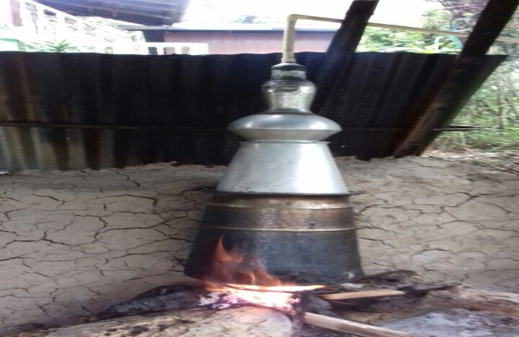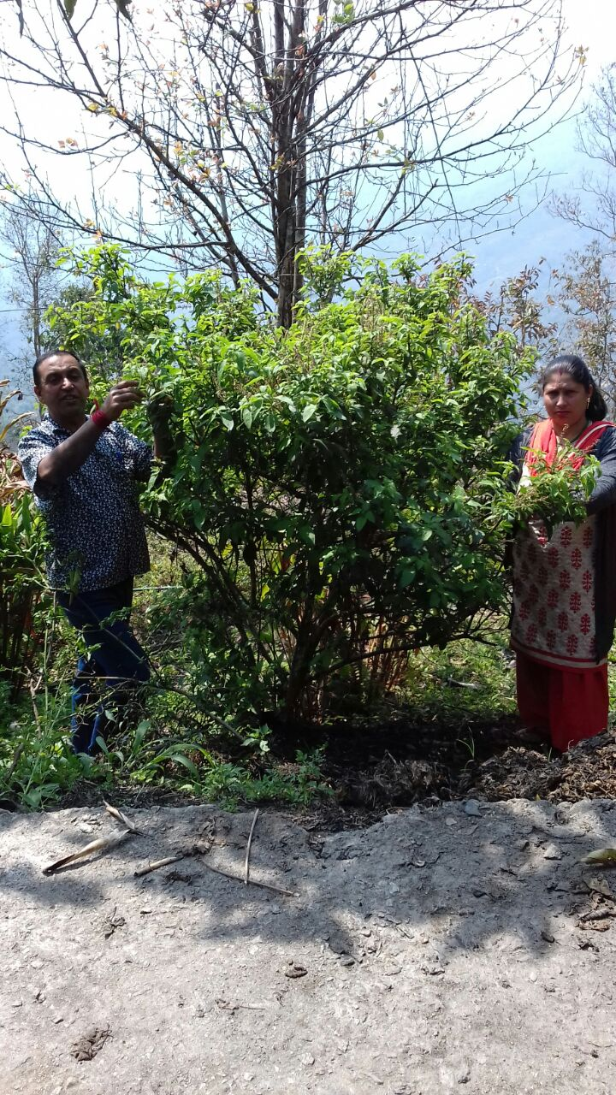

Harvesting of Tulsi leaves Traditional distillation system

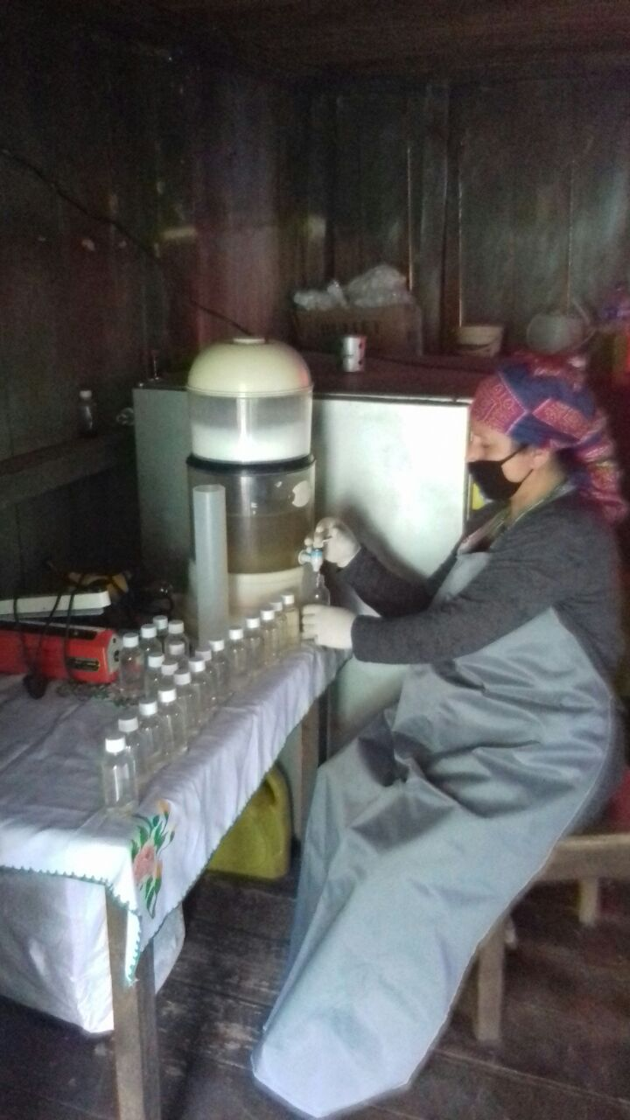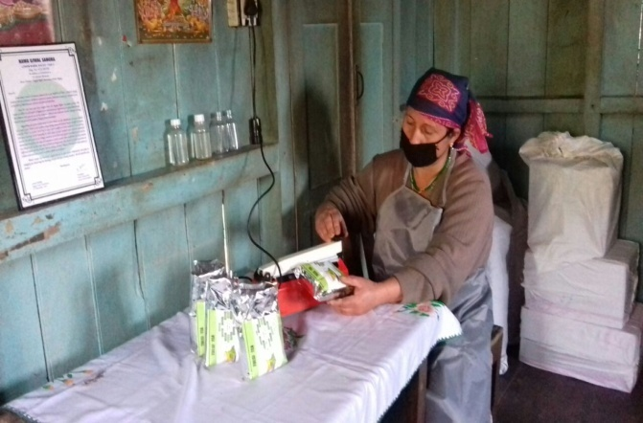

Packaging of Tulsi Tea Bottling of Tulsi Ark

4.6. Any other initiative taken by the KVK

5. LINKAGES

5.1. Functional linkage with different organizations

|  |  |
| --- | --- |
| **Name of organization** | **Nature of linkage** |
| State Agriculture Dept., Govt. of West Bengal | Training |
| Regional Research Station (Hill Zone), Uttar Banga Krishi Viswavidyalaya, Kalimpong |
| Dept. of Animal Recourses Development, Govt. of West Bengal |
| Sasastra Seema Bal (SSB), Siliguri Frontier |
| Regional Station, Indian Agricultural Research Institute, Kalimpong |
| Regional Research Station (Hill Zone), Uttar Banga Krishi Viswavidyalaya, Kalimpong | Demonstration |
| State Agriculture Dept., Govt. of West Bengal |
| Regional Research Station (Hill Zone), Uttar Banga Krishi Viswavidyalaya, Kalimpong | Joint Survey |
| State Agriculture Dept., Govt. of West Bengal |
| State Agriculture Dept., Govt. of West Bengal | Technical Support |
| Regional Research Station (Hill Zone), Uttar Banga Krishi Viswavidyalaya, Kalimpong |
| Dept. of Animal Recourses Development, Govt. of West Bengal |
| Spices Board, Kalimpong, Govt. of India |
| Regional Station, Indian Agricultural Research Institute, Kalimpong |

5.2. List of special programmes undertaken during 2017-18by the KVK, which have been financed by ATMA/ Central Govt/ State Govt./NABARD/NHM/NFDB/Other Agencies **(information of previous years should not be provided)**

a) Programmes for infrastructure development

|  |  |  |  |  |
| --- | --- | --- | --- | --- |
| Name of the programme/scheme | Purpose of programme | Date/ Month of initiation | Funding agency | Amount (Rs.) |
| Repairing and maintenance of Building | Darjeeling KVK | 2016-17 | ICAR | 4.00 |
| Repairing and maintenance of Farm Road | Darjeeling KVK | 2016-17 | ICAR | 2.00 |
| Support to IFS | Darjeeling KVK | 2016-17 | ICAR | 4.90 |

(b) Programme for other activities (training, FLD,OFT, Mela, Exhibition etc.)

|  |  |  |  |  |
| --- | --- | --- | --- | --- |
| Name of the programme/scheme | Purpose of programme | Date/ Month of initiation | Funding agency | Amount (Rs.) |
| - | - | - | - | - |

1. PERFORMANCE OF INFRASTRUCTURE IN KVK

6.1. Performance of demonstration units (other than instructional farm)

|  |  |  |  |  |  |  |  |  |  |
| --- | --- | --- | --- | --- | --- | --- | --- | --- | --- |
| Sl. No. | Name of demo Unit | Year of estt. | Area(Sq.mt) | Details of production | | | Amount (Rs.) | | Remarks |
| Variety/breed | Produce | Qty. | Cost of inputs | Gross income |
| 1. |  |  |  |  |  |  |  |  |  |
| 2. |  |  |  |  |  |  |  |  |  |
| 3. |  |  |  |  |  |  |  |  |  |
| 4. |  |  |  |  | | | | |  |
| 5. |  |  |  |  |  |  |  |  |  |
| 6. |  |  |  |  |  |  |  |  |  |
| 7. |  |  |  |  |  |  |  |  |  |
|  | Total |  |  |  |  |  |  |  |  |

6.2. Performance of Instructional Farm (Crops)

|  |  |  |  |  |  |  |  |  |  |
| --- | --- | --- | --- | --- | --- | --- | --- | --- | --- |
| Name  Of the crop | Date of sowing | Date of harvest | Area (ha) | Details of production | | | Amount (Rs.) | | Remarks |
|  |  | Variety | Type of Produce | Qty.(q) | Cost of inputs | Gross income |
|  |  |  |  |  |  |  |  |  |  |
|  |  |  |  |  |  |  |  |  |  |
|  |  |  |  |  |  |  |  |  |  |
|  |  |  |  |  |  |  |  |  |  |
|  |  |  |  |  |  |  |  |  |  |
|  |  |  |  |  |  |  |  |  |  |
|  |  |  |  |  |  |  |  |  |  |
|  |  |  |  |  |  |  |  |  |  |
|  |  |  |  |  |  |  |  |  |  |

* 1. Performance of Production Units (bio-agents / bio pesticides/ bio fertilizers etc.,)

|  |  |  |  |  |  |
| --- | --- | --- | --- | --- | --- |
| Sl.  No. | Name of the Product | Qty. (Kg) | Amount (Rs.) | | Remarks |
| Cost of inputs | Gross income |
| 1. |  |  |  |  |  |
|  |  |  |  |  |  |

* 1. Performance of instructional farm (livestock and fisheries production)

|  |  |  |  |  |  |  |  |
| --- | --- | --- | --- | --- | --- | --- | --- |
| Sl.  No | Name  of the animal / bird / aquatics | Details of production | | | Amount (Rs.) | | Remarks |
| Breed | Type of Produce | Qty. | Cost of inputs | Gross income |
| 1. | **-** | **-** | **-** | **-** | **-** | **-** | **-** |

* 1. Utilization of hostel facilities

Accommodation available (No. of beds)

|  |  |  |  |
| --- | --- | --- | --- |
| Months | No. of trainees stayed | Trainee days  (days stayed) | Reason for short fall (if any) |
| April 17 | 12 | 5 |  |
| June 17 | 20 | 5 |  |
| Oct 17 | 16 | 2 |  |
| Nov 17 | 30 | 3 |  |
| Feb 18 | 27 | 5 |  |
| Mar 18 | 30 | 3 |  |
| Total : |  |  |  |

(For whole of the year)

* 1. Utilization of staff quarters

Whether staff quarters has been completed: Yes

No. of staffquarters: 6

Date of completion: 2009

Occupancy details:

|  |  |  |  |  |  |  |
| --- | --- | --- | --- | --- | --- | --- |
| **Months** | **Q I** | **QII** | **Q III** | **QIV** | **Q V** | **QVI** |
| Dec 2009 to till date | B1 |  |  |  |  |  |
| March 2010 to till date |  | C2 |  |  |  |  |
| February 2012 till date |  |  | C1 |  |  |  |
| Feb 2014 to till date |  |  |  | B2 |  |  |
| Vacant |  |  |  |  | B3 |  |
| Vacant |  |  |  |  |  | A1 |

1. FINANCIAL PERFORMANCE

7.1. Details of KVK Bank accounts

|  |  |  |  |
| --- | --- | --- | --- |
| **Bank account** | **Name of the bank** | **Location** | **Account Number** |
| Darjeeling KVK | State Bank of India | Kalimpong | 11283931150 |
| Darjeeling KVK | Bank of India | Kalimpong | 429310110000033 |

* 1. Utilization of funds under CFLD on Oilseed *(Rs. In Lakhs)*

|  |  |  |  |  |  |
| --- | --- | --- | --- | --- | --- |
| Item | Released by ICAR | | Expenditure | | Unspent balance as on - |
| Kharif | Rabi | Kharif | Rabi |
| -- | -- | -- | -- | -- | -- |

7.3. Utilization of funds under CFLD on Pulses *(Rs. In Lakhs)*

|  |  |  |  |  |  |
| --- | --- | --- | --- | --- | --- |
| Item | Released by ICAR | | Expenditure | | Unspent balance as on 1st April 2018 |
| Kharif | Rabi | Kharif | Rabi |
| Field Pea |  |  |  |  |  |
| Black Gram |  |  |  |  |  |

* 1. Utilization of KVK funds during the year 2017-18(Not audited)

|  |  |  |  |  |  |  |
| --- | --- | --- | --- | --- | --- | --- |
| **Item / Head** | **Sanction grant Council,’s share (Rs.)** | **Release during the year (Rs.)** | **Expenditure council’s share (Rs.)** | **Variation** | | **Reason for variation** |
| **Savings (+) (Rs.)** | **Excess (-) (Rs.)** |
| Recurring |  |  |  |  |  |  |
| Pay & Allowance | 1,05,00,000 | 1,05,00,000 | 91,98,405 | 13,01,595 |  |  |
| TA | 1,30,000 | 1,30,000 | 1,29,970 | 30 |  |  |
| HRD | 30,000 | 30,000 | 29,965 | 35 |  |  |
| Contingency |  |  |  |  |  |  |
| Office Expenses | 11,10,000 | 11,10,000 | 11,09,967 | 33 |  |  |
| Training | 4,20,000 | 4,20,000 | 4,19,919 | 81 |  |  |
| FLD | 2,80,000 | 2,80,000 | 2,79,978 | 22 |  |  |
| OFT | 1,40,000 | 1,40,000 | 1,39,741 | 259 |  |  |
| Maintenance of Building | 5,00,000 | 5,00,000 | 4,99,945 | 55 |  |  |
| **Total** | **1,31,10,000** | **1,31,10,000** | **1,18,07,890** | **13,02,110** |  |  |
| Non-Recurring |  |  |  |  |  |  |
| Vehicles (Replacement) | ------ | ------ | ---- | ------ |  |  |
| Equipment Furniture & furnishing | 3,00,000 | 3,00,000 | 2,98,767 | 1233 |  |  |
| Library | -- | -- | -- | --- |  |  |
| Works | -- | -- | -- | --- |  |  |
| Soil & Water testing Lab (Equipment) | ----- | ------ | ---- | ---- |  |  |
| **Total** | **3,00,000** | **3,00,000** | **2,98,767** | **1233** |  |  |
| **Grand Total** | **1,34,10,000** | **1,34,10,000** | **1,21,06,657** | **13,03,343** |  |  |

7.5. Status of revolving fund (Rs. in lakh) for last three years

|  |  |  |  |  |
| --- | --- | --- | --- | --- |
| Year | Opening balance as on 1st April | Income during the year | Expenditure during the year | Net balance in hand as on 1st April of each year (Kind + cash) |
| 2015-16 | 4.16841 | 17.24056 | 16.37151 | 5.03745 |
| 2016-17 | 5.03745 | 2.11967 | 2.78520 | 4.37192 |
| 2017-18 | 0.43719 | 11.96326 | 10.65400 | 5.68118 |

* 1. (i) Number of SHGs formed by KVKs

(ii) Association of KVKs with SHGs formed by other organizations indicating the area of SHG activities

(iii) Details of marketing channels created for the SHGs

* 1. Joint activity carried out with line departments and ATMA

|  |  |  |  |  |  |
| --- | --- | --- | --- | --- | --- |
| Name of activity | Number of activity | Season | With line department | With ATMA | With both |
|  |  |  |  |  |  |
|  |  |  |  |  |  |
|  |  |  |  |  |  |

8. Other information

8.1. Prevalent diseases in Crops

|  |  |  |  |  |  |
| --- | --- | --- | --- | --- | --- |
| Name of the disease | Crop | Date of outbreak | Area affected (in ha) | % Commodity loss | Preventive measures taken for area (in ha) |
| - | - | - | - | - | - |

8.2. Prevalent diseases in Livestock/Fishery

|  |  |  |  |  |  |
| --- | --- | --- | --- | --- | --- |
| Name of the disease | Species affected | Date of outbreak | Number of death/ Morbidity rate (%) | Number of animals vaccinated | Preventive measures taken in pond (in ha) |
| - | - | - | - | - | - |

9.1. Nehru YuvaKendra(NYK) Training

|  |  |  |  |  |  |
| --- | --- | --- | --- | --- | --- |
| Title of the training programme | Period | | No. of the participant | | Amount of Fund Received (Rs) |
|  | From | To | M | F |  |
| - | - | - | - | - | - |

9.2. PPV & FR Sensitization training Programme

|  |  |  |  |  |
| --- | --- | --- | --- | --- |
| Date of organizing the programme | Resource Person | No. of participants | Registration (crop wise) | |
| Name of crop | No. of registration |
| - | - | - | - | - |

9.3. *mKisan*Portal (National Farmers’ Portal/ SMSPortal)

|  |  |  |
| --- | --- | --- |
| Type of message | No. of messages | No. of farmers covered |
| Crop | 26 | 36400 |
| Livestock | 46 | 64400 |
| Fishery | - | - |
| Weather | - | - |
| Marketing | - | - |
| Awareness | 8 | 11200 |
| Training information | - | - |
| Other | 5 | 7000 |
| **Total** | 85 | 1,19,000 |

9.4. *KVK* Portal and Mobile App

|  |  |  |
| --- | --- | --- |
| Sl. No. | Particulars | Description |
| 1. | No. of visitors visited the portal | - |
| 2. | No. of farmers registered in the portal | 260 |
| 3. | Mobile Apps developed by KVK | Darjeeling KVK |
| 4. | Name of the App | KVK online Agimart |
| 5. | Language of the App | English |
| 6. | Meant for crop/ livestock/ fishery/ others | All |
| 7. | No. of times downloaded | 225 |

9.5. a. Observation of Swacha Bharat Programme

|  |  |
| --- | --- |
| Date of Observation | Activities undertaken |
|
|  | Cleaning programme in schools |
|  | Sweeping of footpaths |
|  | Cleaning and beautification of office surrounding |
|  | Waste management |

b. Details of Swachhta activities with expenditure

|  |  |  |
| --- | --- | --- |
| **Activities** | **Number** | **Expenditure (in Rs.)** |
| 1. Digitization of office records/ e-office |  |  |
| 1. Basic maintenance |  |  |
| 1. Sanitation and SBM |  |  |
| 1. Cleaning and beautification of surrounding areas | 2 | 1875 |
| 1. Vermicomposting/   Composting of biodegradable waste management & other activities on generate of wealth for waste | 1 | 4050 |
| 1. Used water for agriculture/ horticulture application |  |  |
| 1. Swachhta Awareness at local level |  |  |
| 1. Swachhta Workshops | 1 | 5000 |
| 1. Swachhta Pledge |  |  |
| 1. Display and Banner |  |  |
| 1. Foster healthy competition |  |  |
| 1. Involvement of print and electronic media |  |  |
| 1. Involving the farmers, farm women and village youth in the adopted villages (no of adopted village) | 4 | 4800 |
| 1. No of Staff members involved in the activities | 14 |  |
| 1. No of VIP/VVIPs involved in the activities |  |  |
| 16. Any other specific activity (in details) |  |  |
| **Total** |  |  |

9.6. Observation of National Science day

|  |  |
| --- | --- |
| Date of Observation | Activities undertaken |
|
|  |  |

9.7. Programme with Seema Suraksha Bal (SSB)

|  |  |  |
| --- | --- | --- |
| Title of Programme | Date | No. of participants |
| Toy Making for sustainable development of Rural Youth | 05-10 April 2017 | 30 |
| Scientific Goat farming | 10-15 April 2017 | 30 |
| Scientific Poultry farming | 05-10 April 2017 | 30 |

9.8. Agriculture Knowledge in rural school:

|  |  |  |  |
| --- | --- | --- | --- |
| Name and address of school | Date of visit to school | Areas covered | Teaching aids used |
| SUMI, Kalimpong | 5-6 th March 2018 | Fruits and Vegetable cultivation |  |
| Dalapchand Basic Primary School | 16 January 2018 | Gardening |  |
| Dungra Basic Primary School | 19 April 2017 | Gardening |  |

Give good quality 1-2 photograph(s)

9.9. Details of ‘*Sankalp Se Siddhi’*Programme

|  |  |  |  |  |  |  |  |  |  |  |  |  |
| --- | --- | --- | --- | --- | --- | --- | --- | --- | --- | --- | --- | --- |
| Date of programme | No. of Union Ministers attended the programme | No. of  Hon’ble MPs (Loksabha/ Rajyasabha) participated | No. of State Govt. Ministers | Participants (No.) | | | | | | | Coverage by Door Darshan (Yes/No) | Coverage by other channels (Number) |
| MLAs Attended the programme | Chairman ZilaPanchayat | Distt. Collector/ DM | Bank Officials | Farmers | Govt. Officials, PRI members etc. | Total |
| - | - | - | - | - | - | - | - | - | - | - | - | - |

9.10. Details of Swachhta Hi Sewaprogramme organized

|  |  |  |  |  |  |
| --- | --- | --- | --- | --- | --- |
| Sl.  No. | Activity | No. of villages Involved | No. of Participants | No. of VIPs | Name (s) of VIP(s) |
| 1 | Swachhta Awareness at local level | 4 | 78 | - | - |

9.11. Details of Mahila Kisan Divas programme organized

|  |  |  |  |  |  |
| --- | --- | --- | --- | --- | --- |
| Sl.  No. | Activity | No. of villages Involved | No. of Participants | No. of VIPs | Name (s) of VIP(s) |
| 1 | Exhibition  Debate  Drama  Quiz | 3 | 30 | - | - |

9.12. No. of Progressive/Innovative/Lead farmer identified (category wise)

|  |  |  |  |
| --- | --- | --- | --- |
| Sl.  No. | Name of Farmer | Address of the farmer with contact no. | Innovation/ Leading in enterprise |
|  |  |  |  |

9.13.HRD programmes attended by KVK person

|  |  |  |  |  |
| --- | --- | --- | --- | --- |
| Training programme/ Seminar/ Symposia/ Workshop etc attended | Duration | Name of the  participants | Designation | Organizer of the training Programme |
| Persuasive communication & Soft Skills Development for SMS, Farm Manager & Prog. Asst (Lab. Tech) | 2 Days | Dr. M. W Moktan  Dr. Rakesh Roy  Dr. Pranab Barma  Miss Akriti Pradhan  Dr. Basu Deo Kharga  Mr. Akash Deep Thapa | SS & Head  SMS  SMS  SMS  PA  FM | DEE, UBKV |
| “Workshop on Quality seed production” - a step towards food security | 1 day | Dr. M. W Moktan  Dr. Rakesh Roy  Dr. Pranab Barma  Miss Akriti Pradhan  Dr. Basu Deo Kharga | SS & Head  SMS  SMS  SMS  PA | DEE, UBKV |
| HRD for Programme Assistant (Computer) | 2 days | Mr. Subrata Manna | PA | DEE, UBKV |
| Research methodology using Statistical Packages | 10 days | Mr. Subrata Manna | PA | Visva Bharati |
| Conservation of Indigenous breeds of small ruminate in their respective tracts | 10 days | Dr. Rakesh Roy | SMS | WBUAFS, Kolkata |
| Preparation of Bio-formulation of fungal & bacterial bio control agents for management of Biotic stress of Agricultural crops | 10 days | Dr. Pranab Barma | SMS | AAU, Jorhat, Assam |

9.14. Revenue generation

| Sl.No. | Name of Head | Income(Rs.) | Sponsoring agency |
| --- | --- | --- | --- |
| 1. |  |  |  |
| 2. |  |  |  |
| 3. |  |  |  |

9.15. Resource Generation:

|  |  |  |  |  |  |
| --- | --- | --- | --- | --- | --- |
| Sl.No. | Name of the programme | Purpose of the programme | Sources of fund | Amount  (Rs. lakhs) | Infrastructure created |
| - | - | - | - | **-** | **-** |

9.16. Performance of Automatic Weather Station in KVK

|  |  |  |
| --- | --- | --- |
| Date of establishment | Source of funding i.e. IMD/ICAR/Others (pl. specify) | Present status of functioning |
| - | - | - |

9.17. Contingent crop planning

|  |  |  |  |  |  |
| --- | --- | --- | --- | --- | --- |
| Name of the state | Name of district/KVK | Thematic area | Number of programmes organized | Number of Farmers contacted | A brief about contingent plan executed by the KVK |
| - | - | - | - | - | - |

10. Report on Cereal Systems Initiative for South Asia (CSISA) :NA

1. Year:
2. Introduction / General Information:

|  |  |  |  |  |  |  |
| --- | --- | --- | --- | --- | --- | --- |
|  | Title | Objective | Treatment details | Date of sowing | Replication | Result with photographs |
| Experiment 1 | - | - | - | - | - | - |
| Experiment 2 |  |  |  |  |  |  |
| Others (If any) |  |  |  |  |  |  |

11. Details of TSP : NA

1. Achievements of physical output under TSP during 2017-18

|  |  |
| --- | --- |
| **Programmes** | **Physical achievements** |
| Asset creation (Number; Sprayer, ridge maker, pump set, weeder etc.) | - |
| On-farm trials (Number) | - |
| Frontline demonstrations (Number) | - |
| Farmers training (in lakh) | - |
| Extension personnel training (in lakh) | - |
| Participants in extension activities (in lakh) | - |
| Seed production (in tonnes) | - |
| Planting material production (in lakh) | - |
| Livestock strains and fingerlings production (in lakh) | - |
| Soil, water, plant, manures samples testing (in lakh) | - |
| Provision of mobile agro – advisory to farmers (in lakh) | - |
| No. of otherprogrammes (Swachha Bharat Abhiyaan, Agriculture knowledge in rural school, Planting material distribution, Vaccination camp etc.) | - |

1. Fund received under TSP in 2017-18 (Rs. In lakh):
2. Achievements of physical outcomeunder TSP during 2017-18

|  |  |  |  |
| --- | --- | --- | --- |
| Sl. No. | Description | Unit | Achievements |
|
| 1 | Change in family income | % | - |
| 2 | Change in family consumption level | % | - |
| 3 | Change in availability of agricultural implements/ tools etc. | No. per household | - |

1. Location and Beneficiary Details during 2017-18

|  |  |  |  |  |  |  |
| --- | --- | --- | --- | --- | --- | --- |
| ***District*** | ***Sub-district*** | ***No. of Village covered*** | ***Name of village(s)***  ***covered*** | ***ST population benefitted***  ***(No.)*** | | |
| M | F | T |
| - | - | - | - | - | - | - |

12.Progress report of NICRA KVK (Technology Demonstration component) during the period

(Applicable for KVKs identified under NICRA): NA

Natural Resource Management

|  |  |  |  |  |  |
| --- | --- | --- | --- | --- | --- |
| Name of intervention undertaken | Numbers under taken | No of units | Area (ha) | No of farmers covered / benefitted | Remarks |
| - | - | - | - | - | - |

Crop Management

|  |  |  |  |
| --- | --- | --- | --- |
| Name of intervention undertaken | Area (ha) | No of farmers covered / benefitted | Remarks |
| -  - | - | - | - |

Livestock and fisheries

|  |  |  |  |  |  |
| --- | --- | --- | --- | --- | --- |
| Name of intervention undertaken | Number of animal covered | Number of units | Area (ha) | No of farmers covered / benefitted | Remarks |
| - | - | - | - | - | - |

Institutional interventions

|  |  |  |  |  |
| --- | --- | --- | --- | --- |
| Name of intervention undertaken | No of units | Area (ha) | No of farmers covered / benefitted | Remarks |
| - | - | - | - | - |

Capacity building

|  |  |  |  |  |
| --- | --- | --- | --- | --- |
| Thematic area | No. of Courses | No. of beneficiaries | | |
| Males | Females | Total |
| - | - | - | - |  |

Extension activities

|  |  |  |  |  |
| --- | --- | --- | --- | --- |
| Thematic area | No. of activities | No. of beneficiaries | | |
| Males | Females | Total |
| - | - | - | - | - |

Detailed report should be provided in the circulated Performa

13. Awards/Recognition received by the KVK

|  |  |  |  |  |  |
| --- | --- | --- | --- | --- | --- |
| Sl. No. | Name of the Award | Year | Conferring Authority | Amount | Purpose |
| - | - | - | - | - | - |

Award received by Farmers from the KVK district

|  |  |  |  |  |  |  |
| --- | --- | --- | --- | --- | --- | --- |
| Sl. No. | Name of the Award | Name of the Farmer | Year | Conferring Authority | Amount | Purpose |
| - | - | - | - | - | - | - |

14. Any significant achievement of the KVK with facts and figures as well as quality photograph

15. Number of commodity based organizations/ farmers’ cooperative society/ FPO formed/ associated with during last one year (Details of the group/society may be indicated)

|  |  |  |  |  |  |  |  |  |
| --- | --- | --- | --- | --- | --- | --- | --- | --- |
| Sl. No. | Name of the organization/ Society | Trust Deed No.& date | Date of Trust Registration        Address | Proposed Activity | Commodity Identified | No. of Members | Financial position  (Rupees in lakh) | Success indicator |
| - | - | - | - | - | - | - | - | - |

1. Integrated Farming System (IFS)

Details of KVK Demo. Unit

|  |  |  |  |  |  |  |  |
| --- | --- | --- | --- | --- | --- | --- | --- |
| Sl.  No. | Module details (Component-wise) | Area under IFS (ha) | Production (Commodity-wise) | Cost of production in Rs. (Component-wise) | Value realized in Rs. (Commodity-wise) | No. of farmer adopted practicing IFS | % Change in adoption during the year |
| 1 | -- | 0.25 ha | Poultry  Piggery  Goatery  Vermi compost  Polyhose  Mushroom unit  Kitchen Garden  Apiary | -- | -- | -- | -- |

1. Technologies for Doubling Farmers' Income

|  |  |  |  |  |  |
| --- | --- | --- | --- | --- | --- |
| Sl. No. | Name of the Technology | Brief Details of Technology (3- 5 bullet points) | Net Return to the farmer (Rs.) per ha per year due to the technology | No. of farmers adopted the technology in the district | One high resolution ‘Photo’ in ‘jpg’ format for each technology |
| 1 | Grading up of local poultry breeds by RIR cock |  | 31850 | 30 | IMG_20161227_145137 |
| 2 | Grading up of local pig breeds by Hampshire breed |  | 28150 | 30 | 2 |
| 3 | Disease management in ginger with Hot water treatment and application of bio agent |  | 57200 | 14 | IMG_6990 |
| 4 | Nutritional Management of Darjeeling Mandarin (*Citrus reticulata*) |  | 1,47,500 | 5 |  |
| 5 | Cultivation of oyster mushroom on hot water treated substrate (straw) |  | 3500 | 5 | IMG-20161028-WA0011 |

1. Report on Digital Farming Initiatives in Agriculture/ Digital Ag. Extension Service

|  |  |  |  |  |  |
| --- | --- | --- | --- | --- | --- |
|  | Database prepared/ covered for | | KVK level Committee | | Various activity conducted for farmers |
| Phase | Total no. of villages | Total no. of farmers | Date of formation | Name of members |
| I (up-to 175.03.2018) | - | - | 22/05/2018 | 4 |  |
| II (up-to 284.04.218) | - | - | - |
| Total9 | 18 | 650 |  |

19. Any other programme organized by KVK, not covered above

|  |  |  |  |  |  |
| --- | --- | --- | --- | --- | --- |
| Sl.  No. | Name of the programme | Date of the programme | Venue | Purpose | No. of participants |
| - | - | - | - | - | - |